

LOS ANGELES UNIFIED SCHOOL DISTRICT
EARLY CHILDHOOD EDUCATION DIVISION



EARLY EDUCATION CENTER
PROGRAM MANUAL

PROGRAM POLICY
CSPP, CCTR

EESIS
Early Education Student Information System

Issued January 1, 2014
Revised May 5, 2017

Table of Contents

1 OVERVIEW 6
1.1 Vision 6
1.2 Mission 6
1.3 Beliefs 6
1.4 Hours of Operation 7
1.5 General Qualifications 7
1.6 Programs 7
1.7 Program Quality 9
1.8 Child Days of Enrollment 9
1.9 References 10
2 GENERAL REQUIREMENTS 11
2.1 Residency 11
2.2 Child Ages 11
2.2.1 CSPP 12
2.2.2 CCTR 13
2.2.3 Priorities 13
2.3 Admission Procedures 13
2.4 Needs 14
2.5 Income 17
2.5.1 Income Ceilings 17
2.5.2 Total Countable Income 18
2.6 Eligibility List 20
2.7 Admission Priorities 20
2.8 Pre-Enrollment 21
2.9 Emergency Information 22
2.10 Health 22
2.11 Certification 23
2.11.1 CD 9600 23
2.11.2 Notice of Action (NOA) 23
2.12 Scanning 25
3 DOCUMENTING ELIGIBILITY AND NEED 26
3.1 Documentation of Employment 26
3.1.1 Why, when and how to verify income 26
3.1.2 Pay Stubs 26
3.1.3 Cash Payments 27
3.1.4 Monthly Income Worksheet 28
3.1.5 Employer Contact 28
3.1.6 Varying Schedule 29
3.1.7 Income Fluctuation 30
3.1.8 New Job 30
3.1.9 Self-Certification of Income 31
3.1.10 Self-Employed Parent 31
3.1.11 Travel 34
3.1.12 Sleep 34
3.2 Documentation of Public Assistance 35
3.3 Documentation of Seeking Employment 35
3.4 Documentation of Vocational Training 36
3.4.1 Progress 37
3.4.2 Hours of Care 37
3.5 Documentation of Homelessness 38
3.6 Documentation of Seeking Permanent Housing 38
3.7 Documentation of Parental Incapacity 40
3.7.1 Pregnancy 40
3.7.2 Update to Application 40
4 CONTINUING / ENDING SERVICE 42
4.1 Recertification 42
4.1.1 At Risk 42
4.1.2 Child Protective Services 42
4.1.3 Other Families 42
4.1.4 Recertification Documents 43
4.2 Change in Need or Eligibility 43
4.3 Termination 43
4.3.1 Reasons for Termination 44
4.3.2 Suspected Fraud 45
4.3.3 Due Process 45
4.4 Disenrollment 46
5 FAMILY SIZE 51
5.1 Single Parents Error! Bookmark not defined.
5.2 Definition of Family 52
6 ATTENDANCE 59
6.1 Attendance Exceptions 59
6.2 Sign-In Sheet Requirement 59
6.2.1 Sign-In Sheets 59
6.2.2 Signature 60
6.2.3 Actual Time 60
6.2.4 Supplemental Sign-In Sheets 61
6.2.5 Review of Sign-In Sheets 61
6.2.6 Absence Notification Policy 61
6.3 Absence Codes 63
6.3.1 Attendance and Absences 63
6.3.1.1 Reimbursement for Absences 63
6.3.1.2 Definition of Absence Types 64
6.3.2 Attendance Reports 67
7 FAMILY DATA FILE 69
7.1 Recommended Organization 69
7.2 Recertification 72
7.3 Changes 73
7.4 Termination 73
7.5 Record Retention 73
8 FEES 74
8.1 Establishing Family Fees 74
8.2 Notice of Action for Fees 76
8.3 Invoices 77
8.4 Fee Collection 79
8.4.1 Delinquent Fees 79
8.4.2 Payment Plan 79
8.4.3 Methods of Payment 80
8.5 Receipts 81
8.6 Fee Exclusions 82
8.7 Fee Adjustments 83
8.8 Over/Underpayment of Fees: 83
8.9 Processing of NSF (Non-Sufficient Funds) Checks 85
8.10 Credits/Refunds for Overpayment of Fees 85
8.11 Banking of Fees 85
8.11.1 Distribution of Deposit Slips 85
8.11.2 Special Month-End Deposit Procedure 86
8.11.3 Fee Reports 86
9 DUE PROCESS REQUIREMENTS 89
9.1 Notice of Action 89
9.2 Parent Request for a Hearing and Procedures 90
9.3 Conducting the Hearing 90
9.4 Hearing Decision 91
9.5 Appeal Procedure for EESD Review 91
10 CONFIDENTIALITY 93
11 UNIFORM COMPLAINT PROCEDURES (UCP) 93
11.1 Compliance Officer 93
11.2 Notifications 94
11.3 Filing of UCP Complaints 94
11.4 Investigation of Complaint 94
11.5 Written Decision 95
11.6 Appeals to the California Department of Education 95
11.7 Complaints Not Under the Jurisdiction of the District’s UCP Process 95
12 EESIS - Security Guidelines 97
13 EESIS - Access 99
13.1 Logging Out 99
14 EESIS - Navigation 101
14.1 Overview of the Navigation Bar 101
14.2 Using the Navigation Bar 102
14.3 Using Features in EESIS 103
14.3.1 Text fields 103
14.3.2 Dropdowns 103
14.3.3 Required fields 103
14.3.4 Preferred fields 103
14.3.5 Multi-select boxes 103
15 EESIS - Searching the Database 105
15.1 Searching by Child 105
15.2 Viewing Multiple Family Records 106
15.3 Narrowing a Search Using the Summary Page 107
16 EESIS - Adding a New Family 108
16.1 Adding a Family - The Family Page 108
16.2 Adding a Family—The Parent Page 111
16.3 Adding a Family – The Needs Page 113
16.4 Adding a Family—The Income Page 116
16.5 Adding a Family—The Child Page 119
16.6 Adding a Family—The Schedule Page 121
17 EESIS - Adding a Schedule to an Existing Family 126
17.1 Active Family 126
17.2 Terminated Family 126
18 EESIS - Completing the Enrollment Process 128
18.1 The Application (9600) 128
18.2 The Notice of Action (NOA) 130
18.2.1 Approval NOAs 130
18.2.2 NOA Corrections 134
19 EESIS – Fee Collection 136
19.1 EESIS - Invoices 136
19.1.1 Batch Printing Invoices 136
19.1.2 Printing an Invoice From the Summary Page 137
19.2 Posting a Payment 138
19.3 Past Due Balance 140
20 EESIS - Attendance 143
21 EESIS - Edits 148
21.1 Terminating a Family 148
21.2 Changing Income 149
21.3 Duplicate Families 152
22 EESIS - Alerts 154
22.1 Processing Alerts 155
22.2 Creating a CM Alert 156
23 EESIS - Scanning Images 157
23.1 Enabling Scanning 157
23.2 Viewing Scanned Documents 158
23.3 Deleting a Scanned Document 158
24 EESIS - Additional Information 159
24.1 The Immunizations Page 159
24.1.1 Immunization Reports 160
24.2 The Medical Page 161
24.3 The File Page 164
25 EESIS - Quick Reference Guide 167
26 INCOME RANKING TABLE 170
27 FAMILY FEE SCHEDULE 172
28 FORMS 173

NOTE:

These excerpts are provided exclusively for use in the
LAUSD CSPP and CCTR programs.

Policies are governed by CDE Funding Terms and Conditions for CCTR and CSPP:

http://www.cde.ca.gov/fg/aa/cd/ftc2013.asp

OVERVIEW
Early Education Centers (EECs) are high quality developmentally appropriate preschool programs that address the social, emotional, physical and cognitive needs of the population served, primarily 3 and 4 year olds. The vision, mission and beliefs of the Early Childhood Education Division outline a commitment and responsibility to the diverse cultural and linguistic needs of children and families.

Vision
All students are entitled to a high quality early education program in a safe and nurturing environment, characterized by high levels of positive adult child interactions to ensure the social and academic success for every student who attends one of our LAUSD Early Childhood Education programs.

Mission
Our mission is to provide every Early Childhood Education professional with the skills and knowledge necessary to provide high quality instruction and social emotional competence so students are supported to their highest potential.

Beliefs
We believe that:
- All students in early education programs have the right to receive effective and developmentally appropriate instruction by highly qualified staff in a safe and nurturing environment.
- The lessons we teach and the interactions that occur with preschool children have a long-term positive influence on their academic success.
- Early Education educators prepare students for success in school and life while valuing and respecting the needs, languages, and cultures of students and their families.
- Every adult in the division has a responsibility to ensure that all children leave our programs fully prepared cognitively and social-emotionally to be successful in Kindergarten.
- All Early Education staff must commit to providing a daily learning environment that is educational, fun, and challenging.
- It is the role of the Early Education staff to welcome, support, and provide guidance so that parents can contribute to and become actively involved in their child’s development.

Hours of Operation
Early Education Centers operate 245 days per year, usually from 6:00 a.m. to 6:00 p.m., Monday through Friday.

General Qualifications
Early childhood education programs provided by the Los Angeles Unified School District are subsidized by the California Department of Education and are subject to strict eligibility and need guidelines. Families requesting full day, full year services must live in the state of California, have an income at or below 70% of state median income, and have a qualifying need such as employment, training, seeking employment, etc.
Children ages 2 through 4 are served at most centers, with priority given to 4 year olds.

Programs
Early Education Centers offer three programs:
- CSPP - The majority of children served in EECs are enrolled in the California State Preschool Program (CSPP) either full day or part day. This is a state-funded program with strict eligibility requirements. Priority for enrollment goes first to 4 year olds and then 3 year olds. At least 50% of children enrolled in CSPP must be 4 years old. Children who turn 5 years old and are eligible for kindergarten or transitional kindergarten are no longer eligible to receive services at the Early Education Center. See Chapter 2.2.
- CCTR - The General Child Care program, known as CCTR, is for children who are 2 years old and may be used for some 5 year olds. See Chapter 2.2.2.
- PCC - Approximately half of the EECs have a Preschool Collaborative Classroom (PCC). The PCC is a 3 hour program providing special education services for children with exceptional needs. The program provides these children with the opportunity to work and play alongside their peers. All PCC children must have an Individualized Education Program (IEP) and there should be a contact from the Special Education program alerting the center that the child will be enrolling. Some special needs children attend only the PCC class and there are no family eligibility (need or income) requirements. Others receive child care services (CCSP or CCTR) due to the need of their parent and also attend the PCC class. These are referred to as “PCC plus another program” and are indicated as such on the Child page in EESIS under the Flags checkbox. When a child with an IEP is enrolled, there is an interface between EESIS and Welligent (Special Education system) that populates the Adjustment Factor Codes field on the Child page in EESIS with either “22-Exceptional Needs” or “24-Severely Disabled”. No action is required on the part of the Office Manager.
The following early education programs are also offered by LAUSD:
- Los Angeles Universal Preschool (LAUP)
LAUP is a part-day program for 4 year old children. In addition LAUP provides for the enhancement of several CSPP programs. LAUP is an independent public benefit corporation created in 2004 and funded by First 5 LA, the commission established by Proposition 10.
- California School Age Families Education (CalSAFE)
CalSAFE, located on high school campuses, is a program for infants and toddlers and their high school-age parents.
- Infant and Preschool Special Education
The District offers a wide variety of Early Childhood Special Education programs, supports and services for children birth to five years of age with identified disabilities as mandated in Federal and State law.

Program Quality
CSPP Program quality requirements are outlined in the California Code of Regulations, Title V, the California Education Code and CDE Funding Terms and Conditions. These include the requirement that an age-appropriate Desired Results Developmental Profile (DRDP) be completed for each child who is enrolled in the program for at least 10 hours per week. The DRDP must be completed for each child within 60 calendar days of enrollment and at least once every 6 months thereafter. Parent education and outreach is provided through a parent advisory council, two parent-teacher conferences per year, parent surveys and parent education. This is detailed in Early Childhood Education Procedures, Guidelines and Information for Parents (also known as the Parent Handbook).

Child Days of Enrollment
A Child Day of Enrollment, or CDE, is a unit of service used to reimburse the District for services provided. One full-time contract (6½ to 10 hours per day) equals one CDE.

If minimum CDE is not earned, the revenue to finance salaries and operating expenses will be less than expected and the federal/state contract amount will be adjusted downward. Fewer dollars to operate programs translates to less services to children and fewer staff members needed.

Schedule for Computing Daily Contract Hours

AMOUNT OF TIME PHYSICALLY  IN THE CENTER | ATTENDANCE CATEGORY
0 minutes -- 3 hours 59 minutes | Half Time
4 hours -- 6 hours 29 minutes | Three Quarter Time
6 hours 30 minutes -- 10 hours 29 minutes | Full Time
10 hours 30 minutes -- 12 hours | Full Time Plus

For each child who is enrolled half time, another half time child should be enrolled in order to equal a whole CDE.

References
Policies contained in this manual are based on:
California Department of Education Management Bulletins:
http://www.cde.ca.gov/sp/cd/ci/allmbs.asp
CCTR Funding Terms and Conditions
Download from http://www.cde.ca.gov/sp/cd/lr/
CSPP Funding Terms and Conditions
Download from http://www.cde.ca.gov/sp/cd/lr/
State Law - California Code of Regulations (CCR), Section 5:
http://www.calregs.com/linkedslice/default.asp?SP=CCR-1000&Action=Welcome
LAUSD Early Childhood Education Bulletins and Memorandums: Found in the Publications link on the left navigation bar of the Early Childhood Education home page: http://eced.lausd.net . These include:
- ECE Bulletins
http://notebook.lausd.net/portal/page?_pageid=33,125815&_dad=ptl&_schema=PTL_EP
- ECE Reference Guides
http://notebook.lausd.net/portal/page?_pageid=33,125785&_dad=ptl&_schema=PTL_EP
ECE Parent Handbook
http://notebook.lausd.net/pls/ptl/docs/PAGE/CA_LAUSD/FLDR_ORGANIZATIONS/FLDR_INSTRUCTIONAL_SVCS/ECE%20HANDBOOK%20ADOPTED%20BY%20THE%20BOARD%206%2021%202011.PDF
EESIS http://eesis.lausd.net
EESIS Tips of the Day - http://eced.lausd.net/eesis

GENERAL REQUIREMENTS
To receive preschool services, a child must meet age criteria and the family must meet residency, income and needs criteria as defined below.

Residency
To be eligible for services the child must live in the state of California. Evidence of a street address or post office address in California is sufficient to establish residency. Residency must be documented at initial certification and at each recertification.
A person identified as homeless is exempt from this requirement and must submit a declaration of intent to reside in California. Homeless is defined as a person or family that lacks a fixed, regular, and adequate night-time residence and has a primary night time residence that is:
1. A supervised publicly or privately operated shelter, transitional housing, or homeless support program designed to provide temporary living accommodations; or
2. A public or private place not designed for, or ordinarily used as, a regular sleeping accommodation for human beings.
A homeless parent should be seeking permanent housing for family stability. (See Chapter 3.6.)
There is no residency requirement with regard to LAUSD District boundaries. A parent may choose to enroll a child close to the home or close to the work place.
The determination of eligibility is without regard to the immigration status of the child or the child’s parent(s) unless the child or the child’s parent(s) is under a final order of deportation from the United States Department of Homeland Security.

Child Ages
The terms “CCTR” (which is used to reference General Child Care) and “CSPP” (California State Preschool Program) are used to distinguish funding sources for the contracts LAUSD has with the California Department of Education. Eligibility requirements for the programs are almost identical except for the ages of the children served.

CSPP
The CSPP program serves children ages three and four as defined below:

2014-2015 School Year:
- Four year old children are defined as children who will have their fourth birthday on or before September 1, 2014 (birth date 12/3/09 through 9/1/10).
- Three year old children are defined as children who will have their third birthday on or before September 1, 2014 (birth date 9/2/10 through 9/1/11).
- Children who turn 5 between September 2 and December 2, 2013 (birth date 9/2/08 through 12/2/09) must attend Transitional Kindergarten.
FY 2014-2015 (July 1, 2014 through June 30, 2015)
 | DOB From |  | DOB To
Kindergarten | 9/2/2008 | - | 9/1/2009
Transitional Kinder | 9/2/2009 | - | 12/2/2009
4 year old (CSPP) | 12/3/2009 | - | 9/1/2010
3 year old (CSPP) | 9/2/2010 | - | 9/1/2011
2 year old (CCTR) | 9/2/2011 | - | 9/1/2012

2015-2016 School Year forward:
- Four year old children are defined as children who will have their fourth birthday on or before September 1.
- Three year old children are defined as children who will have their third birthday on or before September 1.
- Children who turn 5 between September 2 and December 2 must attend Transitional Kindergarten.
FY 2015-2016 (July 1, 2015 through June 30, 2016)
 | DOB From |  | DOB To
Kindergarten | 9/2/2009 | - | 9/1/2010
Transitional Kinder | 9/2/2010 | - | 12/2/2010
4 year old (CSPP) | 12/3/2010 | - | 9/1/2011
3 year old (CSPP) | 9/2/2011 | - | 9/1/2012
2 year old (CCTR) | 9/2/2012 | - | 9/1/2013

CCTR
The CCTR program serves children who have not yet turned three. Prior to 2013, kindergarten-eligible children would have to change schedules from CSPP into CCTR for a few weeks in the summer before starting school. Effective in 2013, if a child is receiving CSPP Full Day services on or before June 30, the child may remain enrolled in CSPP until he starts kindergarten. A five year old child who is NEWLY enrolled between July 1 and the start of kindergarten would be enrolled in CCTR for that short period. Such a child would be given low priority unless receiving Child Protective Services or at risk of abuse or neglect.

Priorities
Within the CCTR and CSPP programs, the following priorities apply:
- First priority is always provided to age-eligible children (1) receiving child protective services through the LA County Department of Children and Family Services or (2) at risk of being abused or neglected.
- Second priority is for all CSPP eligible four year old children.
- Four year olds MUST be admitted before eligible three year olds in accordance with family income ranking with the lowest income ranks admitted first. (See attached priority scale.)
- At least 50% of children enrolled in CSPP programs must be four year olds.

Admission Procedures
Eligibility for services must be established by one of the following:

- Family is receiving child protective services (CPS) through the Los Angeles County Department of Children and Family Services (DCFS). (See BUL-3809.0)
- Family has a child who is at risk of abuse, neglect, or exploitation referral prepared by a legally qualified professional from a legal, medical, or social services agency, or emergency shelter. (See BUL-3809.0)
- Family is a public assistance (CalWORKS) recipient.
- Family is income eligible.
- Family is homeless.

Needs

This guide is written for use in Early Education Centers serving children in programs for the full day (or schedules as dictated by the parent’s documented need) and full year. Part day, part year CSPP programs, such as those in the elementary schools, do not require a parent need reason.
Attendance for “core curriculum hours” is not allowed when there is no need. A child attending an Early Education Center may not be enrolled in CSPP Part Day with a “No Fee” Parent Fee Rate Type. That only applies to part-day/part-year programs at elementary schools (and at designated centers with special CSPP Part Day classes).
A child attending an EEC may qualify for part-time services if:
- The parent need is less than 6 hours and 29 minutes per day, AND
- The family income is under the income ceiling for the family size.
If both of these are true, enroll the child in CSPP Full Day with a Parent Fee Rate Type of “General Childcare”. If the family owes a fee, EESIS will charge a part-time fee.
Need for full day, full year services must be established by one of the following:

- The child is a recipient of child protective services (CPS). “Child protective services" means protective services provided to children through the Los Angeles County Department of Children and Family Services (DCFS). (Use Child Protective Services Form 83.66)
- The child is at risk of abuse, neglect, or exploitation. "At risk of abuse, neglect, or exploitation" means a child who has been identified by a legally qualified professional in a legal, medical, social services agency, or emergency shelter as being at risk of abuse, neglect, or exploitation, and referred for child care and development services. The referral must be dated within the six months immediately preceding the date of application for services. (Use Child Protective Services Form 83.66)
NOTE: Parents of children who are referred for services due to child protective services (CPS) or at-risk of abuse, neglect, or exploitation are excluded from this section (Needs). The CPS referral from DCFS or the “at-risk” referral from an appropriate professional is all that is required to meet both eligibility and need criteria. As long as the fee waiver box is checked on CPS Referral Form 83.66, the parent will not be required to provide documentation of total countable income. If parents or caretakers of children in these categories seek care for their non-referral children (for example, the foster parent’s own children), they will need to provide income documentation and demonstrate a need for services.
- The parent(s) and any other adult counted in the family size are any of the following:
  - Employed (see Chapters 3.1 and 3.2)
  - Seeking employment (see Chapter 3.3)
  - Participating in vocational training leading directly to a recognized trade, paraprofession or profession (see Chapter 3.4)
  - Homeless and seeking permanent housing for family stability (see Chapters 3.5 and 3.6)
  - Incapacitated (see Chapter 3.7)
- Subsidized child care and development services will only be available to the extent which:
  - The parent meets a need as specified above that precludes the provision of care and supervision of the family’s child for some of the day;
  - There is no parent in the family capable of providing care for the family’s child during the time care is requested; and
  - Supervision of the family’s child is not otherwise being provided by school or another person or entity.
- Certification of Eligibility and Need - Prior to initial enrollment and at the time of recertification, the Office Manager or Principal must:
  - Certify each family’s/child’s eligibility and need for child care and development services after reviewing the completed application and documentation contained in the family data file.
  - Based on information entered in EESIS, generate a 9600 and 9600A.
  - Issue a Notice of Action (NOA), Application for Services or a Notice of Action, Recipient of Services. (See Chapters 2.11.2 and 9.1)
At the time of certification and recertification, families must be informed of their responsibility to notify the center, within five (5) calendar days, of any changes in family income, family size, or need for child care and development services.
Joint custody - When a child’s residence alternates between the homes of separated or divorced parents, eligibility, need and fees should be determined separately for each household in which the child is residing during the time child development services are needed (i.e., separate certifications and service agreements). For example, a child may be certified with no fee during part of the week and a fee while with the other parent the rest of the week. This may require creation of a duplicate family in EESIS and should be discussed with the Eligibility Technician in the ECE Fiscal Unit.

Income
California law limits child care and development services to families whose income, based on family size, is less than 70% of California's State Median Income. The parent is responsible for providing documentation of the family’s total countable gross (pre-tax) income and the center is required to verify the information.

Income Ceilings

Schedule of Income Ceilings for Child Care and Development Programs
Family Size | Family Monthly Income | Family Yearly Income
1 – 2 | $3,283 | $39,396
3 | $3,518 | $42,216
4 | $3,908 | $46,896
5 | $4,534 | $54,408
6 | $5,159 | $61,908
7 | $5,276 | $63,312
8 | $5,394 | $64,728
9 | $5,511 | $66,132
10 | $5,628 | $67,536
11 | $5,745 | $68,940
12 | $5,863 | $70,356
CDE Management Bulletin 11-06

Some families may be required to pay fees if their income is below the income ceiling but falls within the Family Fee Schedule limits. See Chapter 8.
See Chapter 3 for how to verify income. Documentation of income must be provided for the month or four week period prior to enrollment. This information must be entered on the Monthly Income Worksheet on the Income page in EESIS for both parents. Even if a parent has no income, an Income page must be completed in EESIS showing $0 with the effective date this was verified. (This generally applies to the CSPP Part Day program where there is no parental need requirement.)
The center must retain copies of income documentation (check stubs, etc.) in the Family File and scan them into EESIS Images.

Total Countable Income
Total countable income for the individuals counted in the family size includes, but is not limited to, the following:

- Gross wages or salary, advances, commissions, overtime, tips, bonuses, gambling or lottery winnings
- Wages for migrant, agricultural, or seasonal work
- Public cash assistance
- Gross income from self-employment (please see Regulations Handbook for more details)
- Disability or unemployment compensation
- Workers compensation
- Spousal support, child support received from the former spouse or absent parent, or financial assistance for housing costs or car payments paid as part of or in addition to spousal or child support.

NOTE: Spousal support or child support PAID by the parent may be deducted from countable income by entering on the Income page in EESIS as a negative number.
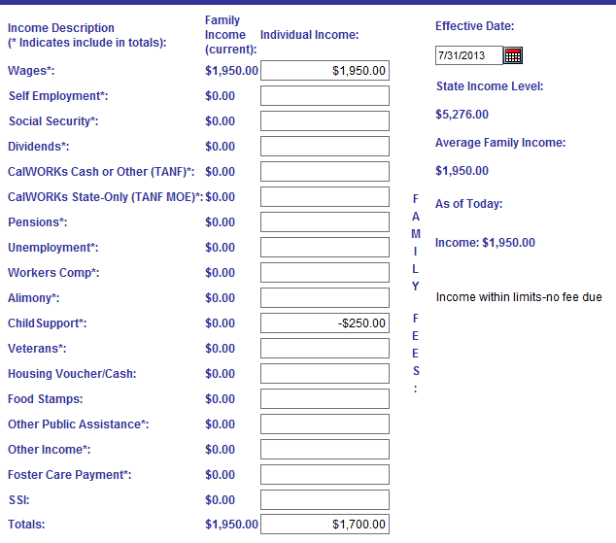

- Survivor and retirement benefits
- Dividends, interest on bonds, income from estates or trusts, net rental income or royalties
- Rent for room within the family’s residence
- Foster care grants, payment of clothing allowance for children placed through child welfare services. If foster children are siblings, all are counted in family size and all foster care payments are counted.
- Financial assistance received for the care of child living with an adult who is not the child’s biological or adoptive parent
- Veteran’s pensions
- Pensions or annuities
- Inheritance
- Allowances for housing or automobiles provided as part of compensation
- Portion of student grants or scholarships not identified for educational purposes as tuition, books, or supplies
- Insurance or court settlements for lost wages or punitive damages
- Net proceeds from the sale of real property, stocks, or inherited property
- Other enterprise for gain

NOTE: For Child Protective Service children, as long as the fee waiver box is checked on CPS Referral Form 83.66, the parent will not be required to provide documentation of total countable income.

Eligibility List
An Eligibility List, also called a waiting list, is maintained at each EEC. The term "eligibility" is used because families are ranked by eligibility factors described above. Families whose children are receiving child protective services or whose children are at risk of being neglected or abused are admitted first. Next are families in accordance with family income, with the lowest income ranking admitted first. Eligible 4 year old children are admitted before eligible 2 and 3 year old children.
A family who inquires about enrolling a child should complete an Eligibility List Form. This helps determine if the family will be eligible for services should there be a vacancy in the center. Past history has shown that when the form is given to parents, the information returned is often incomplete or inaccurate. It is helpful for the Office Manager or Principal to sit with the parent as time allows and assist them in completing the required information. This is particularly important in verifying the monthly gross income for the family. Each EEC must have a system for maintaining an Eligibility List of families requesting services in priority order. See Income Ranking Table, Chapter 26.
When space becomes available, notify the next eligible parent by phone or mail. Provide the parent with a checklist of documents needed to complete the certification and enrollment process. When the parent provides ALL required documentation, schedule an appointment to admit the child and complete the CD 9600 (Confidential Application for Child Development Services and Certification of Eligibility).

Admission Priorities
  - First priority: Families whose age-eligible children are receiving child protective services or families whose age-eligible children are at risk of being abused, neglected, or exploited. Within this priority, children receiving protective services through DCFS must be admitted first.
NOTE: The CPS referral from DCFS or the “at-risk” referral from an appropriate professional is all that is required to meet both eligibility and need criteria. As long as the fee waiver box is checked on CPS Referral Form 83.66, the parent will not be required to provide documentation of total countable income. If parents or caretakers of children in these categories seek care for their non-referral children (for example, the foster parent’s own children), they will need to provide income documentation and demonstrate a need for services.
  - Second priority: All CSPP eligible four-year-old children must be admitted before CSPP eligible three-year old children in accordance with family income ranking, with the lowest income ranks being admitted first. For purposes of determining the order of admission, public assistance grants are counted as income, and must be ranked accordingly. When two or more families have the same income, the family that has a child with exceptional needs must be admitted first. If none of the families with the same income ranking has an exceptional needs child, the family that has been on the waiting list the longest must be admitted first.
  - Services must not be denied or receive lower priority if the family needs less than full-time services.
  - For part-day, part-year service only, CSPP eligible four-year-old children from over income families must be admitted before CSPP eligible three-year-old children from over income families (up to the 15% over income allowance.)
  - Transfers from one center to another are acceptable if space is available. It is not necessary to terminate a family that is being transferred immediately. If space in the other center is not available, the family should be placed on the eligibility list.

Pre-Enrollment
CSPP Full Day and CCTR - Income documentation must be obtained for the month or four week period preceding the child’s start date in the program. This is to allow time to send out an Approval or Denial Notice of Action. Lack of current eligibility documentation is a significant audit issue.
CSPP Part Day - It is acceptable to pre-enroll for the CSPP Part Day program up to 120 days in advance. Verification of income, single parent status and other eligibility requirements may be obtained up to 120 days in advance. This generally applies to programs at the elementary school, not full day, full year programs operated by the EECs.
Enrollment Packet - Enrollment packets should be readily available at all times and reproduced at the EEC. A Parent Enrollment Packet should be provided to each prospective family.

Emergency Information
Every parent, legal guardian or caregiver must complete an Emergency Information card for the child at time of enrollment. Emergency information must include the following:
- Home address and current telephone number, including cell phones
- Employment/business addresses and phone numbers
- Relative/friend’s first and last names, addresses and telephone numbers, authorized to pick-up and care for a child due to illness, in an emergency situation, or after program closing hours, if a parent cannot be reached.
A child may only be released to an adult at least 18 years old listed on the Emergency Information card.

It is the responsibility of every parent, legal guardian or caregiver to immediately inform the center of any change of address, telephone number or emergency information on the official Emergency Information card.

Health
The parent must provide a record of current immunizations for the child. As of January 1, 2014, state law requires the completion of a Personal Belief Exemption (PBE) form, CDPH 8262 (10/13), to exempt children from immunizations that are required for school entry or advancement. The PBE form CDPH 8262 is a statement signed and dated by a health care practitioner and the parent indicating that the practitioner has provided, and the parent has received, information about the benefits and risks of immunizations and the risks of vaccine-preventable diseases. Form CDPH 8262 (10/13) is available in English, Spanish, Chinese, Arabic, Armenian, Farsi, Russian, Cambodian, Hmong, Vietnamese, Tagalog, Korean and Japanese. These can be downloaded from http://www.shotsforschool.org/immunizationlaws/ .

Prior to, or within 30 calendar days following enrollment, a written report of the child’s physical exam, prepared by a licensed physician, must be provided. The preferred form is the Department of Social Services Form LIC 701, “Physician’s Report”. TB tests are not required for children entering preschool programs unless certain risk factors are present. The LIC 701 has a checkbox at the bottom that indicates whether there is a need for TB screening. Any physician’s report provided by the parent must be less than one year old.

Certification
In order to complete the enrollment process, all required documents must be provided by the parent and all information must be entered in the Early Education Student Information System, EESIS. This includes, at a minimum:
- Family page (after searching the database to see if the family already exists)
- Parent page (one per parent)
- Needs page (one per parent)
- Income page (one per parent)
- Child page (one per child in the family)
- Schedule page

CD 9600
The 9600 (Confidential Application for Child Development Services and Certification of Eligibility) and the Notice of Action are then generated from the Family Summary page in EESIS. Verify that the information, including all dates, are correct on the 9600. The 9600 must be signed in Section VII by the EEC Principal. The parent must sign and date Section V.

Notice of Action (NOA)
A Notice of Action must be generated in order to finalize the process and generate fees, if applicable. The Notice of Action advises the parent of due process requirements if they disagree with the agency’s actions. The NOA must be given to the parent at least fourteen (14) calendar days before the effective date of the intended action (19 calendar days if mailed). See Chapter 9 for more information about the appeal process.
NOAs are generated from the Summary page in EESIS.
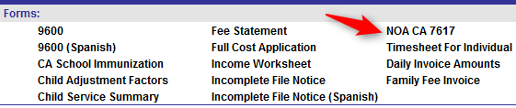
There is a radio button under the Reason for Action section to select English or Spanish. Several types of NOAs can be selected from the dropdown:
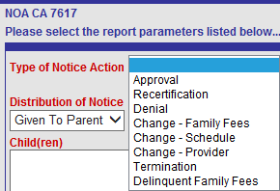
- Approval – Use for the initial certification of a child. The NOA effective date is the date the child will start attending (Schedule Start Date). In the month of initial certification, the fee is effective immediately. If a second child in the family is subsequently enrolled, create another Approval NOA for that child.
- Recertification – Create subsequent to the first certification, generally 12 months later, although recertification may be done at any time during the 12 month certification period if the parent reports a change. Recertification should correspond with the need of the parent. For example, the recertification of a parent seeking employment would be based on the 60 day seeking employment calendar.
- Denial – Use if the family has been entered in EESIS but denied before services begin. If services have begun, use a Termination NOA.
- Change – Family Fees – ALWAYS required if a fee becomes required or changes. The fee change will not go into effect without a NOA. EESIS will automatically calculate fees based on new income information. If a change results in a DECREASE in fees, the NOA Effective Date will be the first day of the following month. If a change results in an INCREASE in fees, the NOA Effective Date will be the first day of the month after the appeal process is exhausted.
- Print a copy of the Income Calculation Worksheet for the family file.
- Change – Schedule - Used when a child’s program changes, for example a child who becomes a programmatic 3 year old would change from CCTR to CSPP. A NOA is not necessary when only the classroom changes.
- Change – Provider – Not used in LAUSD
- Termination – Used when terminating services for either a child or the whole family. If one child is leaving the center, but a sibling continues to be enrolled, the Termination NOA would be only for the child. If all children in the family are being terminated, all children would be selected. See Chapter 4.2 for termination reasons and Chapter 21.1 for terminating in EESIS.
- Delinquent Family Fees – Although this is a valid type of NOA, it is preferable to create a Termination NOA when a family has delinquent fees. A termination NOA will inform the parent that services will be terminated by the effective date unless delinquent fees are paid. This prevents the delinquency from continuing over a longer period of time.
Although the Reason For Action dropdown has a selection of frequently used text, the Office Manager may type in additional text to clarify the reason. Depending on the situation, particularly certain terminations, type as much additional detail as possible in the Reason for Action block on the NOA to substantiate the decision.
All signed/initialed NOAs should be scanned into the Images page in EESIS.
Never regenerate a Notice of Action that has already been signed. It may be reprinted from the NOA History page or the Images page in EESIS.

Scanning
For new enrollments, recertifications and other changes, scan documents with signatures into EESIS, along with any other documents necessary for audit purposes. Scanned documents for a family are uploaded on the Images page in EESIS (Family > Images). See Chapter 23 for instructions.
The following documents, at a minimum, must be scanned:
- CD9600, pages 1 and 2 - signed by Principal and parent
- CD9600A – signed by parent
- Employment / income verification documents
- Notice of Action (NOA) – signed by Principal and initialed by parent
- Verification of single parent status, if applicable
- Birth certificates
- Verification of California residence

DOCUMENTING ELIGIBILITY AND NEED

Documentation of Employment
The parent is responsible for providing documentation of the family’s total countable income and the EEC is required to verify the information. The parent must document total countable gross income for all adults counted in the family size. Each employed parent must be asked to sign a Verification of Employment Form (Form 83.56, Rev. 3/2013). This form authorizes (1) the employer to release information to the center and (2) the center to contact the employer to verify employment. If the parent feels that such a request for employment documentation would adversely affect their employment, or if the employer refuses or fails to provide documentation, the parent may sign a Self-Certification of Income Form (Rev. 3/2013) under penalty of perjury. (See Self-Certification of Income below.)

Why, when and how to verify income
Because early childhood education services in the CSPP and CCTR programs are subsidized by state dollars, services must be provided to needy families who meet the eligibility qualifications. Office Managers are not expected to be investigators, but are expected to verify that the information provided is accurate. Auditors expressed concern about the opportunity for fraud because parents were responsible for obtaining the documentation from their employer and returning it to the center. The Verification of Employment form was revised in March 2013 for that reason. The parent is not expected to complete the form but may provide as much information as possible along with their check stubs. The Office Manager must use their best judgment and verify when needed, but should note how they made their decision in the LAUSD Section of the form. If the employer refuses to complete the form, note “Employer declined to complete” on the employer signature line and add additional language in the LAUSD section about how verification was made.

Pay Stubs
When a parent is employed and payroll check stubs are issued to the parent, those payroll check stubs for the preceding month or preceding four week period must be submitted to the center to document income eligibility. Additional pay stubs may be requested if there are questions about the pay stubs submitted. Lack of current eligibility documentation is a significant audit issue.
Check stubs alone may be sufficient verification if they:
- Show total hours worked during the pay period
- Show the rate and frequency of pay
NOTE: Be careful with bi-weekly and bi-monthly. Bi-weekly means every 2 weeks (14 days), or 26 paydays a year. Bi-monthly means twice a month (such as the 1st and the 15th), or 24 paydays a year. This can make a difference in fees.

- Show days and hours of employment during the pay period
- Indicate overtime, tips, other compensation, variability of hours/days, etc., if applicable.
If the employer is known in the community and the Office Manager is satisfied that the pay stubs have been issued by the employer, it may not be necessary to contact the employer. In this situation, the Office Manager can make a note of explanation in the LAUSD Section of the Verification of Employment Form indicating their reasonable belief that the days and hours of employment correlate with the total hours of employment and the parent’s need.
All pay stubs must be scanned into EESIS. See Chapter 23.

Cash Payments
A parent who is paid in cash may not have pay stubs. The CDE is generally looking at the nature of the income, how that profession takes place and what indicates that the person is working in that profession. In other words, does the way the family lives and the reason they need child care make sense? Do the pieces of the puzzle fit together? If the case is questionable or high risk, the Office Manager and Principal should discuss and possibly bring in the Eligibility Technician before deciding to approve care.

The Office Manager should attempt to obtain a letter from the source of income or other documentation from the employer. If the income cannot be independently verified, the Office Manager should make notes on the Verification of Employment Form indicating how they determined the income information to be reliable, reasonable or consistent with community practice. The self-declaration of income should only be used when all other options have been exhausted and should not be used as the default.

Monthly Income Worksheet
Enter pay stub information for each parent on the parent’s Income page in EESIS. Click the Monthly Income Worksheet button, enter the pay period frequency and pay stubs for each job then click the Calculate button. Press Control P to print a copy for the family file.

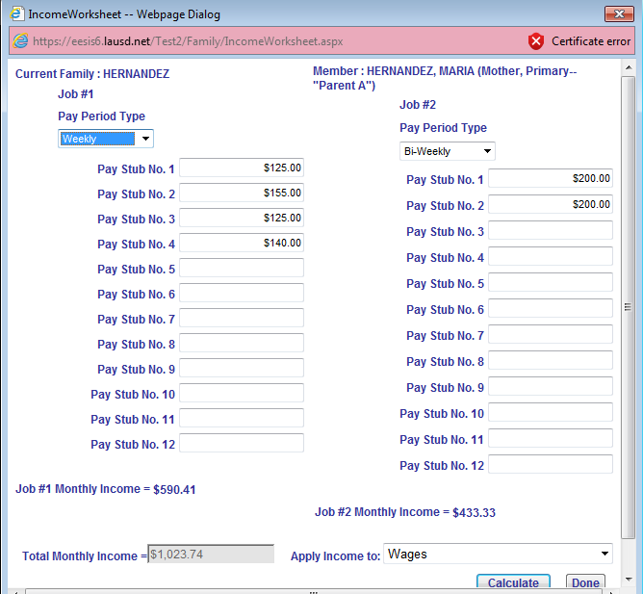

Employer Contact
If additional verification is needed, the Office Manager may verify in various ways:
- It may take less time to complete the enrollment if the Office Manager simply telephones the employer, writes the responses in the Employer Section of the Verification of Employment Form and then notes in the LAUSD Section how the information was obtained. In this case, an employer signature is not needed.
- The form may be mailed, faxed or scanned and emailed to the employer and returned in the same way. It should not be hand-carried by the parent.

Varying Schedule
If the parent’s employment is variable or unpredictable and the Office Manager cannot verify specific days and hours of employment or work week cycles, specify on the application and in EESIS that the parent is authorized for a variable schedule for the actual hours worked.
At initial enrollment – Use the verified work schedule for the past 4 months and project the average number of hours the parent is expected to work over the next 4 months.
At recertification – Average actual hours of the child’s attendance during the past 4 months to determine the monthly average hours needed. This is the basis of the fee.
If the parent’s work schedule is unpredictable, continue recertifying every 4 months, or until it becomes predictable.
On the child’s Schedule page, do not indicate Max Pattern Days. Fees are no longer adjusted based on Pattern Days. Using the parent’s average work schedule for the last 4 months, set up a schedule for an average week. For example, if a parent usually works 3 days a week, regardless of which 3 days, create a varying schedule with a max number of hours for 3 days:
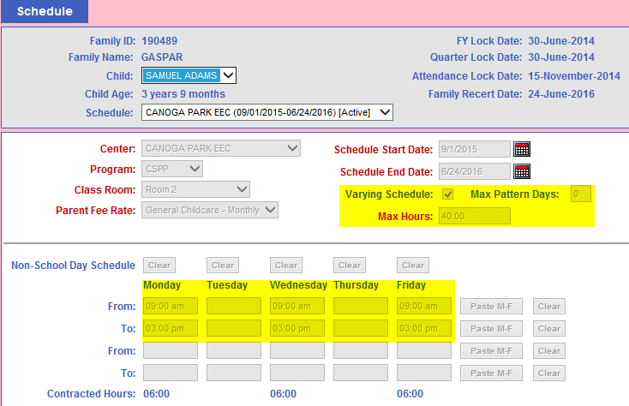
The child’s name will appear on the Sign-In Sheet and the Attendance page based on the schedule but the parent will sign in and out on the actual days of attendance and attendance will be entered in EESIS on those days.
There will not be a fee adjustment if the parent uses more or less hours. The fee is set at the time of enrollment or recertification.

Income Fluctuation
Families with variable or unpredictable work schedule must update their need for services in accordance with 5 CCR, sections 18086(b)(2)(D) and 18086(c)(2), or when their work schedule becomes predictable. When updating the need for services, the contractor can reassess the fee by averaging the actual hours of attendance in the preceding three to four months to determine the monthly average by which the family fee will be based on. When the family’s work schedule becomes predictable, the fee will be reassessed and collected based on the newly certified hours of need determined in accordance with 5 CCR, Section 18086.
A Notice of Action must be issued when the update of the file results in a change to the service agreement. If a new family fee is assessed, the fee will become effective on the first day of the month after the 14/19 day appeal request period is exhausted. If an appeal is filed, the effective date of the new fee will be stayed until the first day of the month after the appeal process is exhausted. The reassessed fee must be collected monthly in accordance with 5 CCR, Section 18114.
Contractors will continue to assess fees for families with variable or unpredictable work schedules, the contractor will reassess the fee by averaging the actual hours of attendance in the preceding three to four months to determine the monthly average by which the family fee will be based on.
A Notice of Action must be issued upon recertification. If a new or changed family fee is assessed, the fee will become effective on the first day of the month after the 14/19 day appeal request period is exhausted. If an appeal is filed, the effective date of the new fee will be stayed until the first day of the month after the appeal process is exhausted. The reassessed fee must be collected monthly in accordance with 5 CCR, Section 18114.

New Job
If the parent gets a new job, the parent must report a change in employment status and income to the EEC within five calendar days. In these situations, the parent would not have all the payroll check stubs for a full month from the new employer. To document the new income the parent may submit a letter from the employer or other record of wages issued by the employer for purposes of determining eligibility. The Office Manager may also phone the employer to verify the date of hire and verify information on the Verification of Employment form.

Self-Certification of Income
The self-declaration of income should only be used when all other options have been exhausted and should not be used as the default.
If the employer refuses or fails to provide documentation, or if requesting documentation from the employer would in any way jeopardize the parent’s employment, the parent can provide other records to document income along with a Self-Certification of Income form signed under penalty of perjury.
Other records may include:
- List of clients and amounts paid
- Tax returns
- Quarterly estimated tax statements
- Bank statements to show deposits
- Receipts of work related expenses
The Office Manager should make notes in the LAUSD Section of the Self-Certification to indicate how the reasonableness of the income was assessed and should also note that the employer declined to complete the form.

Self-Employed Parent
- If the parent is self-employed, the documentation of need based on employment shall consist of the following:
  - Parent provided information that includes:
    - A declaration of need under penalty of perjury that includes a description of the employment and an estimate of the days and hours worked per week;
    - To demonstrate the days and hours worked, a copy of one or more of the following: appointment logs, client receipts, job logs, mileage logs, a list of clients with contact information, or similar records; and
As applicable, a copy of a business license, a workspace lease, or a workspace rental agreement.
- A statement by the contractor assessing the reasonableness of the total number of days and hours requested per week based on the description of the employment and the documentation provided pursuant to this section and section 18084. If the parent has unpredictable hours of employment, the contractor shall authorize the parent for a variable schedule not to exceed the number of hours determined to be needed per week. Need for services for unpredictable hours shall be updated at least every four months and shall be based on the requirements of subdivision (c). If the contractor has been unable to verify need based on the documentation provided, the contractor shall take additional action to verify self-employment that includes any one or more of the following:
  - If the self-employment occurs in a rented space, contacting the parent's lessor or other person holding the right of possession to verify the parent's renting of the space;
  - (B) If the self-employment occurs in variable locations, independently verifying this information by contacting one or more clients whose names and contact information have been voluntarily provided by the parent; or
  - Making other reasonable contacts or requests to determine the amount of time for self-employment.
    - If the contractor is unable to make a reasonable assessment of the hours needed for self-employment after attempting to verify such hours and documenting the attempts, the contractor may divide the parent's self-employment income, as defined in section 18078(q)(4), by the applicable minimum wage. The resulting quotient shall be the maximum hours needed for employment per month.

If the Office Manager has been unable to verify need based on the documentation provided, additional action must be taken to verify self-employment that includes any one or more of the following:
- If the self-employment occurs in variable locations, independently verify this information by contacting one or more clients whose names and contact information have been voluntarily provided by the parent; or
- If the self-employment occurs in a rented space, contact the parent’s lessor or other person holding the right of possession to verify the parent’s renting of the space;
- Make other reasonable contacts or requests to determine the amount of time for self-employment.
If the Office Manager is unable to make a reasonable assessment of the hours needed for self-employment after attempting to verify hours and documenting the attempts, it is acceptable to divide the parent’s self-employment income by the minimum wage. The 2008 California minimum wage rate is $8.00. The resulting quotient is the maximum hours needed for employment per month.

Travel
If requested, a reasonable amount of travel time may be authorized between the center and the place of employment, not to exceed half of the daily hours authorized for employment to a maximum of four hours per day. This time is indicated on the Needs page in EESIS as Grace Period.
Examples of dividing authorized work hours/day by 2:
- Authorized for 9 hours for employment. Maximum travel time is up to 4 hours, not 4.5 hours (2 hours each way). Parent works 1 hour away from the child care provider. Therefore, two additional hours authorized for travel. 1 + 1 = 2 < 4.
- Authorized for 6 hours for employment. Maximum travel time would be up to 3 hours (1.5 hours each way). Parent works ½ hour away from the child care provider. Therefore, one additional hour authorized for travel. ½ + ½ = 1 < 3.
- Authorized for 6 hours for employment. Maximum travel time would be up to 3 hours (1.5 hours each way). Parent works 2 hours away from the child care provider. Only three additional hours may be authorized for travel. 2 +2 = 4 > 3.

Sleep
If the parent is employed anytime between 10:00 p.m. and 6:00 a.m., sleep time may be authorized, not to exceed the number of hours authorized for employment and travel between those hours. Sleep time is not automatic. Sleep time would be appropriate when the parent has a child to care for during the time needed for sleep. Sleep time would not be appropriate to authorize if both the parent and child would be sleeping at the same time or if another parent is available to care for the child.
Examples:
- Parent works from 8 p.m. until 2:00 a.m. and has a half hour commute; 4½ hours of the parent’s work and travel time fall between 10 p.m. and 6 a.m.; so the parent could have up to 4½ hours for sleep time. Parent comes home and goes to bed.
  - If mom has only school-age children, a license-exempt caregiver (friend or relative) would come over at 6:30, wake up the children and get them fed and ready for school and drive them to school, dropping them off at 8:00 a.m. In this case, the parent would be authorized for 1½ additional hours of service for sleep, while the children are in the provider’s care.
  - If mom had a preschooler, she might have the caregiver come over as above, that any school-age children to school and then take the preschooler to the State Preschool program at 9:00. In this scenario, the parent could be authorized for 2½ additional hours for sleep time.
- Parent works from 10:00 p.m. to 6:00 a.m. The parent does not need care for the preschool-aged child at night because the other parent is at home, but in the morning that parent goes to work. The night shift parent could be authorized for 8 hours of sleep time.

Documentation of Public Assistance
Public assistance under TANF or CalWORKS is counted as income and may be documented with a copy of the parent’s grant award, check stub or Notice of Action. If the center has electronic access to the amount of public assistance received by a parent, print the verification of the grant amount and place it in the family data file for documentation purposes.

Documentation of Seeking Employment
If the parent’s stated need is seeking employment, the period of eligibility is 60 consecutive working days (Monday through Friday, excluding federal holidays), which allows the parent to seek for employment on any day between the start date and the end date, but for no more than 5 days during a week and for less than 30 hours a week. Some days may be for 6 hours a day; some may be less, but overall the services cannot exceed part-time care. Auditors review the time the parent signs the child in and out rather than the scheduled hours. However, due to audit problems when services are scheduled for exactly 30 hours per week, it is recommended that the schedule be set for less than 6 hours one day a week. This need criterion is per parent, not per family. Since this is a part-time benefit, if both parents are unemployed and requesting services, care can only be provided to the extent that the parents cannot take turns caring for the child while the other person seeks employment.

The parent must sign a Seeking Employment Agreement (BUL-4363.0 Rev. 12/2013) under penalty of perjury. This identifies the days and hours the parent will seek employment and the activities used to secure a job. During the period of authorization and if necessary to verify need, the Office Manager may request that the parent provide, no more than once a week, a description of the activities he or she has undertaken during the previous week to seek employment and, as appropriate, may require additional documentation. A Seeking Employment Calendar will be provided to each EEC for the school fiscal year (July 1 through June 30) so that the Office Manager can tell the parent the end date and can set the child’s schedule to end on that date unless a job is found.

NOTE: Always add an end date on the Need page in EESIS and monitor alerts to be sure the need does not expire.
A parent may not receive child care to seek employment for more than 60 days in a school fiscal year (July 1 through June 30). However, if the parent secures employment before the end of the eligibility period, the remaining number of days may be “banked” for future job search in that fiscal year, if needed.

If the parent has concurrently received services based on employment or vocational training for at least twenty (20) working days while receiving services for seeking employment, eligibility for seeking employment may be extended for an additional twenty (20) working days. For such a parent, services for this purpose may not exceed 80 working days during the contract period.

Documentation of Vocational Training

If the parent’s stated need is vocational training leading to a recognized trade, paraprofession, or profession, child care services are limited to whichever expires first:
- Six (6) years from the initiation of vocational training services (even if the vocational goal changes); or
- Twenty-four (24) semester units, or its equivalent, after the attainment of a Bachelor’s Degree.
The parent must submit a Training Verification, Form CD-9605, in order to be determined eligible for early education services. There must be a specific training or vocational goal. Services may be provided for classes related to the General Education Development (GED) test or English language acquisition if those courses are needed to reach the parent’s vocational goal, but the parent must provide detail on the employment goal the training will lead to. The verification form must include the projected completion date of the training program. The training institution does not have to complete the “Class Schedule” section of the CD-9605 when the parent provides an electronic print-out from the training institution with the parent’s current class schedule.
On-line or televised instructional classes that are unit bearing classes from an accredited training institution are counted as class time at one hour a week for each unit. The parent must provide a copy of the syllabus or other class documentation and, as applicable, the web address of the on-line program. The accrediting body of the training institution must be recognized by the United States Department of Education.
The parent must report any change in class schedule related to the days and times of any class, including a withdrawal from a class, within five calendar days of requesting the change from the institution.
A new Training Verification, Form CD-9605 is required for each new term or prior to the expiration of the previous verification, whichever comes first.

Progress
The parent must provide periodic documentation of progress in reaching the training goal. Within ten (10) calendar days of the end of each quarter, semester, or training period, a Progress Report, Form 99.1 Rev. 3/2013, must be provided with signatures from teachers or school officials.
Adequate progress for continuation of child care services is defined as:
- In a graded program, earn a 2.0 grade point average; or
- In a non-graded program, pass the program’s requirements in at least 50 percent of the classes or meet the training institution’s standard for making adequate progress.
If the parent fails to meet this standard, services may be provided for one additional quarter, semester, or training period, to improve the parent’s progress. At the conclusion of that session, if the parent has not made adequate progress, services must be terminated.
After termination, a parent must wait six months before reapplying to receive child care services for training.

Hours of Care
The Office Manager must determine reasonable hours of care needed based on the class schedule hours, travel time and study time required.
- Travel time to and from the institution may not exceed half the weekly hours authorized, with a maximum of 4 hours per day.
- Study time, including study time for on-line and televised instructional classes, may not exceed:
- Two hours per week per academic unit in which the parent is enrolled;
- On a case-by-case basis and as may be confirmed with the class instructor, additional time not to exceed one hour per week per academic unit in which the parent is enrolled; and
- On a case-by-case basis, no more than the number of class hours per week for non-academic or non-unit bearing training.

Documentation of Homelessness

If the basis of eligibility stated on the application for services is homelessness, the family data file must include documentation of homelessness including:
- A written referral from an emergency shelter or other legal, medical or social service agency; or
- A written parental declaration that the family is homeless and a statement describing the family’s current living situation.

Documentation of Seeking Permanent Housing

If the parent’s stated need is seeking permanent housing for family stability, the period of eligibility is 60 consecutive working days (Monday through Friday, excluding federal holidays), which allows the parent to seek housing on any day between the start date and the end date, but for no more than 5 days during a week and for less than 30 hours a week. Some days may be for 6 hours a day; some may be less, but overall the services cannot exceed part-time care. Auditors review the time the parent signs the child in and out rather than the scheduled hours. However, due to audit problems when services are scheduled for exactly 30 hours per week, it is recommended that the schedule be set for less than 6 hours one day a week. This need criterion is per parent, not per family. Since this is a part-time benefit, if both parents are requesting services, care may only be provided to the extent that the parents cannot take turns caring for the child while the other person seeks housing.

Documentation of seeking permanent housing must include a written parental declaration signed under penalty of perjury that the family is seeking permanent housing. The declaration must include the parent’s search plan to secure a fixed, regular, and adequate residence and must identify a general description of when services will be necessary. If the family is residing in a shelter, services may also be provided while the parent attends appointments or activities necessary to comply with the shelter participation requirements.

The Office Manager will determine the number of weeks available for seeking permanent housing and the child care schedule, which may be a variable schedule, based on the documentation. Because the 60 day limit applies to both seeking employment and seeking permanent housing, the Seeking Employment Calendar may be used to calculate the period of authorization. If necessary to verify need, the Office Manager may request that the parent provide, no more than once a week, either a declaration signed under penalty of perjury describing the activities the parent has undertaken during the previous week to seek permanent housing or a signed statement from the shelter, transitional housing agency, or homeless support program regarding the parent’s search progress to date.

If the parent does not expect to secure housing prior to the end of the eligibility period:
- The parent may request an extension in a declaration of need signed under penalty of perjury that includes an update of the parent’s search plan and either a description of the activities during the previous week to seek permanent housing or a signed statement from the shelter, transitional housing agency, or homeless support program indicating the parent’s continued need for services; and
- The Office Manager may authorize an extension of search eligibility for up to twenty (20) additional working days.

A parent may not receive child care to seek permanent housing for more than 60 days in a school fiscal year (July 1 through June 30). However, if the parent secures housing before the end of the eligibility period, the remaining number of days may be “banked” for future eligibility in that fiscal year, if needed.

Documentation of Parental Incapacity
Services may be provided to children on the basis of parental incapacity, including a medical or psychiatric special need, to the extent that the parent’s ability to provide normal care for the child is significantly limited, as verified by a physician. Services are not provided to disabled parents unless the disability significantly impairs their ability to provide care for their children.
A Statement of Incapacity, Form CD-9606, must be provided with the application. It must include the physician’s estimate of the duration of incapacity as it concerns the parent’s ability to care for the child. If the Statement of Incapacity is not clear enough to support the requirement for service, (i.e., “unable to care for the child”), the Office Manager may contact the physician or legally qualified health professional for verification or clarification.

Pregnancy
Pregnancy is not in itself a disability establishing the need for service. If a physician indicates that the mother requires the service for a period of time, service can be provided but Form CD-9606 must be submitted.

Update to Application
Families being served under this policy must update their applications prior to the expiration date indicated on the Statement of Incapacity so as to insure continuity of eligibility for service. Lacking an update, family service must terminate on the date indicated in the statement. In no case can the date for recertification extend beyond 12 months. State regulations make no provisions for “permanent” incapacity conditions.

REFERENCES
Parent Definition | Education Code (EC) section 8208(u);  Title 5 Regulations Handbook
Homeless Policy | http://www.ed.gov/programs/homeless/legislation.html;  Title 5 Regulations Handbook
Family File | Funding Terms and Conditions(I) (H),  Title 5 Regulations Handbook  EC 8261 and 8263; 5CCR 18081
Documentation of Employment | 5CCR 18086; Funding Terms and Conditions,  CSPP section II
Verification of Monthly Income | BUL-4358.0
Documentation of Seeking Employment | LAUSD BUL-4365.0; 5CCR 18086.5;  CSPP Funding Terms and Conditions, section II
Documentation of Training | LAUSD BUL 4359.0; 5CCR 18087;  CSPP Funding Terms and Conditions, section II
Documentation of Seeking Permanent Housing | 5CCR 18091;  CSPP Funding Terms and Conditions, section II
Documentation of Public Assistance | 5CCR 18085; CSPP Funding Terms and Conditions, section II
Documentation of Incapacity | LAUSD BUL4361.0;  CSPP Funding Terms and Conditions, section II;  5CCR 18088
Travel Time | Title 5 Regulations Handbook, 18086
Sleep Time | Title 5 Regulations Handbook, 18086
FORMS / REPORTS
Verification of Employment | Form 83.56, Rev. 10/2013
Progress Report | Form 99.1 Rev. 3/2013
Seeking Employment Agreement | BUL-4363.0 Rev. 12/2013
Training Verification | Form CD-9605
Self-Certification of Income | Self-Certification of Income Form (Rev. 3/2013)
Parental Incapacity | Form CD-9606

CONTINUING / ENDING SERVICE

Recertification
In order to continue services after the initial certification period (generally 12 months), the Office Manager must recertify eligibility by verifying family need and eligibility. Follow the list of items on the Organization of Family Files document (see Chapter 7) or the Notice of Recertification, Form 84.65 Rev. 7/13. The Office Manager should ask questions to see if there have been any changes in need, income, single parent status, immunizations, residency or other eligibility criteria.

At Risk
Families receiving services because a child is at risk of abuse, neglect or exploitation are limited to receiving services for up to three (3) months. When Eligibility Type is set to “At risk of abuse” on the Family page in EESIS, the next Recertification Date cannot exceed three months. The family can continue to receive child care and development services based on any of the following reasons:
a. The child is receiving protective services and child care and development services are part of the case plan.
b. The family meets other need and eligibility criteria.

Child Protective Services
Families receiving services because the child has a child protective services referral must be recertified at least every twelve (12) months. Recertification must be completed prior to the date identified on the child protective services referral (Form 83.66) as the duration of care. Families may continue to receive child care and development program services for child protective services children as needed, if the Department of Children and Family Services social worker certifies that the family continues to receive child protective services and that child care and development services are part of the case plan or if the family meets other need and eligibility criteria.

Other Families
All other families must be recertified at intervals not to exceed twelve (12) months.

Recertification Documents
Each recertification requires:
- New 9600, pages 1 and 2
- New 9600A
- New Notice of Action (NOA)
- New verification of need
- New income verification (consecutive pay stubs from the past month)
- New Income Calculation Worksheet
- New verification of single parent status, unless there is a court order.
- New verification of residency

Change in Need or Eligibility
A change in the parent’s need for services, income, employment status or family size requires a new Notice of Action. The most frequently used NOAs are:

- Change – Schedule NOA. Used when a child’s program changes, for example a child who becomes a programmatic 3 year old would change from CCTR to CSPP. A NOA is not necessary when only the classroom changes. Changes in schedule hours usually relates to recertification.
- Change – Family Fees NOA. EESIS will automatically calculate fees based on new income information. If a change results in a DECREASE in fees, the NOA Effective Date will be the first day of the following month. If a change results in an INCREASE in fees, the NOA Effective Date will be the first day of the month after the appeal process is exhausted. Print a copy of the Income Calculation Worksheet for the family file.

Termination
If the change or termination is involuntary or initiated by the Early Childhood Education program, the parent/caretaker has 14 calendar days (19 if the Notice of Action is mailed) to appeal. When given to the parent, the parent’s initials acknowledging receipt are required.

Reasons for Termination
Causes for Termination Policy
The following are causes for termination of early education center services, not to exceed three occasions per year:
- Violation of program policies and procedures
- Behavior of a family member that presents a risk to children and staff such as a parent using profane language, threats or destroying property
- Delinquent family fees. Fees are due on the first working day of each month and are delinquent seven days after that date. One the eighth day, a termination NOA will be issued and services will be terminated in 14 days if hand-delivered, 19 days if mailed if fees are not paid in full.
- Failure of parent/guardian to comply with a plan for payment of delinquent fees.
- Expiration of 60 day seeking employment period.
- Excessive unexcused absences are limited to five days per school year.
- Failure to cooperate with District personnel where such failure materially disrupts the smooth and efficient operation of the program.
- Failure to follow sign-in/sign-out procedure.
- Failure of parent/guardian to notify the center within five calendar days of any pertinent change in material, family, financial status, employment or other information relating to eligibility or need.
- Making a false material statement regarding family, financial status, employment or other information relating to eligibility or need.
- Conduct of child tending to seriously disrupt the smooth and efficient operation of the program.
- Child not trained in toilet habits.
- Failure of parent/guardian to provide eligibility or need information within five calendar days after a written request by the center.
- Failure of parent/guardian to respond promptly when requested to remove child from center because of child’s illness or suspension.
- Violation of contract hours, early drop-off or late pick-up, on three occasions per school year.
- Late pick-up of children after center closing or program ending hours (termination of services may occur on the fourth instance of late pick-up following three written warnings within a one year period of time)

- Making a false material statement regarding family, financial status, employment or other information relating to eligibility or need.
- Conduct of child tending to seriously disrupt the smooth and efficient operation of the program.
- Failure of parent/guardian to provide eligibility or need information after a written request by the center.
- Failure of parent/guardian to respond promptly when requested to remove child from center because of child’s illness or suspension.
- Violation of contract hours.
- Late pick-up of children after center closing or program ending hours (termination of services may occur on the fourth instance of late pick-up following three written warnings within a one year period of time)

Notice to Families of Their Responsibility to Notify Contractor of Changes to Family Circumstances.
At the time the contractor certifies or recertifies eligibility of a family/child for child care and development services, the contractor shall inform the family of the family's responsibility to notify the contractor within five calendar days of any changes in family income, family size, or the need for services.

Suspected Fraud
Office Managers and Principals may observe suspicious behavior or have reason to question the authenticity of eligibility information provided by some parents. It is acceptable to make further contacts and request additional information. If the parent fails to respond to reasonable requests for additional documentation, or if the information appears to be falsified, the child may be terminated. In order to substantiate the decision, type as much additional detail as possible in the Reason for Action block on the Notice of Action. The parent(s) may always appeal the decision following the steps outlined on page 2 of the NOA. Because the decision may be appealed, it is useful to keep detailed case notes in the family file explaining reasons for suspicion and actions taken.

Due Process
If the parent does not agree with the action as stated in the Notice of Action, she may appeal the intended action. To protect appeal rights, the parent must follow the instructions described in each step listed on the back of the Notice of Action. If she does not respond by the required due dates or fails to submit the required appeal information with the appeal request, the appeal may be considered abandoned. The appeal should go to the Early Childhood Education Division address that appears on the back of the Notice of Action. See Chapter 9, Due Process Requirements, for further detail.

Disenrollment
When children must be disenrolled (generally when they will be leaving to go to kindergarten), families must be displaced in the reverse order of admission priorities.
  - First to be disenrolled: Families with the highest monthly income adjusted for family size as determined by the Income Ranking Table. (See Chapter 26).
  - When two or more families have the same income ranking:
The family with an exceptional needs child will be disenrolled after all other families in the same income ranking have been disenrolled,
and
If there are no families with exceptional needs child, families will be disenrolled in enrollment date order, last “in” first “out".
  - Last to be disenrolled: Families with a child that is receiving child protective services or has been identified as being at-risk of abuse, neglect, or exploitation, will be disenrolled last.
The Schedule End Date in EESIS for all kindergarten-age children must be no later than the first day of school. A Termination Notice of Action must be issued and initialed by the parent. Under Reason for Action, select “Kinder Termination”. The text reads “Terminated because the child is transitioning to kindergarten.” The Spanish version is included as well. Additional text can always be added. The family should be terminated on the Family page in EESIS as of the day AFTER the last day of attendance. The Exit Status on the Family page will generally be “Left in good standing” UNLESS there are outstanding fees due. Every effort should be made to collect outstanding fees before the child leaves the center.
NOTE: In order to maintain consistent Child Days of Enrollment (CDEs), the center should attempt to stagger the disenrollment while backfilling with new children.

4.5 FULL COST FAMILIES
If a parent provides documentation of income that exceeds the State Median Income for that family size, a popup will appear on the Income page in EESIS:
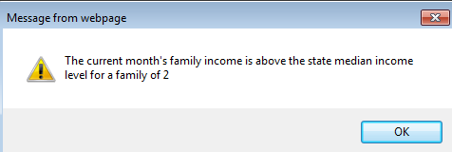
THIS MEANS THE FAMILY IS NOT ELIGIBLE.
In order to continue services, the family must pay full cost or services will be terminated. The Summary page no longer indicates that full cost is required and the NOA setup box will show the highest fee for that family size rather than showing that the family is ineligible for subsidized services:
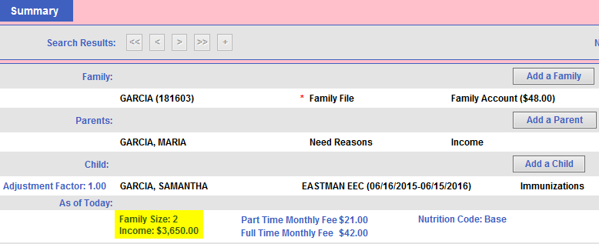
This incorrect fee is a bug in EESIS that will be corrected in an upcoming release.)
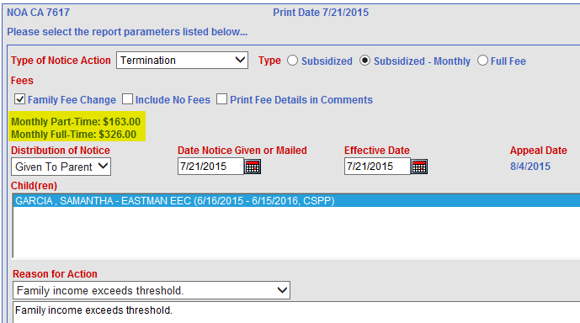
In this situation, the child will be eligible to continue services at the current fee rate until the end of the appeal period. (In the example above, this would be a subsidized rate of $21.00/$42.00.)

To set this up in EESIS:
- Create a NOA with type “Termination”. It will default the appeal date 14 days forward.
- UNCHECK the Family Fee Change box. This will prevent the fee from changing to a higher rate.
- Change the Effective Date to the day after the Appeal Date. This will allow the child to receive services through the appeal date.
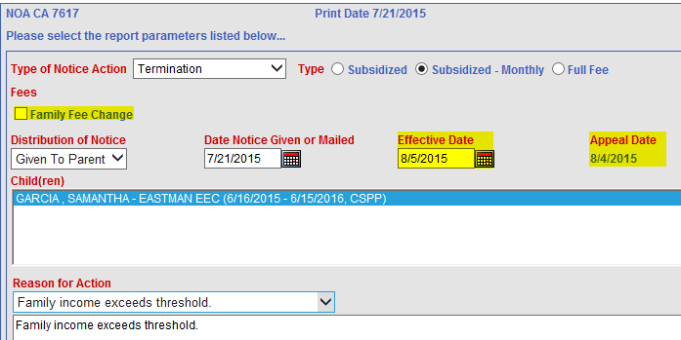
- In the example above, EESIS will calculate the August invoice based on the 130 hour rule and the family will owe a part time fee for August.
- When an appeal date occurs during the same month, if the parent has already paid a full time fee for the month and only used part time hours, the difference between the full time and part time fee can be refunded.

If a parent appeals a termination for any reason, care should be continued pending the outcome of the appeal process.
Be sure to either terminate the family at the end of the appeal period or create a new full cost schedule.
A family who wishes to continue at the full cost rate per day ($45 full time / $35 part time per child) should complete a Full Cost Application and full cost NOA (from Summary page in EESIS). A new full cost schedule should be created starting the day after the end of the appeal period. In the example above, the subsidized schedule ends 8/4/15 and a full cost schedule would begin 8/5/15.
No babysitter or Other Care Provider Receipts are allowed to offset full cost fees.
Only an existing family enrolled in the center should be allowed to continue services at full cost.

FAMILY SIZE

The parent must provide supporting documentation regarding the number of children and parents in the family. The information input into EESIS on the Parent page(s) and Child page(s) will calculate family size.
The number of children must be documented by providing one of the following documents, as applicable. Note that legal documents are preferable.
    - Birth certificates;
    - Court orders regarding child custody;
    - Adoption documents;
    - Records of Foster Care placements;
    - School or medical records;
    - County welfare department records; or
    - Other reliable documentation indicating the relationship of the child to the parent.

Children who are 18 and have been continuously attending high school are considered minors and included in family size. If a dependent child in the home over 18 is no longer in high school, he should not be included in family size.

Definition of Family
“Parent” means a biological parent, stepparent, adoptive parent, foster parent, caretaker relative, or any other adult living with the child who has responsibility for the care and welfare of the child.
“Any other adult living with a child who has responsibility for the care and welfare of the child” can include a neighbor who is temporarily entrusted by the parent who has been incarcerated with the care of the child. This includes any person standing “in loco parentis” (in the place of the parent) while the parent is away from the home for more than one day at a time. Parents whose work takes them away from the home for 24 hours or more need to identify the person who is acting “in loco parentis.”
Numerous household compositions and configurations could meet the definition of family. One key factor in determining whether two adults living together are considered a family is if they have a child in common, regardless of marital status and whether or not the child in common is receiving subsidized child development services.
Some examples of household compositions that would constitute a family for purposes of determining family size are listed below. (Excerpts from CDE Title 5 Regulations Handbook)

Combined Family Example 1 is composed of mom, mom’s child from a previous relationship, mom’s boyfriend, and a child in common.

Combined Family Example 1

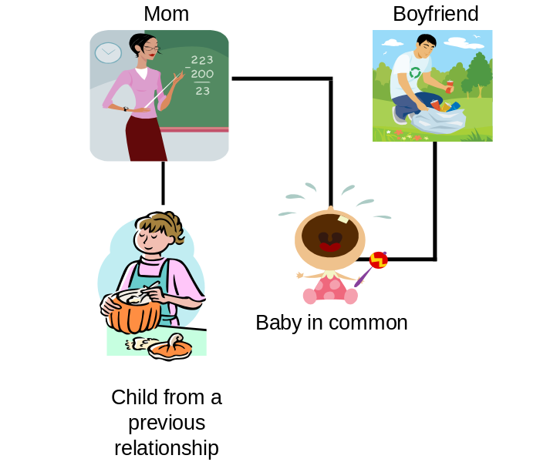

In Combined Family Example 1 the family size is four.

Examples of families where all persons are counted in family size.
In these examples the other adult (parent) has been voluntarily listed on the application by the parent completing the application and no additional documentation would be required to prove the person is accepting responsibility for the care and welfare of the child.

Combined Family Example 2 is composed of mom, mom’s child from a previous relationship, mom’s boyfriend. Mom and boyfriend do not have a child in common; however, the boyfriend accepts the responsibility for the care and welfare of the child.

Combined Family Example 2

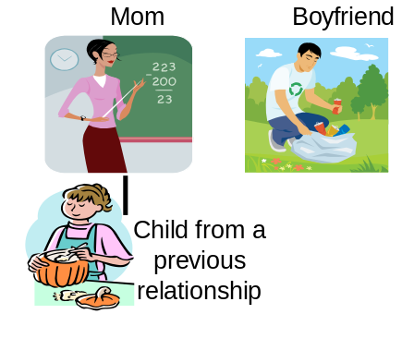

In Combined Family Example 2 the family size is three.

Combined Family Example 3 is composed of dad, dad’s two children, and dad’s mom (grandmother). In this family the grandmother accepts responsibility for the care and welfare of the children. NOTE: It has been determined that grandmother is unable to be the child care provider in this case.

Combined Family Example 3



In Combined Family Example 3 the family size is four.

Combined Family Example 4 is composed of domestic partners and one of the partners has a child.
Combined Family Example 4



In Combined Family Example 4 the family size is three.
Other examples are:
Mom is in jail and 2 children are staying with mom’s sister = family size of 2 (treated like 2 foster children).
Dad, 2 children from a previous relationship, and 3 other children for whom he has custody every other week = family size one week 3, the next week 6. In this example, the larger family may be eligible, but not the smaller or both may be eligible, but one may have a family fee.
Mom, 3 children (but one of them is 18 and out of high school) = family size of 3.
Examples of household compositions where one or more individuals are excluded from the family for purposes of determining family size:
In these examples the other adult is not listed on the application by the parent completing the application and no additional documentation would be required to prove the adult has not accepted the responsibility for the care and welfare of the child(ren).
Separate Family Example 1 is composed of mom, mom’s child from previous relationship, and mom’s boyfriend. In this family the boyfriend does not accept the responsibility for the care and welfare of the child.
Separate Family Example 1

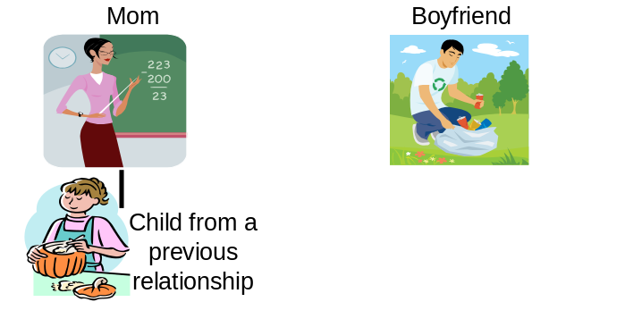

In Separate Family Example 1 the family size is two.

Separate Family Example 2 is composed of mom, mom’s child, and mom’s mother (child’s grandmother). In this family the grandmother does not accept the responsibility for the care and welfare of the child. NOTE: If the mother had more children who needed care, sufficient to ensure minimum wage, the grandmother could be the children’s child care provider.

Separate Family Example 2

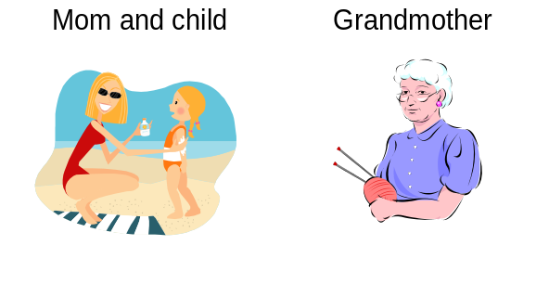

In Separate Family Example 2 the family size is two.

Separate Family Example 3 is composed of mom, mom’s child, mom’s sister, and mom’s sister’s child. Sisters do not claim responsibility for each other’s child.

Separate Family Example 3

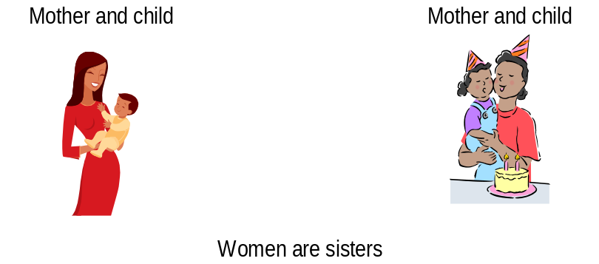

In Separate Family Example 3, each sister and her child are
considered a separate family of two.

Separate Family Example 4 is composed of mom, mom’s child from a previous relationship, mom’s boyfriend, and mom’s boyfriend’s child from previous relationship living together but neither adult claiming responsibility for the other’s child.
Separate Family Example

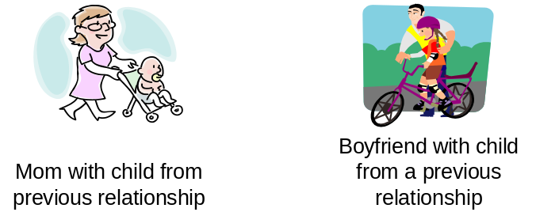

In Separate Family Example 4 mom and her child and dad and his child are each considered a separate family of two.
Separate Family Example 5 is composed of two foster parents (married) with two children of their own, a foster care brother and sister, and an unrelated foster child.

Separate Family Example 5

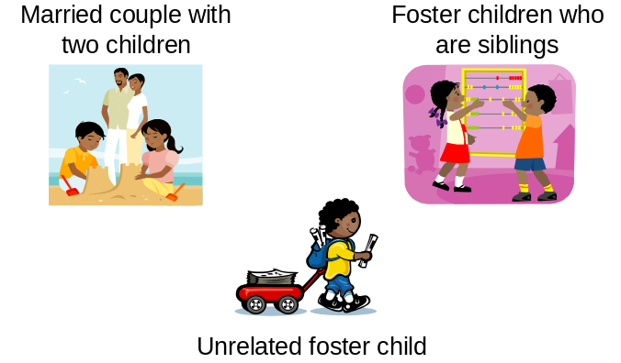

In Separate Family Example 5 the foster parents and their two children are a family of four. The foster siblings are a separate family of two.
The unrelated foster child is a family of one.

Separate Family Example 6 is composed of a child living with his/her grandparents who has not been adopted by the grandparents.
Separate Family Example 6

Separate Family Example 6 is a family size of 1

ATTENDANCE

Attendance Exceptions
The District is reimbursed by CDE based on the least amount among three factors: the contract with the state, actual expenditures or actual attendance. LAUSD’s reimbursement is almost always for actual attendance. It is critical that:
- Centers maintain enrollment to their maximum capacity throughout the year
- Daily attendance is entered in EESIS
- The child is enrolled in the correct program according to the programmatic age

See Chapter 20 for additional details about entering attendance in EESIS.

Sign-In Sheet Requirement
The daily Sign-In Sheet is the primary source document for audit and reimbursement purposes. The Sign-In Sheet is used to verify that service was provided on a given day. At no time may white-out be used on the sign-in/sign-out sheets. Sign-In sheets must be maintained in the center in chronological order for a period of five (5) full fiscal years.

Sign-In Sheets
On a weekly basis, print the Sign-In sheets from EESIS for the following week. Go to Reports > Administrative Reports > Sign-In Sheet. Enter Center, Program(s), Classroom(s), select the Starting and Ending Dates for the next week and click the Print button. Depending on where the children are dropped off and picked up, sheets may be printed by classroom or for the entire center. Sign-In Sheets should be printed on 8 ½ X 14 paper in order to allow sufficient room for signatures and bar codes.
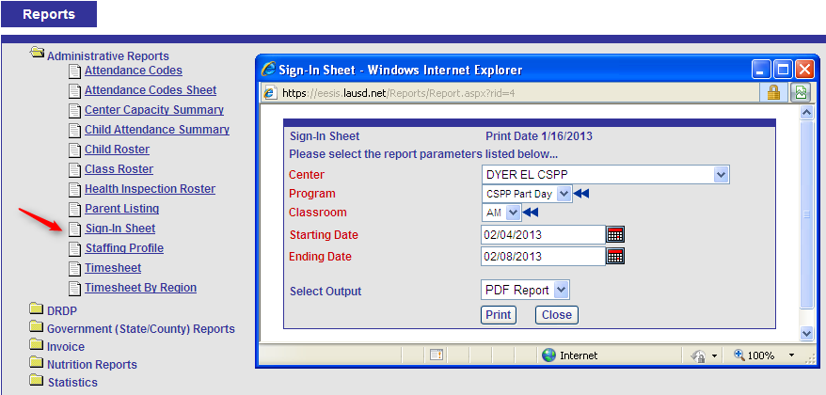

Signature
One of the following persons must enter the daily time of arrival and departure on a sign-in/sign-out sheet and must sign the sheet using their full signature:

- The parent or other adult authorized by the parent to drop off/pick up a child; or
- The staff person designated by the contractor as the person responsible for entering the times of arrival and departure if the child is not dropped off/picked up by a parent or other adult authorized by the parent. An example might be when a child leaves the center to go to a special ed class for 3 hours during the day and the center representative signs him out and back in when he returns (using a full signature).
The “full signature” means the legal signature of the individual (e.g., signature normally used on checks and other documents). Initials are not acceptable. If the individual is not literate in written English, the individual may sign with an “X” which must be witnessed and initialed by the center authorized staff.

Actual Time
The sign-in sheet indicates the scheduled arrival/departure time but the actual time each child arrives and the actual time each child leaves with the parent or designee must be entered by the parent or designee. There may be times when there is a variance in the arrival/departure and a late pickup notice to the parent may help resolve the problem. If there is a variance of more than ½ hour between the scheduled time and the actual time of arrival and departure that continues for more than five school days, the Principal or Office Manager should talk with the parent to determine the cause and make a schedule change, as necessary. Violation of contract hours can be a cause for termination in chronic situations.
NOTE: Remember that seeking employment and seeking permanent housing must be LESS THAN 30 hours per week. Auditors determine this by the time the parent signs the child in and out rather than the scheduled hours.

Supplemental Sign-In Sheets
If a child enrolls mid-week and the sign-in sheets have already been printed, a blank sheet may be printed from EESIS allowing the Office Manager time to enter the enrollment in the system so that the child’s name shows appropriately the following week. All required information from the official sheets should be hand-written. A blank sheet should never be used for a child more than the first week of enrollment.

Review of Sign-In Sheets
At the end of each week the Principal should review the Sign-In sheets, note variations in attendance patterns, verify that FULL signatures are present for each child who attended, note that all absences are entered correctly and determine if parent conferences are needed based on Remarks.
The Principal should also review the Attendance screen for the week in EESIS to ensure that attendance has been entered for each child for each day of the week and that absences are consistent with those on the Sign-In Sheets.

Absence Notification Policy
When there are circumstances where a child must be absent from school, it is the parent’s responsibility to notify the center of the reason for the absence on the same day of the absence, or, in case of an emergency, as soon as possible. In order to obtain an accurate meal count, parents should call before 9:00 am on the day of the absence. If the parent does not know the duration of the absence, she should call each day the child is out. Excessive absences, or failure to contact the center in a timely manner when a child is out, may result in termination from the program. This requirement is contained in the Parent Handbook.

If the parent does not call when a child is absent, the Office Manager should attempt to make contact with the parent by phone within the week. After 3 to 5 days of no contact, a letter should be sent or a termination NOA should be initiated. The NOA may be rescinded if the parent can provide a satisfactory reason for the absences. However, once the termination is effective, if services are requested again, the family should be placed back on the eligibility (waiting) list.

Parents are responsible for payment of fees on days the child is absent. (An exception is made for a pre-approved leave of absence. See 6.3.1 below.)

Absence Codes

Attendance and Absences
Attendance includes excused absences because of illness of the child, illness of their parent, family emergency, court-ordered visitations or a reason which is clearly in the best interest of the child. Excused absences are reimbursable; unexcused absences are not.
If the absence is claimed as an excused absence, the attendance accounting records require verification that includes:
- The name of the child
- The date(s) of absence
- The reason for the absence (specific type of illness not required)
- The signature of the parent or the Office Manager/Principal if verification is made by telephone
This information should be recorded in the center’s official Communication Log.
Record the applicable absence codes daily. If a child is absent, use the following codes to indicate reason for absence:
- F - Family Emergency
- G - On Leave of Absence
- I - Illness
- O - Court Order
- P - Pattern Day
- Y - Best interest of the child
- U - Unexcused absence

6.3.1.1 Reimbursement for Absences
The California Department of Education reimburses for these absences:
- F - Family Emergency
- I - Illness
- O - Court Order
- Y - Best interest of the child

These are unreimbursed absences:
- U - Unexcused absence
- G - On Leave of Absence
- P – Pattern Day

6.3.1.2 Definition of Absence Types
Center staff may use their best judgment in determining circumstances that would constitute an excused absence for "family emergency" and "in the best interest of the child." Except for children who are recipients of protective services or at risk of abuse or neglect, excused absences "in the best interest of the child" are limited to ten (10) days during the fiscal year (July 1 through June 30).
I - Illness - Illness of the child or the parent
O - Court Ordered - If an excused absence is based on time spent with a parent or other relative as required by a court of law, the family data file must contain a copy of the Court Order.
P - Pattern Day - The term “Pattern” day is used to indicate days that the child is not expected to attend because the parent does not have a need on that day. This may be the same day every week or the day may vary from week to week, depending on the parent’s work schedule. This is established on the child’s Schedule page in EESIS. If it is a fixed Pattern Day, there will be no scheduled hours on the Sign-In Sheet. If it varies, the parent or Office Manager should indicate a P on the Sign-In Sheet for that day. See Chapter 16.6 for more information.
F - Family Emergency - An emergency by its very definition is an unplanned occurrence which could mean a day or some weeks out of the center at any one time. These emergencies include:
- death of member of immediate family
- accident involving members of immediate family
- automobile failure
- imminent danger to the home occasioned by disaster such as flood, fire, or earthquake
The duration of family emergencies for reporting attendance would depend on the nature of the emergency and the place of occurrence. For example, a death in the family necessitating a trip outside of the country could mean absence from the center of approximately two weeks. Discretion should be exercised in the process; each case is different and in every case, the determining factor should be what is reasonable and normal under each specific circumstance.

Y - Best Interest of the Child - This category includes absences due to reasons other than illness, family emergency, or court ordered visitations that could be an excused absence for reasons in the “best interest” of the child. Only ten (10) Y days each fiscal year (July 1 through June 30) are allowed. The days also include:
- vacation time with the parent
- days with the parent during school intersessions (that do not meet leave requirements)
- days with the parent during work stoppage (that do not meet leave requirements)

O - Court Ordered - If an excused absence is based on time spent with a parent or other relative as required by a court of law, the family data file must contain a copy of the Court Order.
U - Unexcused - Before showing an absence as unexcused, attempt to determine if the absence would qualify for reimbursement as F-Family Emergency or Y-Best Interest of the Child. Ten Y days are allowed each fiscal year and are considered excused, or reimbursable. If the reason for an absence is not known at the time attendance is entered for the day, a U-Unexcused code may be used. After consulting with the parent, the U code should be changed to another excused absence code if appropriate.
A pattern of unexcused absences is cause for termination. Parents should be informed in advance that they are in danger of being terminated for excessive absences. This is included in the Unexcused Absence section of the Parent Handbook. No more than 10 5 unexcused absences per year can be recorded in EESIS for a child.
G - Leave of Absence - A limited-term service leave of absence may be granted to accommodate parents who temporarily do not have a qualifying need for subsidized child care but the center is willing to hold the child’s slot. This occurs when parents are able to provide care for their child because of:
    - Employment break, school break, non-court ordered visit with non-custodial parent or vacation in excess of Best Interest days (maximum leave of 12 consecutive weeks); or
    - On leave from work because of maternity or other family medical reasons (maximum leave of 16 consecutive weeks, doctor’s certificate required).

Paperwork must be completed at the Early Education Center prior to the start of the limited-term leave. Such leaves are not reimbursable and result in loss of CDEs and income to the District unless supplemented by a temporary enrollment from the waiting list. Fees are not required during a leave of absence. When a leave of absence is requested, review specific requirements in BUL 4362:

http://notebook.lausd.net/pls/ptl/docs/PAGE/CA_LAUSD/FLDR_ORGANIZATIONS/FLDR_EARLY_CHILDHOOD/BUL-4362-0%20LIMITED%20TEMPORARY%20SERVICES.PDF

Form No. 84.24, rev. 6/08 (print from above-referenced Bulletin) must be submitted during certification or recertification except for medical leave, in which case, the form must be filled-out before the start of the leave and approved by the Principal or Office Manager.

For leaves of at least three (3) weeks, a Termination NOA must be generated in EESIS and given to the parent stating that services will be terminated if the family does not return on the day after the end of the leave indicated on Form 84.24. If a family is terminated for failure to return from leave and later wants readmission into the program, the family should be placed on the waiting list.

The leave of absence should be entered in EESIS so that attendance is not expected and fees are not generated. Select the family, then click on the Absence Period link on the left navigation bar. Select the child, enter the dates and reason. Absence Code on this page should ALWAYS be G-Leave of Absence

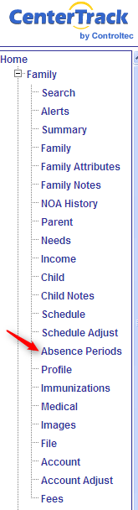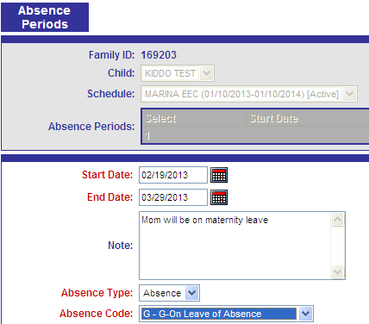

Attendance Reports
The following reports in EESIS are helpful in determining the status of absences for a single child or for all children:

- View Absent Days button on Child page - for absence totals on a single child.

- Attendance Exceptions Report (Reports > Statistics) - Shows if AT LEAST one child is missing attendance.

- Child Attendance Exceptions (Reports > Statistics) - Shows each day each child is missing attendance during the selected time period.

- 9400 LAUSD Report (Reports > Government Reports) - Month at a glance. Shows all absences for each child by classroom.

- Child Attendance Summary (Reports > Administrative Reports) - Summary totals unless the Details box is checked. Print in CSV for spreadsheet format. This can be useful when a court order requires attendance documentation for a child during a period of time.

REFERENCES
 | Parent Handbook
BUL 2577 | Sign-In
BUL 3310 | Excused / Unexcused
BUL 4362 | Limited Term Service Leave
FORMS / REPORTS
Form No. 84.24, rev. 6/08 | Interruption of service contract/limited term service leave
EESIS Report | Attendance Exceptions
EESIS Report | Child Attendance Exceptions
EESIS Report | Child Attendance Summary
EESIS Report | 9400 LAUSD
EESIS Report | Absent Days button on Child page

FAMILY DATA FILE

A family data file must be established for all families with children receiving child care and development services.

Recommended Organization
The recommended organization of the family file record is shown below:

Left Side of Family File
Handbook Documents
New Forms After July 1st, 2011
From Early Childhood Education Procedures,
Guidelines & Information for Parents

- 1. Personal Rights (LIC 613A)
- 2. Parent’s Rights (LIC 995)
- 3. Receipt of Annual Notification of Information
for Parents

- 4. Information Release Form
- 5. Annual Pesticide Use Notification
- 6. Acknowledgement of Receipt of Licensing
Reports (LIC 9224) if cited.

Family ID #: ____________________________________________

Name of the Child: _______________________________________

Please put a checkmark (✓) in the box/circle to indicate that the document is complete.

Family File Checked by ___________________________.
OM or SAA’s Initial & Date

___________________________.
Principal’s Initial & Date

Right Side of Family File

Initial Enrollment Documents

- 1. CD9600 pages 1 and 2 with proper box checked, date and both parent AND
Principal signatures
- 2. CD9600A with proper box checked, date & parent signature
- 3. CD7617 Notice of Action (NOA) with parent initial or receipt of certified mail
& principal signature
- 4. Income & Need Information (as per application):
- € A full month’s consecutive pay stubs & other documents to verify employment income
€ Employment Verification (83.56)

€ Self-Certification of Income if paid cash (Attachment B)

- Seeking Employment (83.14)
- € Training Verification (CD 9605)
€ Progress report/s (99.1)

€ Study time written statement

- Protective Services (83.66)
- Statement of Incapacity (9606) & State Disability Insurance (SDI) or Unemployment Benefits if received
- Verification of Temporary Assistance for Needy Families (TANF) or other cash assistance
- 5. Monthly Income Worksheet (print from EESIS)
- 6. Verification of California Residence
- 7. Verification of Single Parent Status if needed
- 8. Birth Certificates or other documents for enrolled children & all siblings counted in family size
- 9. Home Language Survey (83.76)
- 10. Current Health card and Emergency Information, Physician’s Report (LIC 701)
- 11. Center Eligibility List Form (if there is a waiting list)
- 12. CA School Immunization Record (can be kept at Nurse’s station)

*Always Scan and Upload Documents #1 - 9 to EESIS

Recertification: 1€, 2€, 3€, 4€, 5€, 6€ & 7€ (if not court order)

Eligibility / Need Change: 3€, 4€ & 5€

Termination: 3€

Recertification
Recertification requires new:
- CD9600 pages 1 and 2
- CD9600 A
- Income verification
- Need verification
- Monthly income worksheet from EESIS
- Verification of single parent status, if applicable and if there is no court order
- CD7617 Notice of Action (NOA)

Changes
Change in need or eligibility require new:
- Income or need verification
- Monthly income worksheet from EESIS
- CD7617 Notice of Action (NOA)

Termination
Termination of services to a child or the whole family requires:
- CD7617 Notice of Action (NOA)

Record Retention
All records must be maintained for a minimum of five (5) years.

REFERENCES
Family File | 5CCR 18081; CSPP Funding Terms and Conditions, Program Requirements (II)(E)
Recertification | 5CCR 18081; CSPP Funding Terms and Conditions, Program Requirements (II)(V)

FEES
California law limits child care and development services to families whose income, based on family size, is less than 70% of California's State Median Income.

Schedule of Income Ceilings
for
Child Care and Development Programs
Family Size | Family Monthly Income | Family Yearly Income
1 – 2 | $3,283 | $39,396
3 | $3,518 | $42,216
4 | $3,908 | $46,896
5 | $4,534 | $54,408
6 | $5,159 | $61,908
7 | $5,276 | $63,312
8 | $5,394 | $64,728
9 | $5,511 | $66,132
10 | $5,628 | $67,536
11 | $5,745 | $68,940
12 | $5,863 | $70,356
CDE Management Bulletin 11-06

Some families may be required to pay fees if their income is below the income ceiling but falls within the Family Fee Schedule limits.

Establishing Family Fees
Fees are established when a family is certified for child care services, and adjusted whenever there is a rate change or when there is a change in family eligibility or income. When a fee is established incorrectly, a correction must be made as soon as it is detected. A Notice of Action must be issued to notify the parent of the correct fee and effective date. A cover letter must accompany the Notice of Action.
State law changed in 2014 to require parents to pay a flat monthly fee rather than a daily fee for services.
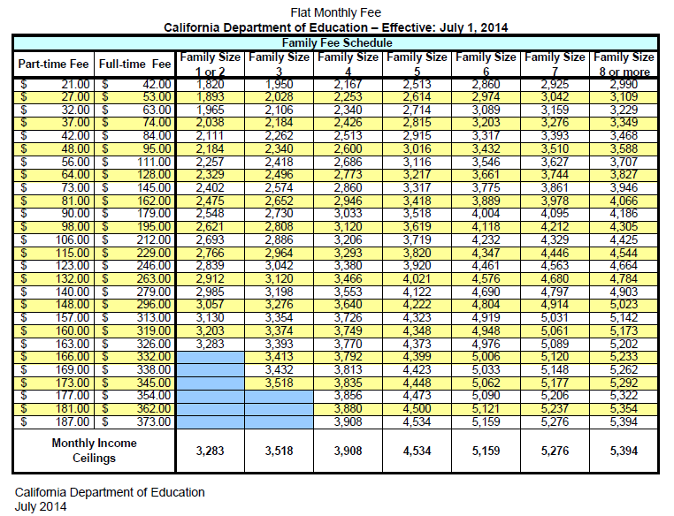
The fee amount is calculated in EESIS based on:
- The adjusted gross monthly income entered in EESIS for each parent
- The family size, based on the number of parents and children entered in EESIS
NOTE: Incorrect fees may appear in EESIS if family members are entered in the system on different days. Be sure to enter all family information at the time of enrollment. Failure to do so may require the EESIS vendor to backdate a family member in the database. Email eesis@lausd.net for assistance with this type of issue.

The Family Fee Schedule (Chapter 27) indicates the monthly fee rate for both part-time and full-time care. EESIS will calculate the number of schedule hours to determine the fee:
  - Part-time fee for less than 130 hours of care per month
  - Full-time fee for 130 hours of care or more per month

If the parent has a variable or unpredictable schedule, use the average hours of the last 4 months.

A family receiving CSPP or CCTR services pays one monthly fee per family regardless of the number of children enrolled. The family fee is based on the child who is enrolled for the longest period (most hours).
CSPP - 3 and 4 year olds
Full Time Fee - 130 hours of care or more per month
Part Time Fee - Less than 130 hours of care per month

CCTR - 2 year olds
Full Time Fee - 130 hours of care or more per month
Part Time Fee - Less than 130 hours of care per month

PCC Only - No fees. The child will be enrolled in the PCC Only program which requires that he have an IEP. No family income or need information is required.

PCC Plus Another Program – A child who is enrolled due to the parent’s need and income may also have special needs and attend the PCC class. This child should be flagged on the Child page as “PCC plus another program”. The child’s schedule may be handled two different ways:
- Non-fee paying family – If the family does not owe a fee, it is acceptable to show the CSPP/CCTR schedule hours for the entire time the child attends the center, including the PCC class time. This will usually result in a full CDE.
- Fee-paying family – If the family owes a fee, it may be more advantageous to break out the hours into two separate, non-overlapping schedules. For example, create a schedule for PCC Only from 8 am to12 pm and a second schedule for CSPP from 12:01 pm to 4 pm, thus resulting in lower fees for the parent (but only a part-day CDE for the center.)
- See Chapter 16.6.1 for additional EESIS entry instructions.

Notice of Action for Fees
A Notice of Action (NOA, or CD-7617) must be issued whenever a family is:
- Assessed a fee
- A fee amount is changed
- A fee is no longer required

The NOA is generated from EESIS. The NOA MUST be initialed by the parent and signed by the EEC Principal.
- In the month of initial certification, the fee is effective immediately.
- If a change results in a DECREASE in fees, the NOA Effective Date will be the first day of the following month.
- If a change results in an INCREASE in fees, the NOA Effective Date will be the first day of the month after the appeal process is exhausted.

Invoices

Family invoices are generated in EESIS seven (7) days before the start of the month. This may be changed in some months to accommodate holiday schedules. See the annual Early Education Fee Cycle Calendar. Invoices may be printed in bulk by going to Invoice > Print Queue in EESIS. Invoices may be printed for a single family by going to the Family Summary page in EESIS and clicking the Family Fee Invoice link in the Forms section at the bottom. Use this option if a child is enrolled after the invoices for that month have already been generated.

Billing Related to Changes in Fees
Fees may change when a family reports a change in income or family size.

If the fee goes down, it will become effective the first day of the following month. If it goes up, it will be effective the first day of the month after the appeal process is exhausted. There are no credits for partial months.
For the initial and last (based on Schedule End Date) month of certification, EESIS will calculate the lesser of:
- Cost of care ($36.10 per day) OR
- Part Time Fee OR
- Full Time Fee

A NOA MUST BE generated in order for a fee change to take effect. The NOA will still allow the parent 14 days (19 days if mailed) to file an appeal. If a change results in a decrease in fees, the NOA Effective Date will be the first day of the following month. If a change results in an INCREASE in fees, the NOA Effective Date will be the first day of the month after the appeal process is exhausted.

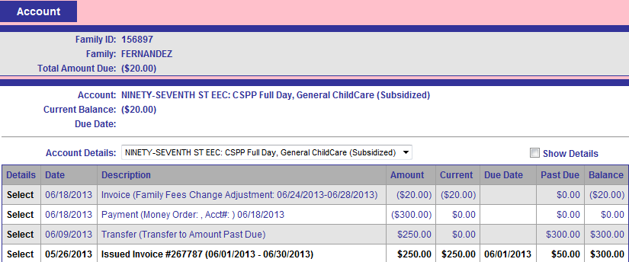

In the example above, the parent has a credit that will automatically be applied to the next invoice.

Fee Collection
All fees are due on the first working day of each month. Parents must be informed of the payment policy at the time of enrollment or whenever a fee is assessed. This information is contained in the Fees section of the Parent Handbook. Payments should be collected and banked the same day if possible, but at least by Friday of the same week. Payment must be posted immediately to generate a receipt from EESIS. A copy of the receipt must be signed by the Office Manager and provided to the parent.

Delinquent Fees

If, for any reason, the parent has not paid the fee within 7 calendar days, the fee becomes delinquent and the amount is automatically moved into the Past Due column on the Account page in EESIS. On the eighth day, a termination NOA will be issued and services will be terminated in 14 days if hand-delivered, 19 days if mailed if fees are not paid in full not to exceed three occasions per year

A family terminated for delinquent fees should always show an Exit Status on the Family page in EESIS of “Outstanding Fee Due”. This will prevent the family from reenrolling in any LAUSD Early Childhood Education program until past due fees are paid in full.

Payment Plan
A payment plan may be created in rare situations where the parent can provide a valid reason for being unable to pay in full by the 7th of the month. The Payment Plan should establish a date by which the balance must be paid in full, not to exceed ONE MONTH. The parent must pay all delinquent fees and current fees within that time frame. If a termination NOA has been issued, it can be Rescinded. If a termination NOA has not been issued, issue a termination NOA with an effective date of the date by which all payments must be current. Terms of the payment plan can be typed into the Reason for Action box. If fees are paid, rescind the NOA. If not, the termination will go into effect.
Payment plans are never allowed on terminated families. In order for the family to receive services again, the past due balance must be paid in full.

Methods of Payment

All fees must be paid in advance by check, money order, or other non-negotiable instruments. Cash is not acceptable. Payments must be made payable to LAUSD Early Childhood Education Fund (or LAUSD). Payments made out to CASH or third party endorsements are not acceptable because they are negotiable and have all the problems of cash.

Credits for Outside Care Payments (also called babysitter receipts)

If a family has additional child care needs that are not met by the center, Funding Terms and Conditions allow the family a fee credit for the amount they paid to the other provider of child care services. The fee credit applies to the family’s subsequent fee billing period and may be equal to or less than the amount owed. Credit may not carry over to the next month. For example, the family owes a fee of $100 for May and brings in an Other Care Provider receipt for $175 paid in April. Only $100 may be applied to the May payment. A May payment receipt from the other care provider would be needed for June credit at LAUSD.

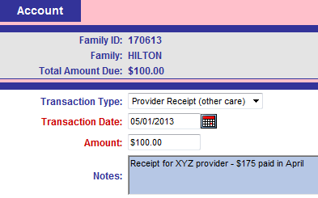

The credit for outside care payment is not applicable to families in the full cost category.

To use this type of credit:
- Have the parent obtain a completed Verification of Other Care Provider form 84.26 (Rev. 12/98) from the outside care provider at the time of certification.
- Keep the completed form in the family file at the center for audit purposes.
- Advise the parent that the payment will only be deducted from the center fee if she submits a signed and dated receipt from the outside care provider or a copy of a cancelled check. Otherwise, the center fee must be paid.
- Attach the outside care provider receipt or cancelled check to the file copy of the center receipt for audit purposes.

Receipts
All fees are due on the first business day of the month and should be collected and banked within the week. Payment must be posted immediately to generate a receipt from EESIS. A copy of the receipt must be provided to the parent. The receipt indicates:
- Date paid
- Parent name
- Family ID
- Child name
- Unique receipt number
- Name of the Office Manager or other individual posting the payment
- Signature of the Office Manager or other individual posting the payment
- Previous balance
- Payment amount
- Transaction date
- Payment type
- Total amount now due
- Comments typed into EESIS by the Office Manager or other individual posting the payment
- A universal comment “Rate of payment and period of service are shown on your monthly invoice.”

Receipts are generated by EESIS when a payment is credited to the family on the Account page. The Transaction Type (check, money order, provider receipt) is selected from a dropdown menu. The amount must be entered. It is optional to enter check number, account number and notes to appear in the Comments section of the receipt. If there is a past due balance, ALWAYS apply payment to the amount past due first. Any remainder should be applied to current balance as shown in the EESIS Account screen below.

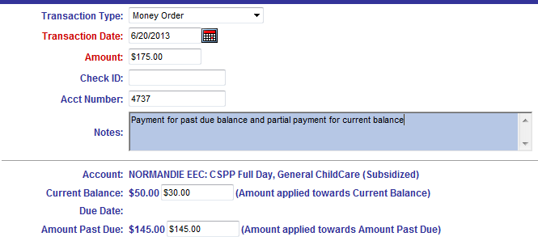
This is how the receipt will reflect the payment:
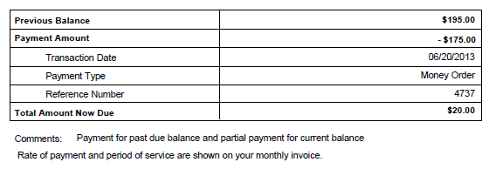

Fee Exclusions
- Fees are not required if the family income level, in relation to family size, is less than the first entry in the Family Fee Schedule. (For example, under $1,950 for a family of 3.)
- Fees are not required when any individual counted in the family size is receiving CalWORKs cash aid.
- Fees may not be required for a family receiving services because the child is at risk of abuse, neglect, or exploitation, if the referral prepared by a legally qualified professional from a legal, medical, or social services agency, or emergency shelter specifies that it is necessary to exempt the family from paying a fee. Fee exclusions for at risk may not exceed three (3) months.
- A family receiving services because the child is receiving child protective services may be exempt from paying fees for up to twelve (12) months if the referral prepared by the Los Angeles County Department of Children and Family Services child welfare services worker specifies that it is necessary to exempt the family from paying a fee. Fee exclusions for protective services may not exceed twelve (12) months.

Fee Adjustments
No fee adjustments are made for excused or unexcused absences. Based on monthly fee policy, a family with a varying schedule will no longer pay an adjusted fee depending on hours used. The fee is established at the time the schedule is created. The use of the absence code P-Pattern Day does not have any effect on fees. See section 3.16.
Joint Custody Issues
When a child’s residence alternates between the homes of separated or divorced parents, eligibility, need and fees should be determined separately for each household in which the child is residing during the time early education services are needed (i.e., separate certifications and service agreements). Please work with your Eligibility Technician in the ECE Fiscal Office on complicated situations like this.

Over/Underpayment of Fees:
If an incorrect fee was due to an error by Early Childhood Education Division personnel and not corrected within forty five (45) days from the day the error occurred, the family may not be held responsible for any additional charges.
Example: The parent provides correct pay stubs but the Office Manager enters them as bi-weekly rather than bi-monthly, resulting in an incorrect fee. Another example would be entering net income instead of gross. When the error is discovered, a new NOA must be generated advising the parent of the correct fee and the effective date the fee will begin. The parent will not be responsible for additional fees prior to that date.
If the error was discovered prior to the 45th calendar day, the family will be held responsible for any additional charges.
If the additional amount due from the family is $5.00 or less, the full amount must be collected within two (2) weeks. If the amount is more than $5.00, the family must be offered the following options:
1. Paying the full amount within two (2) weeks.
2. A weekly schedule of payments which meets the following requirements:
a. Payments must be equal except for the last/final payment.
b. No payment must be less than $1.00 except for the last/final payment.
c. The weekly payments are in addition to the current/adjusted weekly fee.
If the family withdraws from the center before the full underpayment of fees is collected, the center must send the family a request for payment in full. If a family moves to non-paying status, the parent must pay any outstanding balance in full as soon as possible.
If a family paid more money than was required for the following reasons, the adjustment must be made as soon as possible. The family must be notified in writing by a Notice of Action with an accompanying letter.
- family moves from fee-paying to non-paying status
- family voluntarily withdraws from center
- family receives a termination notice from the District
NOTE: Any refund under $10.00 will not be processed due to the processing cost.

An overpayment must be handled as a credit against fees due until the overpayment is recovered.

Processing of NSF (Non-Sufficient Funds) Checks
If for any reason, a check is returned to the ECE Fiscal Office by the bank because of insufficient funds (NSF check), the ECE Fiscal Office will reverse the payment in EESIS, therefore, the invoice will be outstanding. The check will then be returned to the center. It is the center’s responsibility to return the NSF check to the parent along with a Division statement of policy regarding such occurrences. Do not resubmit the NSF check to the bank for payment. The first notice will alert the parent to the seriousness of the problem and will state that a second occurrence will require future payments only by certified bank draft (cashier’s check) or money order. EESIS will not allow a payment transaction of “check” if there have been 2 returned checks.

Credits/Refunds for Overpayment of Fees
Credits for overpayment of fees will be applied to future fee payments until the amount of the overpayment is recovered by the parent. In cases where a family moves from a fee-paying to non-fee-paying status, or where services by the District are terminated, overpayments/credits remaining must be processed using the Claim for Overpayment Form 84.30. The claim form must be completed and signed by the center Principal, signed by the parent, and sent to the Fiscal Unit for processing.

Banking of Fees

Distribution of Deposit Slips
Each deposit slip should be completed in quadruplicate and distributed as follows:
- Original – to bank
- 2nd and 3rd copies – to ECED Fiscal Unit, along with (white) Bank Deposit Receipt
- 4th copy – to be retained by center

Each check should be listed on the deposit slip before taking to the bank for deposit. When the deposit is made, the teller validates the amount received for each deposit slip. The deposit total must agree with the amount entered by the center. Making corrections after the deposit has been completed at the bank is not acceptable.

Special Month-End Deposit Procedure
All funds received during a calendar month should be banked within that month. When inputting checks in EESIS, the receipt date must correspond to the date when fees are deposited to ensure that the fees are properly credited toward the correct week of the month.

Fee Reports
The following reports in EESIS are helpful in determining the status of fees for a center. They are found in the REPORTS > INVOICE section of EESIS.

- Delinquent Fees Report – Shows current fees due for each family as well as past due fees (under 30 days past due, past due between 30 and 60 days, past due between 60 and 90 days, past due between 90 and 120 days, past due over 120 days.) Fees are delinquent 7 days after the due date and the family MUST be terminated if a past due balance continues.

- Fees Charged and Paid – Select the center, start date, end date and check all three check boxes (Show Charges, Show Paid and Show Balance). This report is accurate but it uses the dates literally. For example, if you want to see fees for the month of August, 2013, you would have to show start date as 07/25/13 (the date the August invoices are generated) and end date as 08/25/13 (the day before September invoices are generated.)

- Family Fee Detail Report – Lists families and children by program with fees and effective dates.

- Fee Receipts Report – Shows daily transactions

- Tax Letter – Should be printed each January and provided to all fee paying parents to use when they prepare their taxes. Any time a child leaves the center this batch of reports can be pulled up and you can print the letter for that one parent. It will show fees paid in the calendar year to date.

- Billing Register – Due to design flaws, this is not a reliable report and the balances are not accurate. It should correctly show amount billed, amount paid each week and adjustments but should not be the only report used to view fees.

- Daily Invoice Amounts – This report is printed from the Family Summary page and shows the amount invoiced each day for the specified time period. This can be helpful when there are changes to fees on the NOAs and there is confusion about what the system actually invoiced.

REFERENCES
BUL 3937,  MB 14-03a | Fee Schedule
REF 4368 | Collection and Banking
MB 11-06 | Income Ceilings
MB 12-06 | CSPP Part Day fees
MB 12-14 | CSPP Part Day - 10% can be over income by 15%
CSPP Funding Terms and Conditions, VI. Fee Schedule | Fee assessment, exclusions, other care provider credit, receipts, advance payment, delinquent fees

DUE PROCESS REQUIREMENTS

Notice of Action
A Notice of Action (NOA) must be provided to the parent in the following circumstances:
- Approval of services
- Denial of services
- Termination of services
- Change in services
- Fees need to be increased or decreased
- The amount of services needs to be increased or decreased

The decision to approve or deny services must be communicated to the applicant by mailing or delivering the NOA within thirty (30) calendar days from the date the application is signed by the parent. When possible, NOAs should be in the home language of the parent. EESIS can generate NOAs in both English and Spanish. For translations in Chinese, Korean, Pilipino, Vietnamese and Hmong, see:

http://inet2.cde.ca.gov/cmd/translatedparentaldoc.aspx?docid=3661-3674
Please contact the Early Childhood Education Division if assistance is needed in translating a NOA into another language. Assistance can be provided by the District’s Translations Unit.
The key requirements will be system-generated based on information in EESIS but the Office Manager or Principal should be sure to include a thorough description of the action. The second page of the NOA provides instructions for the parent on how to request a hearing if they do not agree with the center’s decision.
If the action is one the parent can correct, such as providing a specific piece of documentation or paying family fees, the NOA should specify that the parent can correct the NOA by completing the action.
The NOA must be given to the parent at least fourteen (14) calendar days before the effective date of the intended action (19 calendar days if mailed).
To promote the continuity of child care and development services, a family that no longer meets a particular program’s income, eligibility or need criteria may have their services continued pending appeal.

Parent Request for a Hearing and Procedures
If the parent disagrees with an action, the parent may file a request for a hearing with the District within fourteen (14) calendar days of the date the Notice of Action was received.
Accept any request that is made via any communication method including a request in writing, in person, by telephone, by fax, and by email. If a hearing request is not in writing (i.e., made in person or by telephone), it is important to have a written record of the request.
The request should go to:
Los Angeles Unified School District
Early Childhood Education Division
333 South Beaudry – 11th Floor
Los Angeles, CA 90017
Attention: Appeals Coordinator

The ECE central office maintains a log to confirm that a hearing has been requested and the ECE Director assigned to hear that request will notify the center.
The parent may have an authorized representative (AR) attend the hearing on behalf of or with the parent. When a parent has an AR who attends the hearing, the parent is not required to attend his or her hearing.
A parent authorizing an AR may do an authorization form (example at http://www.cde.ca.gov/sp/cd/ci/documents/mb1304att1arform.pdf ), but any written or oral notice that an AR has been duly authorized by a parent, even if not on this form and even if not in writing, is sufficient.
At any reasonable time, including before a hearing, a parent or the parent’s AR has the right to review the data file.
Upon the filing of a request for hearing, services should be continued until the review process has been completed. The review process is complete when the appeal process has been exhausted or when the parent(s) abandons the appeal process.

Conducting the Hearing
Within ten (10) calendar days following the receipt of the request for a hearing, the ECE Director assigned to handle the appeal (referred to as "the hearing officer") will notify the parent of the time and place of the hearing. The parent or parent's authorized representative is required to attend the hearing. If either fails to appear at the hearing, the parent will be deemed to have abandoned the appeal. Only persons directly affected by the hearing are allowed to attend.
An interpreter can be provided at the hearing, if one is requested by the parent.
Since parents have the right to appeal the District’s decision, an appropriate record of the hearing must be made. Video recordings, audio recordings, or transcripts are preferred over written summaries. The NOA should indicate the method to be used and provide reasonable options to accommodate the parent’s request for the hearing to be audio recorded.

The hearing officer will explain the legal, regulatory, or policy basis for the intended action. The parent will be given an opportunity to explain the reason they believe the District’s decision was incorrect. The center staff will present any material facts omitted by the parent.
The parent may submit supporting documentation to the hearing officer. It is acceptable to hold both on-site hearings at the center and alternative methods of conducting local hearings that might include, but not be limited to, telephone and video conference calls (e.g., Skype, ooVoo, FaceTime, or Google Video) that do not require the parent attend the hearing in person. Given the work schedules of many of the families receiving services, it can be challenging to take off work and utilize available transportation to attend a hearing. If the hearing is not in person, the parent must provide authorization and identities of participants will be verified in advance. All hearings will be confidential.

Hearing Decision
The hearing officer will mail or deliver a written decision within 10 calendar days after the hearing. The decision will clearly state the facts of the case and if possible, will be in the home language of the parent. Otherwise, a notice will ask the parent to find someone to translate the information as it affects the family’s ability to receive or continue to receive child development services.
The written decision letter will contain information for the parent on how to file for a second level parent appeal with the EESD, as well as the deadline for filing such an appeal.

Appeal Procedure for EESD Review
If the parent disagrees with the District’s written decision, the parent has fourteen (14) calendar days in which to appeal to the EESD. The address and phone number are shown on page 2 of the NOA. The appeal must be received within 14 calendar days of the date on the District’s written decision. If the parent does not submit an appeal request to the EESD within fourteen (14) calendar days, the parents' appeal process is deemed abandoned and the District may implement the intended action.
The parent must specify in the appeal request the reason why he/she believes the decision was incorrect. A copy of the NOA and written decision must be submitted by the parent with the appeal request.
Upon receipt of an appeal request, the EESD may request copies of the family’s data file and other relevant materials from the center. The EESD may also conduct any investigations, interviews or mediation necessary to resolve the appeal.
The decision of the EESD will be mailed or delivered to the parent(s) and to the contractor within thirty (30) calendar days after receipt of the appeal request.
The District must comply with the decision of the EESD immediately upon receipt of the final decision. The District will be reimbursed for services delivered to the family during the appeal process. If the District’s determination that a family is ineligible is upheld by the EESD, services to the family shall cease upon receipt of the EESD's decision by the contractor.

REFERENCES
Funding Terms and Conditions, Section XI, 5CCR18121 | Due Process Requirements
MB 13-04 | Parent Appeals

CONFIDENTIALITY

Information obtained from families to determine eligibility and complete enrollment is strictly confidential. This information is maintained by authorized District personnel, and can only be viewed by authorized District and funding source personnel. Confidential records will not be released unless stipulated by the parent/s or otherwise authorized by applicable law.

UNIFORM COMPLAINT PROCEDURES (UCP)

The Los Angeles Unified School District recognizes that the District has the primary responsibility to ensure compliance with state and federal laws and regulations governing educational programs. The District shall investigate and seek to resolve complaints at the local level. The District shall follow uniform complaint procedures pursuant to state regulations when addressing complaints alleging failure to comply with the law in Adult Education, Career Technical Education, Child Development Programs,
Consolidated Categorical Programs, Migrant and Indian Education, Nutrition Services, Special Education and laws regarding unlawful student-to-student, adult-to-student, and non-employee discrimination/ harassment on the basis of age, ancestry, color, disability (mental or physical), ethnic group identification, gender, national origin, race, religion, sex (actual or perceived), sexual orientation, or on the basis of a person’s association with a person or group with one or more of these actual or perceived characteristics, in any program or activity conducted by the District. For additional information regarding the District’s Uniform Complaint Procedures process or assistance in filing a complaint, please contact the Educational Equity Compliance Office at (213) 241-7682.

Compliance Officer
The Educational Equity Compliance Office Director has been designated as the District’s Compliance Officer responsible to receive and direct the investigation of complaints, maintain records of complaints and subsequent related actions, and ensure District compliance with the law.

Notifications
The District shall annually notify in writing its students, employees, parents and guardians, district advisory committees, appropriate private school officials or representatives, and other interested parties of these procedures and the person responsible for processing complaints.

Filing of UCP Complaints
A written complaint of alleged noncompliance with a federal or state law or regulation governing education programs must be filed with the District’s Compliance Office in the Educational Equity Compliance Office. When the subject matter of a complaint is not covered by this policy, the complainant will be so advised in writing.

Uniform Complaint Procedures forms are available upon request from any school or District office, or by calling the Educational Equity Compliance Office at (213) 241-7682. Any person, including, but not limited to individuals with a disability, requesting to file a complaint and who is unable to prepare a written complaint will be assisted by District staff in filing the complaint.

Any student, parent, or non-employee individual, or specific group of individuals who allege that he/she or they were subjected to unlawful discrimination may file a Uniform Complain Procedures (UCP) complaint alleging unlawful discrimination. Discrimination complains must be filed no later than six months from the date the alleged discrimination occurred or the date when the complainant first obtained knowledge of the facts of the alleged discrimination unless the time of filing is extended by the District superintendent/designee.

Investigation of Complaint
Upon receipt of the complaint and the determination that the allegations are under the jurisdiction of the Uniform Complaint Procedures process, the Compliance Officer/designee will open a complaint investigation. At the discretion of the District’s Compliance Officer/designee and with the consent of the parties, the Compliance Officer/designee may undertake a resolution of the dispute via mediation. The complainant and/or complaint’s representatives and the District representatives will be provided an opportunity to present information that is relevant to the complaint during the mediation and/or investigative process. By filing a complaint, the complainant authorizes the District to investigate and make disclosures, as may be reasonably necessary to the investigation and resolution of the complaint. To ensure that all pertinent facts are considered, the District’s complaint investigator may request other individuals to provide additional information. Complainants are advised that, while the District will make an effort to protect their privacy and confidentiality, investigation of their complaint may require disclosure of certain information to others. Complainants are protected by law from retaliation for filing a complaint and/or their participation in the complaint investigation process.

Written Decision
Within sixty (60) days of receiving the complaint, unless the complainant agrees in writing to an extension of time, the Compliance Officer/designee shall prepare and send to the complainant a written report of the District’s investigative findings, and corrective action(s) if appropriate. The investigative report shall be written in English and in the language of the complainant whenever feasible or required by law.

Appeals to the California Department of Education
If a complainant is dissatisfied with the District’s decision, the complainant may appeal in writing to the California Department of Education within fifteen (15) days of receiving the District’s decision. The appeal must be in writing and must include a copy of the original complaint, as well as a copy of the District’s decision and specific reasons for appealing the District’s decision. The appeal should be sent to:
California Department of Education
1430 N Street, Sacramento, CA 95814

Complaints Not Under the Jurisdiction of the District’s UCP Process
In accordance with Section 4611 of Title 5 of the California Code of Regulations the following complaints shall be referred to the specified agencies for appropriate resolution and are not subject to these complaint procedures:
- Allegations of employment/work, employee-to-employee or student-to-employee discrimination/harassment complaints may be referred to the District’s Equal Employment Opportunity Office at (213) 241-7685.
- Allegations of suspected child abuse shall be referred to the Los Angeles County Department of Family Children Services (DCFS) or the appropriate city police department or Los Angeles County Sheriff’s Department, as applicable.
- Allegations of fraud shall be referred to the responsible division/branch/department/unit/administrator/supervisor or to the Office of the Inspector General.
- Personnel action complaints shall be referred to the appropriate division/branch/department/unit/administrator/supervisor.
- Health and safety complaints regarding a Child Development Program shall be referred to the Department of Social Services, for licensed facilities.

EESIS
Guidelines for entering data into the
Early Education Student Information System
NOTE: These guidelines are not designed to answer every question about EESIS. A great deal of useful information can be found online in the EESIS Tip of the Day site, http://eced.lausd.net/eesis . The database can be searched by keyword.

EESIS - Security Guidelines

- EESIS uses the District’s Single Sign-On (SSO) user name and password (the same user name and password that is used for email, Learning Zone, BTS, etc.)

- Your SSO password must be at least 8 characters long and must be a combination of letters and numbers, for example, “Lau$d123”.

- DO NOT choose a password that is based on your name or common words found in the dictionary. This will make it more difficult for other users to figure out your password because it is not based on a name that easily identifies you.

- DO NOT write down your password where it is accessible to others.

- You must change your password when you receive a notice telling you that it is going to expire. If you don’t change your password, it will expire and you will be locked out of the system.

- If you accidentally lock yourself out of EESIS, email eesis@lausd.net , call your Eligibility Technician in ECE Fiscal or contact the Help Desk at 213-241-5200.

- DO NOT log on with your user account to access the system for others.

- DO NOT share your user account and password with other users.

- You must log in and out of the system according to the intended login and logout mechanism.

- DO NOT share information downloaded from the system with other employees who normally do not have access to that information.

- DO NOT share sensitive information by non-secure mechanisms, particularly email.

- Follow the District’s Acceptable Use Policy in its entirety when accessing the system.

- Notify the Early Childhood Education Division immediately if you suspect that release of confidential information has occurred.

EESIS - Access

CenterTrack software is called EESIS (Early Education Student Information System) in the Los Angeles Unified School District. EESIS is a secure web-based application accessible over the internet at https://eesis.lausd.net. For authorization to access to EESIS, please contact eesis@lausd.net for a User ID Form.

With the release of CenterTrack Version 2.0, EESIS can be viewed on all browsers including Internet Explorer, Chrome, Safari and Firefox and can be used on mobile devices such as Androids, iPads and iPhones.

Immediately after accessing the EESIS web site you will be greeted by a login page.

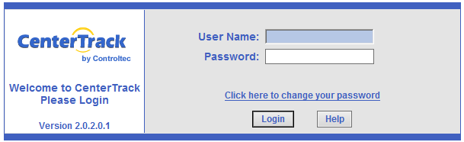

Access the system using your LAUSD Single Sign-On (SSO) User Name and Password.

- Enter your SSO user name in the User Name field.
- Enter your SSO password in the Password field.
- Click the Login button. The EESIS navigation bar will appear on the left.
- Disregard the “Click here to change your password” link. That does not apply to LAUSD users.

Logging Out
Along the top of every page there is a Logout button, which allows you to exit the program.

If you are editing a record or adding a new record and you click the Logout button, your changes will NOT be saved. In order to save your changes before you log out, you must click the Save button, then the Logout button.

EESIS - Navigation

DO NOT USE THE “BACK” BUTTON OF YOUR INTERNET BROWSER.
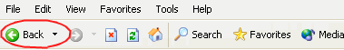

Overview of the Navigation Bar
Depending on your security level, you may not have all the menu items listed in the navigation bar.

Navigate through EESIS using the menu items and links in the navigation bar (below on the left), which consists of Family, Center, Invoice, Attendance Reports, Operator, and Administration.

In the navigation bar, each menu item branches off into links (shown below on the right are the links that branch off from Center and Attendance in the navigation bar).
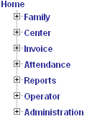
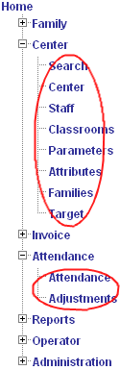

Menu Items

Menu
Items

Links

Links

Using the Navigation Bar

Each of the menu items in the navigation bar has a small plus (+) or minus (-) sign to the left of it. If you click on the plus sign next to a menu item, it expands to display all of the links under it and replaces the plus sign with the minus sign. If you click on the minus sign, it hides all of the links under menu item.

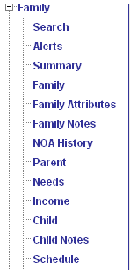

When you click on a menu item, such as Family, the links under Family will appear (Search, Alerts, Summary, etc.) When you click on a link such as Search, the Search page (below) will appear to the right of the navigation bar.

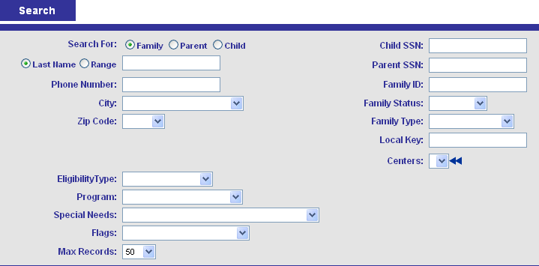


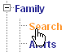

Using Features in EESIS

Text fields

These fields are used to enter text, such as the Last Name field. When you click in a field the box will turn blue.

Dropdowns
These are fields with preselected information available such as the example of Status. You click the down arrow to display the selections available.

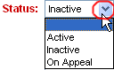

Required fields
Or These fields are in red. If data is not entered into a red field or selected (from a dropdown), you will not be able to save and continue.

Preferred fields
These fields are in green. If data is not entered, a message will appear telling you that one or more preferred fields have been left blank. You can then choose to leave the field blank and continue by clicking OK or return to the page and enter data by clicking Cancel.

Multi-select boxes
These are fields that allow you to open an expanded window to make multiple selections. After you click the double arrows, a window will appear, as shown below. Once you’ve made your selections, click OK.
Check ONLY the boxes you want to select or click the plus sign to select ALL the boxes.
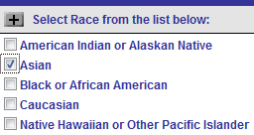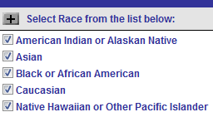

EESIS - Searching the Database
Families may already exist in the EESIS database. It is essential that you search thoroughly in order to avoid entering a duplicate family.

When searching for a family in the system, you can do very broad searches by entering fewer search criteria or very narrow searches by entering more search criteria. For example, a very broad search is when you search for all families with the same last name. A narrower search might be when you add the child’s birth date to the search criteria. Searching by child name is recommended. In some situations a family is entered in EESIS with the child’s name as the Family name and in other situations the mother’s (or father’s) name has been entered as the Family name so be sure to cross-check.

Searching by Child
- Click the Family menu item in the navigation bar and click the Search link.

- The Search page will appear on the right.

- Click Clear at the top of the page. This will clear all the fields that have data from a previous search.
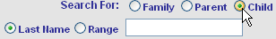
- Click the Child radio button.

- Click the Last Name radio button and enter the first few letters of child’s last name.

- Click on the First Name radio button and enter the first few letters of the child’s first name. This is most helpful when the child has an unusual name that could be misspelled.

- Click Enter or click the Search button at the top of the page.

- This should bring back a list of children with that name. Click on the child’s name to lock into that family.

- Verify that this is the correct child. Cross-reference the name of the parent(s), child date of birth, etc.

- If you don’t find the correct child the first time, click the Refine Search button at the top of the Search page and try again. For common names, add the date of birth.

- It is helpful to keep a list of the Family ID numbers for your children. If you have the Family ID, you can clear the Search screen, enter the number in the Family ID field on the right and click Search to be taken directly to that family.

Viewing Multiple Family Records

When you want to view multiple family records from the Search Results window, you can select multiple records by checking the boxes next to Summary only for those family records that you want to view. You must let the page refresh after each box you check.
You can also check or uncheck all the boxes at once by clicking the plus sign.

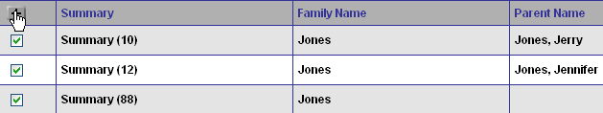

- In the Search Results window, click the plus sign to check all the boxes. This will check all records past the 10 that are on the page, if there are more than 10 records in the search results.
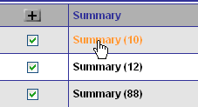
- Click Summary for the first family on the list.


This will take you to the Summary page where you can scroll through each family record by clicking the “back” and “forward” arrows.

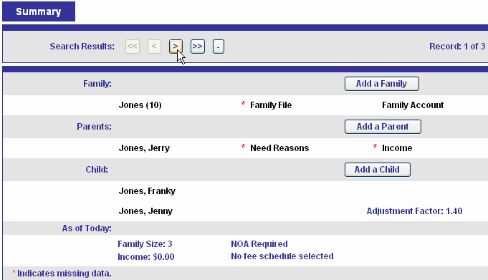

Narrowing a Search Using the Summary Page

The Summary page displays information about a family that may be helpful in identifying a particular family by the children’s names listed for the family. For example, say you have two families with the same last name and the parents’ first names are the same.

In a case like this, if you go to each family’s Summary page, you will see the children listed for each family. This may help to identify the family you are searching for.

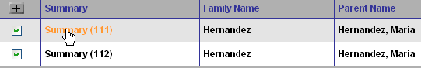

In this example:

- For the first family (ID#111), only one child is listed, Jerry.
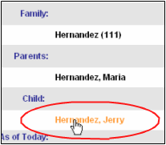

- For the second family (ID#112), two children are listed, Christina and Joseph.
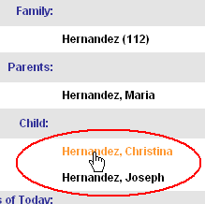

EESIS - Adding a New Family
If you have searched and determined that the family does not exist in the EESIS database, proceed with this step. If the family already exists, see Chapter 17.

To ensure system edits, add a family in the following sequence.

Adding a Family - The Family Page

- Click the Family menu item in the navigation bar and click the Family link.
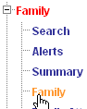

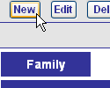

- Click New at the top of the page.

The Family page will appear. Some of the fields, such as City and State will automatically appear with the information from the previous record added. Other fields, such as Family Status, Recertification Date, and Family Type will automatically appear with information that will be the same for most families.
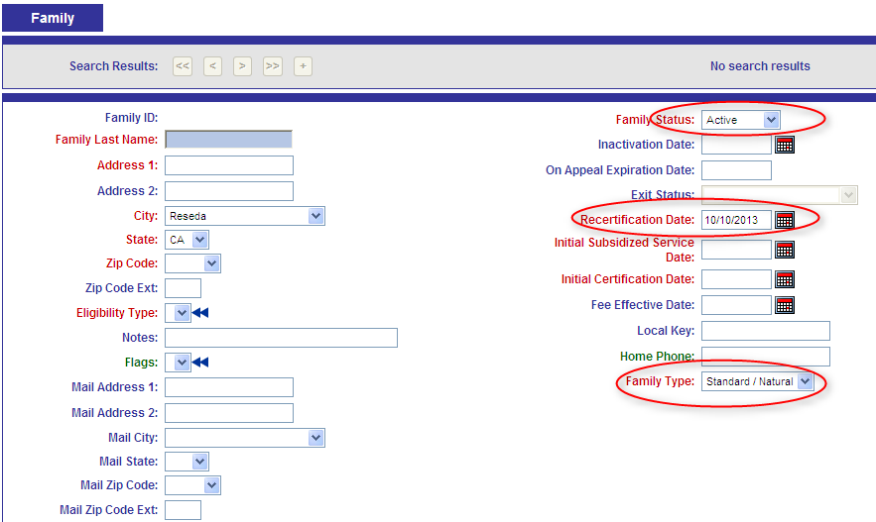

- Enter the family information into the appropriate fields. Remember, all fields in red are required.

- Add Family Name and Address. This is usually the head of household but may be the child’s last name. Always use the child’s last name if the child is in foster care. Note that the state now requires the 4-digit zip code extension.
- Eligibility Type – Use the double arrows and select the appropriate eligibility type. There should be only one eligibility type.
- Most families will be “Income Eligible”
- If the family receives CalWORKS, the type is “Cash Grant”
- If the child has been referred for protective service reasons through the Los Angeles County Department of Children and Family Services, the type is “Protective Services”.
- “At risk” would be selected if the has a child is designated as at risk in a referral prepared by a legally qualified professional from a legal, medical, or social services agency, or emergency shelter. The next recertification date may be no more than three (3) months forward.
- Flags – Click the blue double arrows and select as appropriate, particularly if the parent is a single parent. (Verification required.) Parents who pay fees weekly instead of monthly should have the “Weekly Invoice Cycle” flag checked so that fees do not show as past due until the end of the month.
- Status is Active
- Recertification Date – The field for the next recertification will be prepopulated with the date one year from the date you are adding the family. NOTE: A child at risk of abuse, neglect or exploitation must be recertified every three (3) months.
- Initial Subsidized Service Date - The child’s first start date in the classroom.
- Initial Certification Date - Use the date the application is approved.
- Family Type Field - Defaults to Standard/Natural. You may select Foster or Guardianship as appropriate. If the field is set to Foster or Guardianship, the parent(s) will not be counted in family size. If there is one foster child, it will show a family size of one. But if the foster child has siblings in the same home, all are counted in family size.

Shortcut: Dates and phone numbers in EESIS will automatically format. A date entered as “102113” will change to “10/21/2013” and a phone number entered as “2132411000” will change to “(213) 241-1000”.
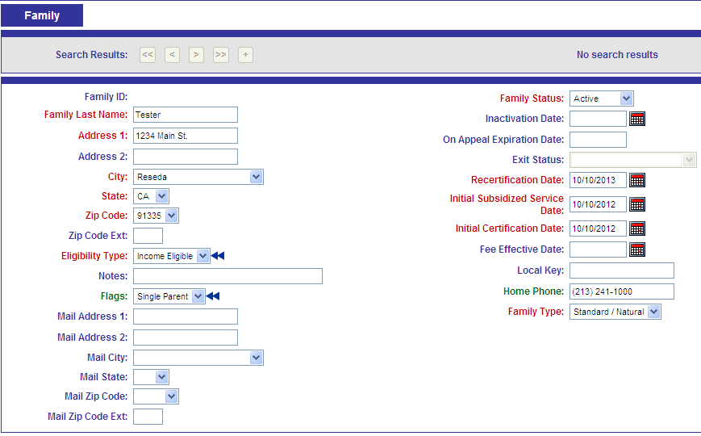

- When you have entered all the information, click Save at the top of the page. The family ID is assigned by the system when the family information is saved.

Adding a Family—The Parent Page
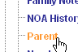
- Click the Parent link on the navigation bar.
You may also add a parent (and other information)
by clicking the links on the Summary page.

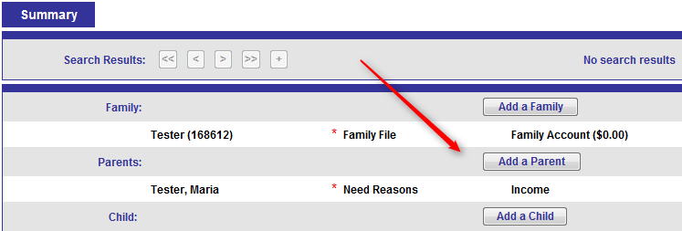

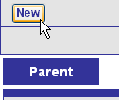

- Click New at the top of the page.

The Parent page will appear. A family ID was assigned when you saved the family and the family name appears at the top. The Last Name field automatically appears with the family last name and the Home Phone field automatically appears with the family phone number (if you enter one in the Family page). The Status field defaults to Active status.

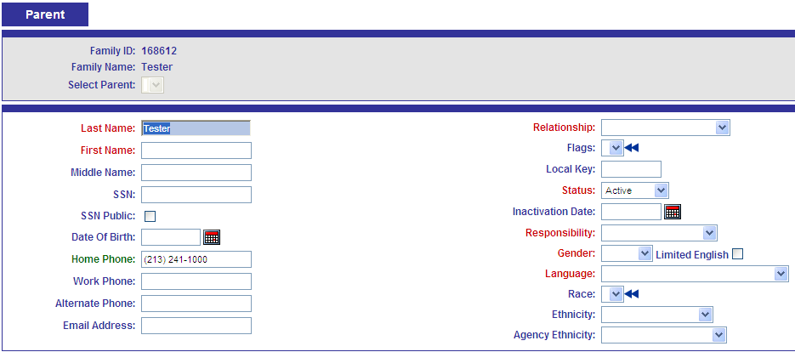
- Enter parent information into the appropriate fields.

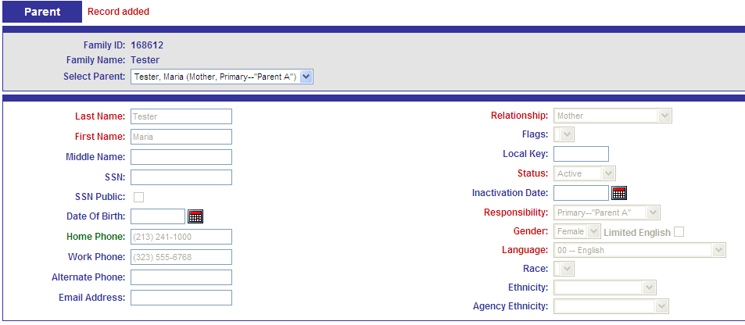

- Click Save at the top of the page.

If this is a two-parent family, click the New button again and add the second parent’s information. Responsibility will be “Secondary - Parent B”. This is particularly important as we assign District IDs to children to determine if there is already a match in the District ID system.

Adding a Family – The Needs Page
- Click the Needs link on the navigation bar.

Notice that the family ID and name will appear at the top. The parent name will appear in the Select Parent dropdown. If there are two parents, you can access both of them from this dropdown.

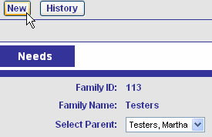

- Click New at the top of the page.
- In the Need Reason dropdown, select the appropriate reason, such as Working.

When the screen refreshes, the Needs page will appear. If you entered a parent work number in the Parent page, this will automatically appear on the Needs page.

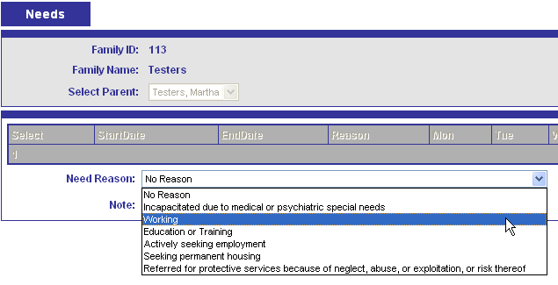

- Enter the parent needs information in the appropriate fields.

Start Date - Must be on or before the initial subsidized service date. If a parent has been working for a long time, you can put the initial start date or the date of initial certification. End date is not needed unless you know that a particular need will end on a specified date (such as Education or Seeking Employment).

Grace Period - The time that you are allowing for drive/commute time from the center to the parent’s workplace and back.

For example, notice that the grace period says “minutes per time.”
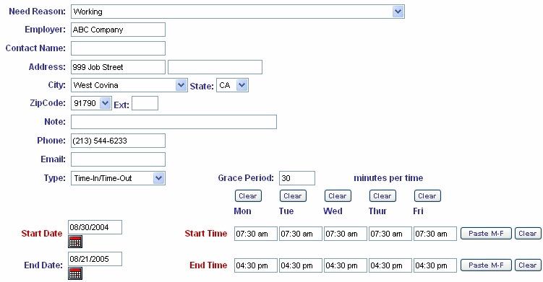

This means that if you add a 30 minute grace period, you will set the Start Time back 30 minutes and the End Time forward 30 minutes in the child’s schedule. So, if the parent works 7:30 to 4:30, and you add a grace period of 30 minutes per time, the parent need will result in 7:00-5:00. When you enter the child’s schedule, the “from/to” times will be 7:00-5:00 because this is when the child is in care.

If you use Total Hours tracking, the grace period becomes “minutes per day.” If you use Max Hours per Week, the grace period becomes minutes per week.”

Enter the start and end times as they relate to the parent’s schedule. If the parent works or needs the same hours of care each day, Paste M-F to paste the Start Time / End Time data to the rest of the days.

Shortcut: Enter “730” and “430” – EESIS will automatically change to “07:30 am” and “04:30 pm”.

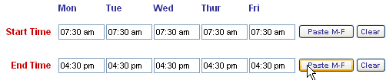

Review the information below and on your screen before saving.
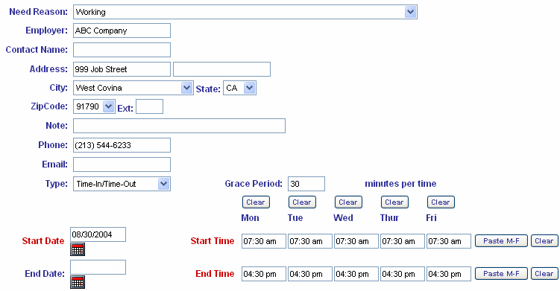

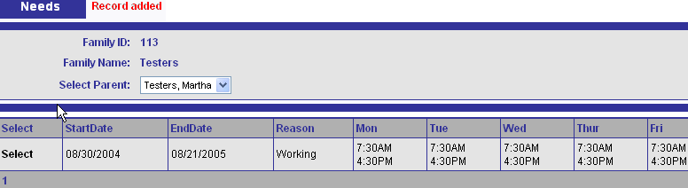
Click Save at the top of the page. The Needs page will show the parent needs in a table format, as shown below.

If this is a two-parent family, click the New button again and add the second parent’s need information.

Adding a Family—The Income Page

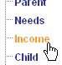
- Click the Income link on the navigation bar.

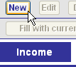
- Click New at the top of the page.

The Effective Date field will default to the date that you are adding the income. You will normally leave this date as it is. The Income Effective Date must be on or before the child’s first day of attendance. When there are income changes, always enter a NEW income with a new effective date. Editing income will cause any change to be retroactive to the original date.

Under Income Description, only the descriptions that have an asterisk (*) are counted in the family income totals. So, for example, an amount entered for Food Stamps will NOT be counted in the total income.
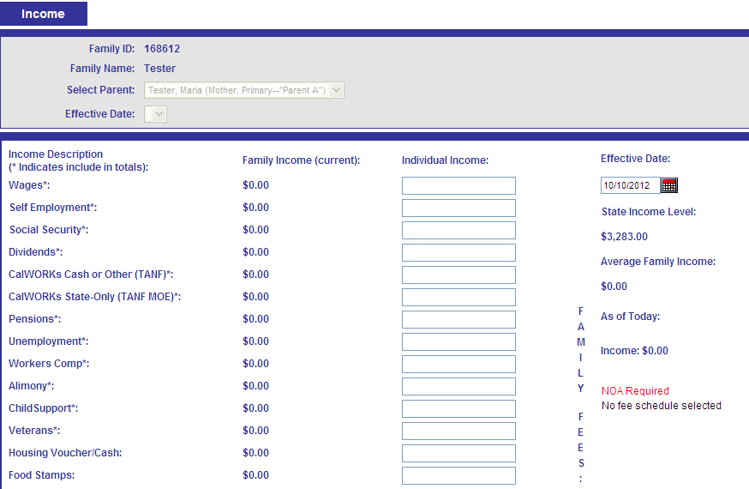

- Click Monthly Income Worksheet at the top of the page.

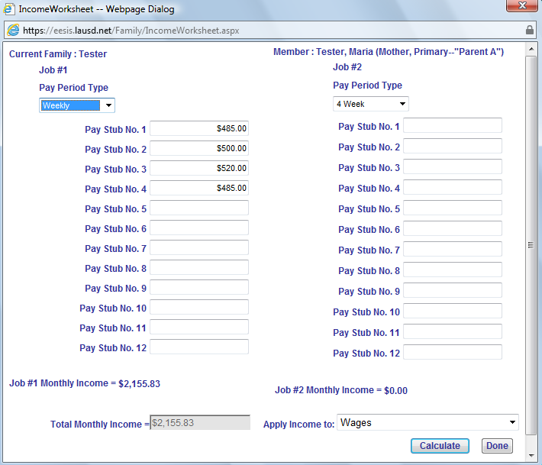

- Under Job #1, click the radio button for the appropriate pay period frequency. In the example above, the frequency is weekly so there should be at least 4 pay stubs to verify income. There must be one month’s worth of pay stubs for the most recent month of employment. Be careful with bi-weekly and bi-monthly. Bi-weekly means every 2 weeks (14 days), or 26 paydays a year. Bi-monthly means twice a month (such as the 1st and the 15th), or 24 paydays a year. This can make a difference in fees.

- In the Apply Income to dropdown, select the appropriate income type. The default is Wages.

- Click Calculate at the bottom right. Notice that this totals the amounts in Job #1 Monthly Income and in Total Monthly Income.

NOTE: You must click Calculate before you click Done in order for the income to save to the Income page.

- Print the Income Worksheet and keep in the paper file. To print click Ctrl and P. Save a copy in the family file

- Click Done.

This will take you back to the Income page and put the total into the Wages field.

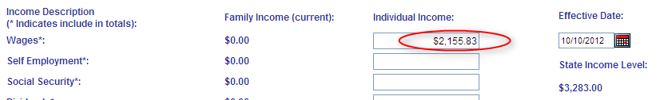

- Click Save at the top of the page.

If this is a two-parent family, click the drop-down arrow next to “Select Parent” and click on the other parent. Then click the New button again and add the second parent’s income information.

ALWAYS enter income for BOTH parents

Even if a parent has no income, an Income page must be completed in EESIS showing $0 with the effective date this was verified.

NOTE: Spousal support or child support PAID by the parent may be deducted from countable income by entering on the Income page in EESIS as a negative number.

Adding a Family—The Child Page

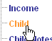
- Click the Child link on the navigation bar. Or
Click the “Add A Child” link on the Summary
Page.
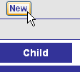
- Click New at the top of the page.

The Child page will appear with the Last Name field automatically set to the family last name.

Keep in mind that the child’s last name may be different from the parent’s last name. Also, the Enrollment Status field will automatically be set to Enrolled.

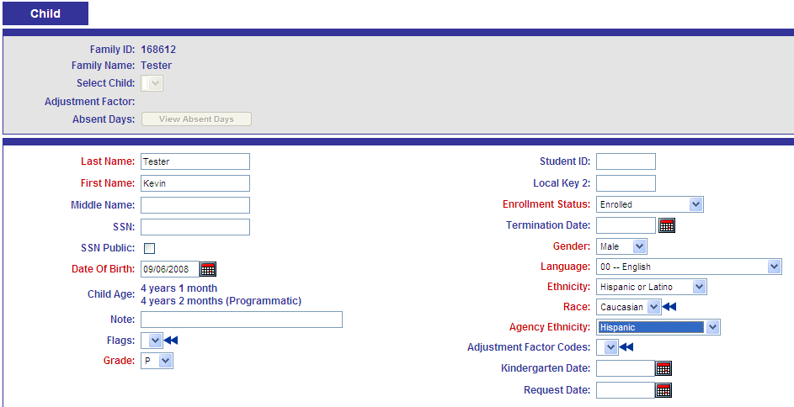

Please be sure to verify the child’s grade. A child should be shown as I/T (Infant/Toddler) until his 3rd chronological birthday. Most children will be coded P for Preschool. The grade affects several reports in EESIS, especially the Staffing Profile which is used to determine the child/staff ratio for the classroom.

Ethnicity vs. Agency Ethnicity - The Ethnicity field matches the code assigned by the state and the Agency Ethnicity field matches the code assigned by LAUSD. All three fields are required.

When a District ID has been assigned it will appear in the Student ID field on the screen. Disregard Adjustment Factors Codes and Request Date fields. If the child has an IEP, the Welligent interface will populate the Adjustment Factor Codes field.

Continue clicking to create New Child until all siblings have been entered. There must be a birth certificate or other birth verification for all children in the family. (Exception made for homeless.)

Adding a Family—The Schedule Page
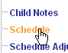
- To create the schedule, click the Schedule link on the navigation bar.

- Select the child from the Child dropdown.

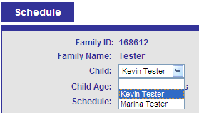

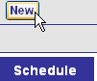
- Click New at the top of the page and the Schedule page will appear.

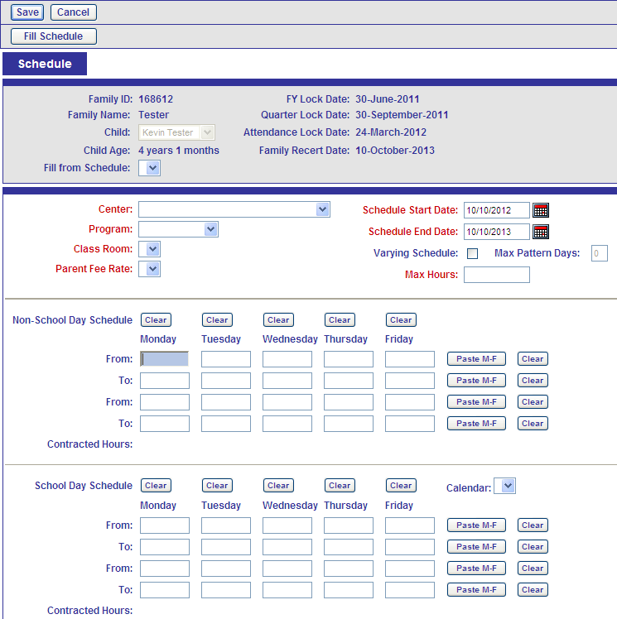

Child Schedule Information
- Center: Select your site.
- Program: Select the appropriate program (CSPP Full Day, CCTR, PCC Only, etc.)

FY 2014-2015 (July 1, 2014 through June 30, 2015)
 | DOB From |  | DOB To
Kindergarten | 9/2/2008 | - | 9/1/2009
Transitional Kinder | 9/2/2009 | - | 12/2/2009
4 year old (CSPP) | 12/3/2009 | - | 9/1/2010
3 year old (CSPP) | 9/2/2010 | - | 9/1/2011
2 year old (CCTR) | 9/2/2011 | - | 9/1/2012
FY 2015-2016 (July 1, 2015 through June 30, 2016)
 | DOB From |  | DOB To
Kindergarten | 9/2/2009 | - | 9/1/2010
Transitional Kinder | 9/2/2010 | - | 12/2/2010
4 year old (CSPP) | 12/3/2010 | - | 9/1/2011
3 year old (CSPP) | 9/2/2011 | - | 9/1/2012
2 year old (CCTR) | 9/2/2012 | - | 9/1/2013

- Class Room: Select the appropriate classroom
- Parent Fee Rate: the appropriate fee type will appear based on the program selected. With the conversion to monthly fees, internal settings in EESIS will be modified so most programs will always select General Childcare-Monthly.

- Schedule Start Date: Today’s date (will be prepopulated) or the first date the child will attend. Change as needed.
- Schedule End Date: One year from today (will be prepopulated) or the first date the child will attend. Active schedules govern many things in EESIS and in order to avoid problems on the Recertifications Due Report, it is helpful to have the Schedule End Date coincide with the Recertification Date.

Non-School Day Schedule: Enter a From time and a To time (i.e., 8:00 am to 5:00 pm). Once you enter the From and To times for Monday, use the Paste M-F button to paste the same times for Tuesday through Friday.

Shortcut: Enter “8” and “5” – EESIS will automatically convert to “08:00 am” and “05:00 pm”.

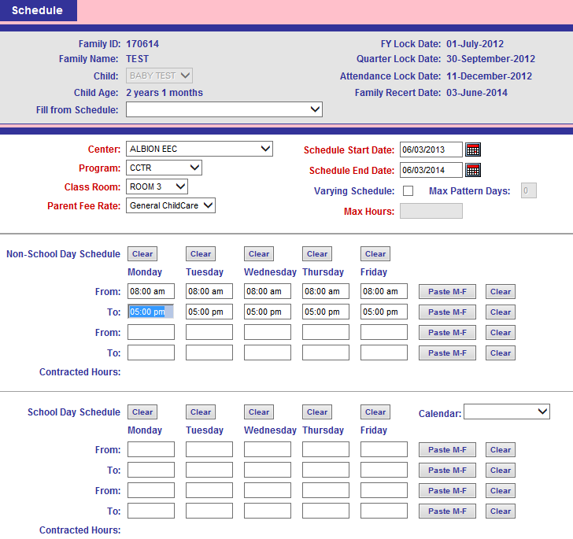

School Schedule: This section is rarely used by EECs as school-age children are no longer served. It is primarily used by CSPP Part Day classes at elementary schools. The calendar selection ties the schedule to the school’s calendar (Single-Track, Traditional).

- Click Save at the top of the page.

16.6.1 PCC Plus Another Program
A child who is enrolled due to the parent’s need and income may also have special needs and attend the PCC class. This child should be flagged on the Child page as “PCC plus another program”. The child’s schedule may be handled two different ways:
- Non-fee paying family – If the family does not owe a fee, it is acceptable to show the CSPP/CCTR schedule hours for the entire time the child attends the center, including the PCC class time. This will usually result in a full CDE.
- Fee-paying family – If the family owes a fee, it may be more advantageous to break out the hours into two separate, non-overlapping schedules. For example, create a schedule for PCC Only from 8 to11 am and a second schedule for CSPP from 11:01 am to 4 pm, thus resulting in lower fees for the parent (but only a part-day CDE for the center.)
- Some PCC classes are held off site. In this situation, the child must be signed out when he leaves and signed back in when he returns. This is a situation when both the Non-School Day and School Day section of the schedule would be used. In the example below, the child is expected to attend the center from 7:30 am until 5 pm on non-school days (summer, spring break, etc.). When school is in session (August through June) the child is dropped off at 7:30, leaves at 7:55 to go to the PCC class, returns at 11:05 and is picked up by the parent at 5. This is reflected on the daily sign-in sheet. The parent would sign the child in at 7:30am and out at 5 pm. The Office Manager would sign the child out at 7:55 and sign him back in at 11:05.

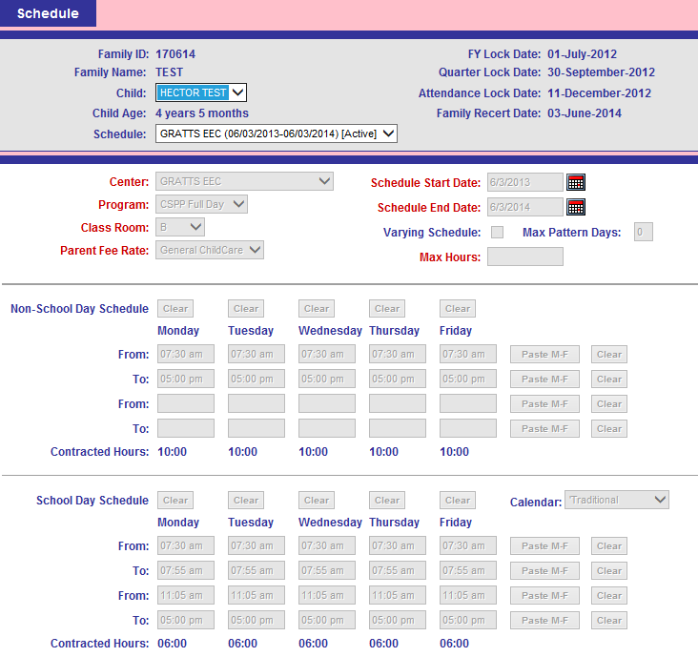

EESIS - Adding a Schedule to an Existing Family
If your search locates the family in EESIS, it may be active or terminated. Either way, DO NOT enter a new family. Update the existing family record as follows;

Active Family
If the child, or a sibling, is currently enrolled in an Early Childhood Education program, you only need to verify that the child’s status is Enrolled on the Child page. Then go to the Schedule page for that child and enter a NEW schedule as described in section 16.6. The schedule end date must not extend beyond the family’s recert date (shown in the top area of the Schedule page). Do not change a Recert Date on a family where the child is currently enrolled in another program. It may be necessary to coordinate with another school or EEC if a family has children enrolled in another LAUSD early education program.

Terminated Family
If you locate a terminated family and the Exit Status is “Outstanding Fee Due”, the system will not allow you to enroll the child. Refer the parent to the site where the fee was owed to pay the outstanding balance. Once cleared, the child may be enrolled.

If your search locates a family that is terminated for other reasons, you must first reactivate the family.
- On the Family page, update any information, change the Family Status to Active and change the Recertification Date to no more than 12 months forward.
- You will get an alert, WPI #1000, reminding you that reactivating a family on the Family page does not reactivate the parents, children and schedules. Those must be reactivated separately. Click Yes to continue the reactivation.
- On the Parent page, update any information and change the Status to Active. Be sure to reactivate both parents.
- On the Child page, update any information and change the Enrollment Status to Enrolled.
- Update the status of any siblings to “Other Family Member”. (Remember that family size impacts fees.)
- On the Schedule page, create a New schedule as described in section 16.6 above.
NOTE: Be sure to complete the reactivation of all family members on the same day to avoid date issues with the NOA.

EESIS - Completing the Enrollment Process
Computers need Adobe Acrobat Reader to view the CD-9600 (application) and CD-7617 (Notice of Action, or NOA), as well as other PDF files.

The Application (9600)

- Once you have selected the family, click the Summary link on the navigation bar. The Summary page will appear. In the bottom section, under Forms, there are several reports to choose from.

- The “Confidential Application for Child Development Services and Certification of Eligibility”, or CD 9600, is required for all children enrolled in an early education program. After the necessary family information has been entered in EESIS, the 9600 must be generated from the Summary page.

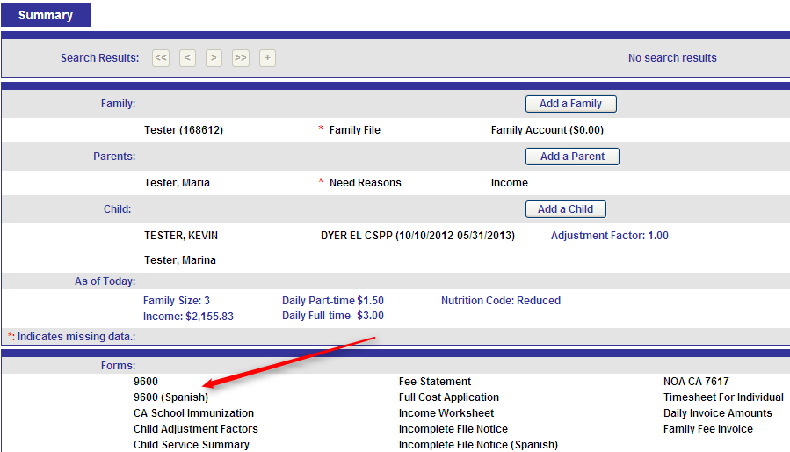

- Click 9600 at the bottom of the page.

The 9600 setup window will appear. Select language.

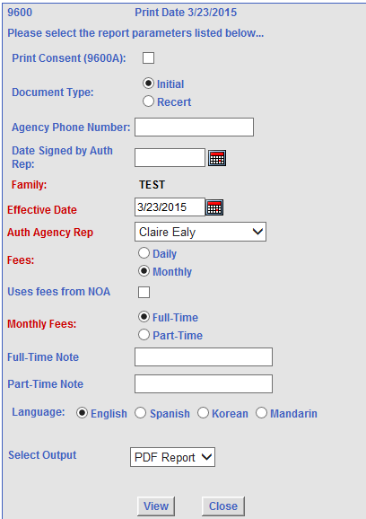

- Consent Form: Check the box to print the 9600A consent form. This allows a parent to signify whether they want to provide their Social Security Number.
NOTE: Auditors require a new 9600A at enrollment as well as each recert.

- Initial radio button: This is the default.

- Agency Phone Number: The phone number associated with your school is pre-populated. You can change it if you like.

- Date signed by Auth Rep: This defaults to today’s date but can be changed. It must be on or before the child’s Schedule Start Date.

- Effective Date: This defaults to today’s date. EESIS has changed the way this field is used and although it is required, the date signed is more important.

- Auth Agency Rep: The EEC Principal’s name should be selected and the Principal should sign the form.

- Use fees from NOA: Disregard

- Click Print. This allows you to preview the report and send it to the printer by clicking the printer icon at the top.

- The parent and the Agency Representative (Principal) must sign the 9600 on the second page. This is a strict audit requirement. The center keeps the original and the parent receives a copy.

The Notice of Action (NOA)

Approval NOAs

- A Notice of Action (NOA CA 7617) is required to approve the enrollment and to establish fees, if any.

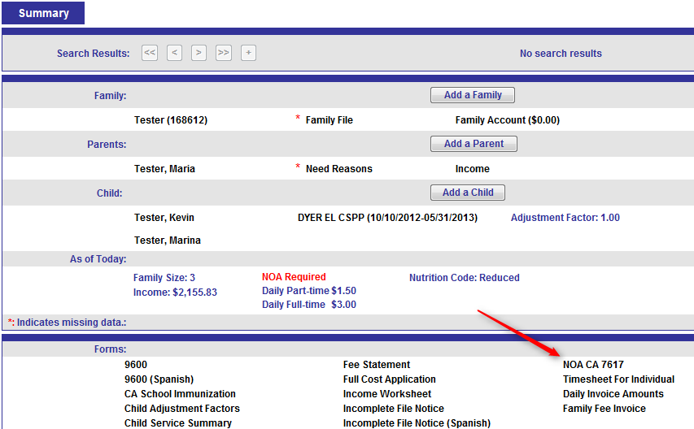

- Click NOA CA 7617 at the bottom of the page and the NOA (7617) setup window will appear.

If the child’s schedule does not start on or after the Effective Date, the child WILL NOT appear in the Child(ren) box.

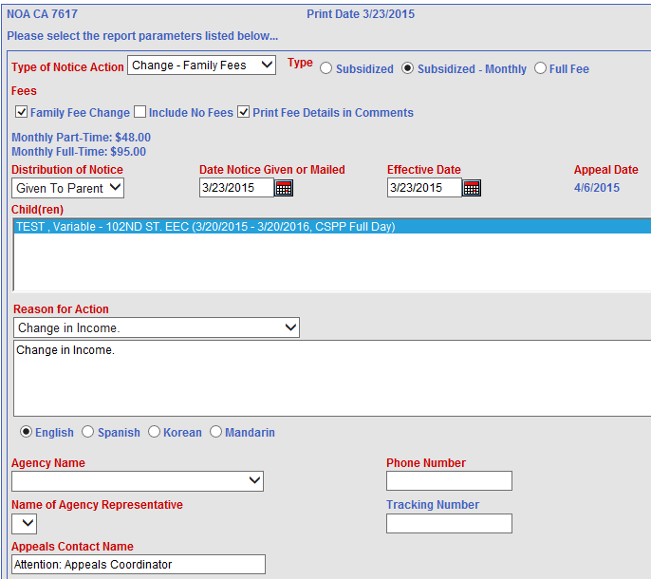

- Type of Notice Action dropdown: Select Approval.
- The Subsidized radio button will be filled.
- Distribution of Notice dropdown: Select Given To Parent, if appropriate. This will set the Appeal Date to 14 days from today’s date, which is the deadline to submit an appeal. If Mailed to Parent is selected, the deadline is set to 19 days from today’s date.
- Date Notice Given or Mailed: This defaults to today’s date but may be changed.
- Effective Date: This date will usually be the same as the schedule start date and the first day of subsidized service (first day of enrollment). For fee-paying families:
- In the month of initial certification, the fee is effective immediately.
- If a change results in a DECREASE in fees, the NOA Effective Date should be the first day of the following month.
- If a change results in an INCREASE in fees, the NOA Effective Date should be the first day of the month after the appeal process is exhausted.

- Appeal Date: This is the deadline for the parent to submit an appeal.
- Child(ren) box: Select the child to be included in the NOA (7617). To select multiple children in the box, hold down the Shift key or the Ctrl key while you click each child.
- Reason for Action: You can type the reason or select a reason from the dropdown.
- Select the English, Spanish, Korean or Mandarin radio button.
- Agency Name dropdown: Select your location.
- Phone Number: The phone number associated with your school is pre-populated. You can change it if you like.
- Name of Agency Representative: The EEC Principal’s name should be selected and the Principal should sign the form.
- Tracking Number: For use with certified mail.
- Click the Print button on the bottom of the setup window. Now you can preview the report and send it to the printer by clicking the printer icon at the top. Check to be sure fees are correct. If not, it is usually a date problem (income effective date, schedule start date, etc.)
- The Agency Representative (Principal) must sign the NOA and have the parent initial at the top. This is a strict audit requirement. The center keeps the original and gives the parent a copy.
- After the NOA has been printed, you can review or reprint by going to the NOA History link. You should not print a new NOA after the parent has initialed the original NOA.
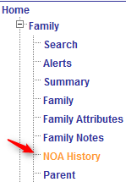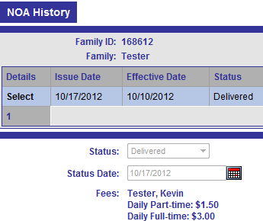

Shortcut: Sort columns by moving your cursor to the column headers. The header will turn orange, which indicates you can sort by Issue Date, Effective Date, etc. This can be important if NOAs become effective out of order. The vast majority of errors that are found in EESIS relate to dates.

NOA Corrections

A Notice of Action must be generated in order to finalize the process and generate fees, if applicable. The Notice of Action advises the parent of due process requirements if they disagree with the agency’s actions. A Notice of Action (NOA) must be provided to the parent in the following circumstances:
- Approval of services
- Denial of services
- Termination of services
- Fees need to be increased or decreased
- The amount of services needs to be increased or decreased

The Office Manager cannot delete a NOA that was printed incorrectly but the NOA can be rescinded, or withdrawn. On the NOA History page, click Edit. Change the status from Delivered to Rescinded and check the date.

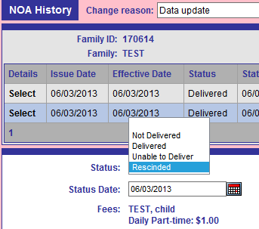

If a fee change had been made on the Account page, rescinding the NOA will cause a fee adjustment.

EESIS – Fee Collection
Fees are always paid in advance. Fees are due on the first day of the month and cover the days of enrollment for that month. Fees must be paid as long as the child is enrolled, even if he is absent.

All fees must be paid by check, money order, or cashier’s check. They may also be offset by Other Care Provider (or babysitter) receipts. See section 8.4.3. Fees that are not paid after seven days are delinquent. Delinquent fees may result in the child being removed from the program. See section 8.4.

Fees are tax deductible. At the end of the school year, a tax letter should be provided to each fee-paying parent. The tax letter is under Reports > Invoices > Tax Letter and will compute fees paid for the year whenever it is triggered to run.

EESIS - Invoices
Invoices for all fee-paying families are system-generated monthly, usually 7 days prior to the beginning of the month. The invoices may be generated early when there is a conflict with a holiday. Refer to the Fee Cycle Calendar for the school year.

The Fee Period shown is for the entire month. The invoice will also show payments made, fees past due, adjustments and the account total.

The fastest way to print invoices is through a batch print process. You may also print a single invoice for a family from the Summary page at any time during the cycle.

Batch Printing Invoices

- Click the Invoice menu item on the navigation bar.
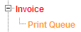
- Click the Print Queue link on the navigation bar.

- Select your center from the Center dropdown.

- Select all the appropriate parameters as shown below.

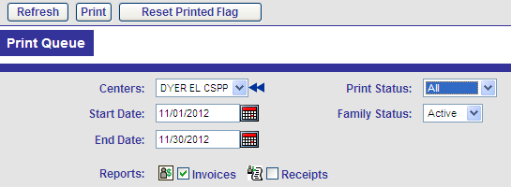

If you want to print invoices and receipts, check both boxes.

- Click Refresh at the top of the page. The list of invoices and/or receipts that match the parameters you set will appear.

- In the far left column, click the plus sign to check all boxes or check only those that you want to print.

- Click Print at the top of the page. The invoices/receipts will appear on your screen. All the invoices will be in one PDF document and all the receipts will be in another PDF document. You can scroll through each page to view them one at a time if you wish to preview them.

- Click the printer icon at the top to send them to the printer.

- In the print queue, the Printed column indicates whether a receipt or an invoice has been printed. Both invoices and receipts can be reprinted at any time.

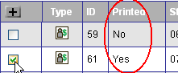

Printing an Invoice from the Summary Page

- Once you select the family, click the Summary link on the navigation bar.

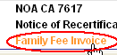
- Click Family Fee Invoice at the bottom of the page.
The family invoice will appear on your screen.

- Click the printer icon at the top to send the invoice to the printer.

An invoice may be generated from the Summary page when a fee changes after the regular monthly invoice cycle.

Posting a Payment
All fees are due on the first business day of the month and should be collected and banked within the week. Payment must be posted immediately to generate a receipt from EESIS. A copy of the receipt must be provided to the parent.

When a payment is received from the parent, follow the instructions below:

- Once you select the family, click the Account link on the navigation bar (under Family).

- Click New at the top of the page

- From the Transaction Type dropdown, select the appropriate transaction:
- Check
- Money Order
- Provider Receipt (Other Care) - If the parent pays for child care for the enrolled child OR a sibling, and can provide a receipt or canceled check for fees paid, that receipt can offset the CSPP fee by an amount up to (but not over) the amount owed. The fee credit applies to the family’s subsequent fee billing period and may be equal to or less than the amount owed. Credit may not carry over to the next month. For example, the family owes a fee of $100 for May and brings in an Other Care Provider receipt for $175 paid in April. Only $100 may be applied to the May payment. A May payment receipt from the other care provider would be needed for June credit at LAUSD.

The credit for outside care payment is not applicable to families in the full cost category.

To use this type of credit:
- Have the parent obtain a completed “Verification of Other Care Provider” form 84.26 (Rev. 12/98) from the outside care provider at the time of certification.
- Keep the completed form in the family file at the center for audit purposes.
- Advise the parent that the payment will only be deducted from the center fee if she submits a signed and dated receipt from the outside care provider or a copy of a cancelled check. Otherwise, the center fee must be paid.
- Attach the outside care provider receipt or cancelled check to the file copy of the center receipt for audit purposes.

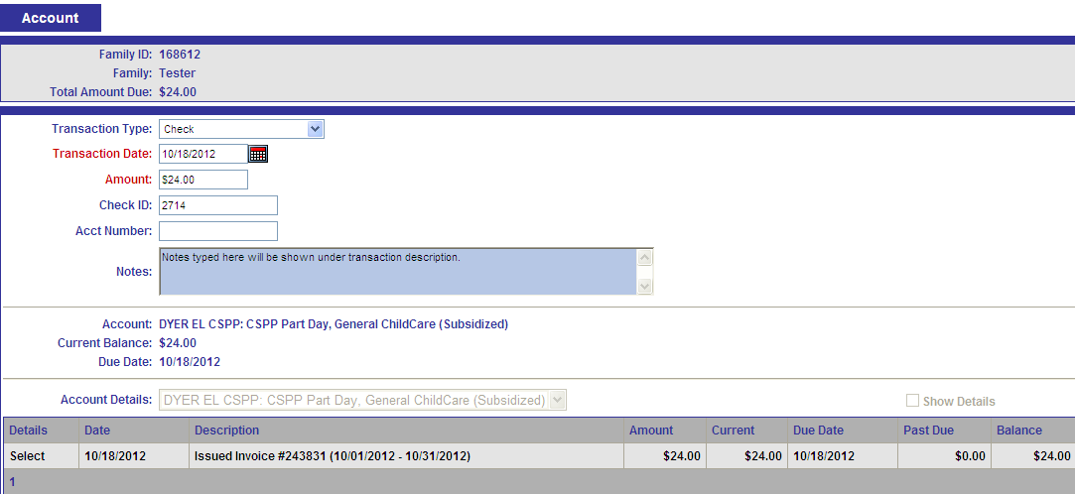

- The Transaction Date defaults to today’s date. The amount must be entered. It is optional to enter check number, account number and notes to appear in the Comments section of the receipt.

- If there is a past due balance, ALWAYS apply payment to the amount past due first. Any remainder should be applied to current balance.

- When you have entered all the information, click Save at the top of the page and the receipt will appear on your screen.

- Click the printer icon at the top to send the receipt to the printer.

- The agency representative must sign the receipt.

- Receipts can be re-printed from the Print Queue under the Invoice page or by clicking to Select the payment on the Account page.

Past Due Balance

Fees are considered delinquent after seven (7) calendar days from the date the fees were due. If this occurs, a Notice of Action should be generated terminating the child for delinquent fees. If the parent pays within the 2 week appeal period, the NOA should be Rescinded on the NOA History page. (Under Details click Select and then Edit.)

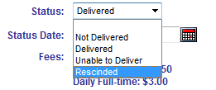

If the parent does not pay, terminate the family on the Family page with an Exit Status of “Outstanding Fee Due”. The system will prevent the family from enrolling at another LAUSD Early Childhood Education program until the outstanding fee is paid.

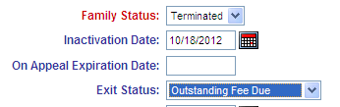

If there is a past due balance, always apply the payment to the past due balance first before applying to current balance.

A Payment Plan may be created in rare situations where the parent can provide a valid reason for being unable to pay in full by the due date for the month. The Payment Plan should establish a date by which the balance must be paid in full, not to exceed ONE MONTH. The parent must pay all delinquent fees and current fees within that time frame. If a termination NOA has been issued, it can be Rescinded. If a termination NOA has not been issued, issue a termination NOA with an effective date by which all payments must be current. Terms of the payment plan can be typed into the Reason for Action box. If fees are paid by the due date, rescind the NOA. If not, the termination will go into effect.

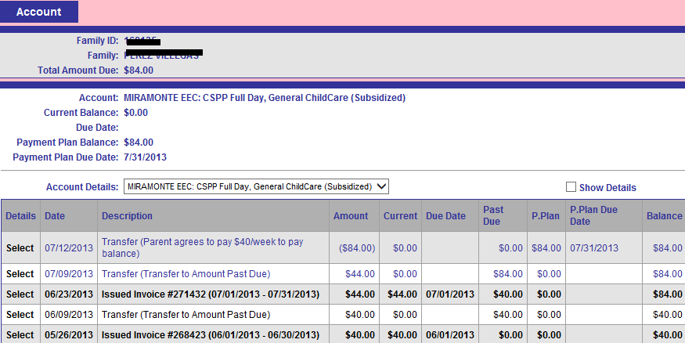

EESIS - Attendance

- All absences must be documented in writing with the name of the child, date of the absence, specific reason for the absence and signature of parent (or school representative if verification is made by telephone). See Chapter 6 for additional details.

- On a daily basis, click the Attendance menu item in the navigation bar and click the Attendance link. The Attendance page will appear.

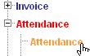

- Select the school from the Center dropdown.

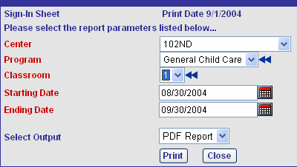
- Click the double arrows for Program(s) and Class Room(s) to select the programs and classrooms that you want to make available in the dropdowns.

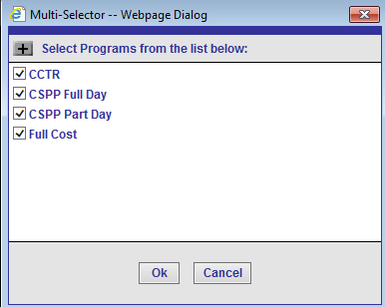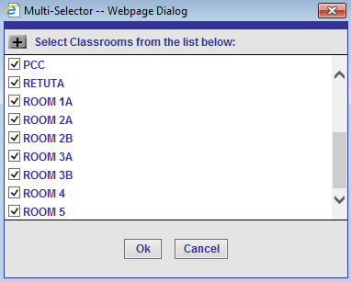

- The Start Date defaults to the current week. To select a different date, click the forward/backward buttons or click the calendar icon to select a date.

- Click View Attendance. The screen will refresh and display a list of all children scheduled for care during the time period selected.

- Entering Attendance by Day - Select the day for which attendance will be entered.

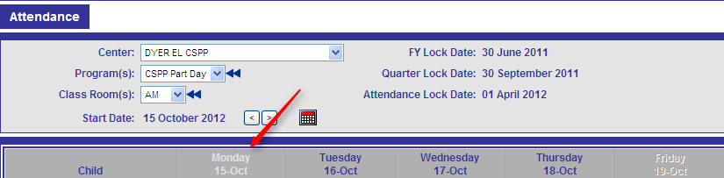

Highlighting the day will open the attendance entry screen for the day selected.

- NEVER click Load Schedule or Clear Attendance without selecting a day or the entire grid for the week will be changed.

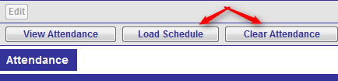

- Entering Attendance by Child - If you want to enter attendance for a single child, click the child’s name. The row for the week, for that child only, will automatically be selected (highlighted in blue) and the attendance entry screen for the child selected. will open. This method is more time consuming and is generally used for corrections to a single child’s attendance.

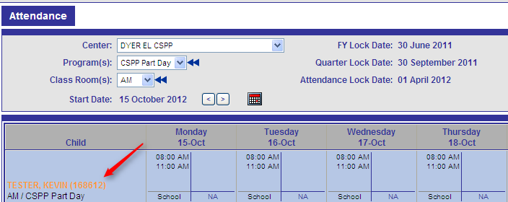

- After the selecting the correct day (or child) the following popup appears. (You no longer have to click the Edit button.) Click OK. The Actual Hours fields will be automatically filled with the scheduled hours. This certifies the attendance.
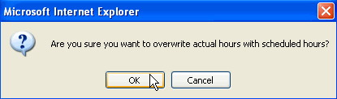

- The Clear Attendance button will clear all times previously entered during the current session.

- Enter absences by selecting the absence type from the dropdown for each child.
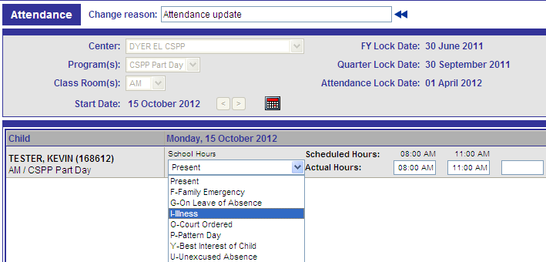

- F - Family Emergency: Unplanned excused absence due to an emergency in the family.

- G - On Leave of Absence: A limited term service leave for reasons such as parent work/school schedules, maternity leave or other medical reasons. This generally should not exceed 12 consecutive weeks. Form 82.24 is required. This type of absence is not reimbursable by the state and results in a loss of income to the District.

- I - Illness: Excused absence due to illness

- O - Court Ordered: Excused absence required by a court of law. The record must contain a copy of the court order.
- P - Pattern Day: The term “Pattern” day is used to indicate days that the child is not expected to attend because the parent does not have a need on that day. This may be the same day every week or the day may vary from week to week, depending on the parent’s work schedule. This is established on the child’s Schedule page in EESIS. The Attendance page in EESIS will have the hours highlighted in pink with the words “Not Scheduled” so hours cannot be entered.

- Y - Best Interest of Child: Excused absence due to reasons other than illness, family emergency or court-ordered visitations. Limit 10 per school year.

- U - Unexcused Absence: This type of absence is not reimbursable by the state and results in a loss of income to the District. Limit 10 per school year but the termination process for excessive absences may begin earlier.

- There are other Restricted/Special codes that must not be used unless a specific emergency authorization is provided.

Some parents may have varying work schedules and this is shown on the child’s Schedule page. The parent may not know which day(s) they will be off each week. The Attendance page in EESIS will have the hours highlighted in green to remind the Office Manager that the child may not have hours shown on that day. The attendance hours entered will be used to adjust the family fee for the month. The invoice will show the amount for the scheduled days. If the child attended fewer days or more days, based on attendance entered in EESIS, the next month’s invoice and the family Account page will show an adjustment.

Review your work and click Save at the top of the page.

ATTENDANCE SHOULD BE ENTERED DAILY

EESIS - Edits

Terminating a Family
Never terminate a family if the child or a sibling is enrolled in another Early Childhood Education program. Coordinate with the other Office Manager.

Setting the Family status to “Terminated” on the Family page will automatically terminate all parents and children and the schedules will automatically end as of the date you terminate the family.

- Select the family you wish to terminate.

- Click the Family link on the navigation bar.

- Click Edit at the top of the page.

- Select Terminated from the Family Status dropdown.

- The Inactivation Date should be the day AFTER the child’s last day of attendance.

- Select the appropriate status from the Exit Status dropdown.

- Click Save at the top of the page.

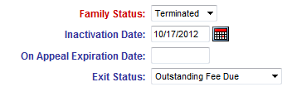

- When a family is terminated with outstanding fees, be sure to indicate the Exit Status “Outstanding Fee Due”. If the parent tries to enroll the child at another LAUSD program, EESIS will prevent enrollment until the past due balance is paid.

Changing Income
- Click the Income link on the navigation bar.

- Click New at the top of the page. Do not
edit the original income.

The Effective Date field will default to the date that you are adding the income but it can be changed.

- Click Monthly Income Worksheet at the top of the page.

Under Job #1, click the radio button for the appropriate pay period frequency. In the example above, the frequency is weekly so there should be at least 4 pay stubs to verify income. There must be one month’s worth of pay stubs for the most recent month of employment.

- In the Apply Income to dropdown, select the appropriate income type. The default is Wages.

- Click Calculate at the bottom right. This totals the amounts in Job #1 Monthly Income and in Total Monthly Income.

NOTE: You must click Calculate before you click Done in order for the income to save to the Income page.

- Print the Income Worksheet and keep in the paper file. To print click Ctrl and P.

- Click Done.

- Go to the Summary page and generate a new Notice of Action. This is required before a fee change will take effect.
- Type of Notice Action dropdown: Select Change – Family Fees.
- The Subsidized radio button will be filled.
- Distribution of Notice dropdown: Select Given To Parent, if appropriate. This will set the Appeal Date to 14 days from today’s date, which is the deadline to submit an appeal. If Mailed to Parent is selected, the deadline is set to 19 days from today’s date.
- Date Notice Given or Mailed: This defaults to today’s date
- Effective Date:
  - In the month of initial certification, the fee is effective immediately.
  - If a change results in a DECREASE in fees, the NOA Effective Date will be the first day of the following month.
  - If a change results in an INCREASE in fees, the NOA Effective Date will be the first day of the month after the appeal process is exhausted.
- Appeal Date: This is the deadline for the parent to submit an appeal.
- Child(ren) box: Select the child to be included in the NOA (7617). To select multiple children in the box, hold down the Shift key or the Ctrl key while you click each child.
- Reason for Action: You can type the reason or select a reason from the dropdown.
- Select either the English, Spanish, Korean or Mandarin radio button.
- Agency Name dropdown: Select your location.
- Phone Number: The phone number associated with your center is pre-populated. You can change it if you like.
- Name of Agency Representative: The EEC Principal’s name should be selected and the Principal should sign the form.
- Tracking Number: For use with certified mail.

- Click the Print button on the bottom of the setup window. Now you can preview the report and send it to the printer by clicking the printer icon at the top.

- The Agency Representative (Principal) must sign the NOA and have the parent initial at the top. This is a strict audit requirement. The school keeps the original and gives the parent a copy.

Duplicate Families

Despite our best efforts to search for existing families, as well as the built-in system edits, duplicate families (the same family under two different family IDs) may be accidentally created. Duplicate families may only be deleted by EESIS administrators. If you realize you have created a duplicate, email eesis@lausd.net or contact the ECE Fiscal Office. Most of the time, duplicates are caught within a week or two of creation when the child goes through the District ID process.

Office Managers may be notified that there is a duplicate family and that they should reactivate the old family ID and clear attendance. The following steps are necessary to resolve the problem. In this example, 1111 is the existing family ID and 9999 is the newly created duplicate family.

- Activate the old family ID (1111). Update all family, parent, child, need, income and any other information.

- Create a new schedule in the old family ID (1111), with the same dates as in the duplicate family (9999).

- Generate a 9600 and NOA in the old family ID (1111).

- Go to the Attendance page. Both children will now appear.

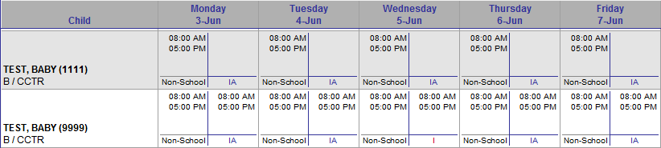

- You will need to do two things:
- Go back to the schedule start date and enter attendance information in the old family ID (1111).
Shortcut: Highlight the Child name. 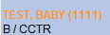 It will turn orange and bring up just that child’s attendance for the whole week.

- Clear the attendance in the newly created ID (9999). To clear attendance, highlight the child’s name. When the attendance for that week comes up, click the Clear Attendance button.

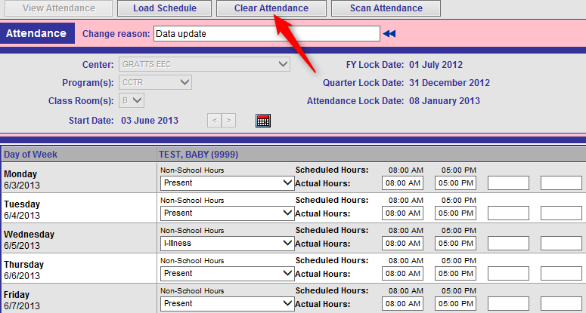

- Now the attendance will show under the correct family ID.

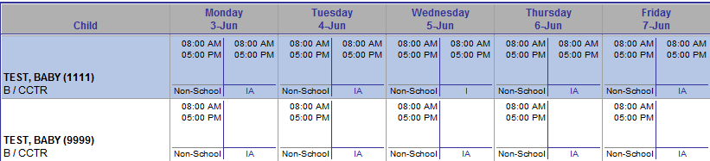

- After this is done, email eesis@lausd.net or the ECE Fiscal Office and let them know the duplicate family can be deleted.

- It is not necessary to terminate the duplicate family (9999).

EESIS - Alerts

Alerts are a way of communicating important information about a case in a quick and convenient manner.

NOTE: The Alerts page allows users to view all alerts assigned to them and should be viewed on a daily basis - at a minimum. This can be a “to do” list, so alerts should not be processed until the work, such as a recertification, is done.

There are two types of alerts:

- System-generated alerts, such as a family approaching a recertification date, a child approaching the maximum number of absences, or overdue fees. These alerts appear before the date that any action may be required. For instance, a family recertification alert will appear 90 days prior to the recertification date.

- User-generated alerts, such as alerts created using the CM (case management) Alert button. These types of alerts are typically case specific, such as one user sending a message to another regarding a particular family.
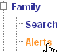
  - Under the Family menu item, click the Alerts link.

Alerts have a Processed status or a Not Processed status. On the Alerts page, there is a check box for each status. You can check each box individually or both to view Processed or Not Processed alerts. Processed alerts indicate that action has taken place. Not Processed alerts indicate that you still need to take some kind of action.

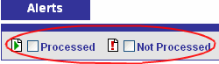
  - Check the Not Processed box.

  - Click the Refresh button at the top.

When the screen refreshes, a list of alerts that have not been processed will appear. The type of action required will depend on what is under the Description column. You can sort by any of the columns, by clicking on the headings, such as Summary, Family, Child, Center, Description, or Alert Date.

For example, if you want to sort by Description to view all upcoming recertifications, click once on the heading Description. This will sort the column in ascending alphabetical order. Click again to sort in descending alphabetical order.

Processing Alerts

From the Summary page, you can click on any link to go to the corresponding page to update information. Once you have gone to the Summary page and taken the appropriate action required in a family file, you can process the corresponding alert.

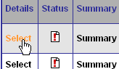
- In the Alerts page, click Select in the Details column for the alert you want to process. The entire row will be highlighted in blue.

- Click Process at the top of the page. The status icon will change to the Processed icon.


You may reset a processed alert at any time by selecting the alert and clicking Reset at the top of the page.
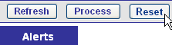


When you do this, the status icon will return to the Not Processed icon.

Creating a CM Alert
At the top of every page there is a CM (case management) Alert button. While working on a specific family, you can send an alert regarding that family from any page by clicking the CM Alert button.


A popup window will appear, allowing you to type your message. Notice that the family name and ID appears in the window. When you click Save, this alert will be saved and it will appear in the Alerts page.

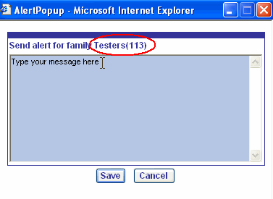

EESIS - Scanning Images

Enabling Scanning

See Chapter 7, Family Data File, for further detail about documents that should be scanned into EESIS. Using any scanner connected to your computer, scan documents into a designated folder on the computer. The scanner can be configured to always scan images into the folder you specify. To load those document images into EESIS, click the Images link on the navigation bar.

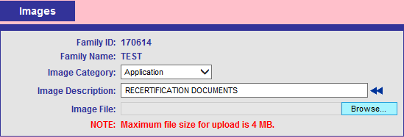

Indicate the Image Category from the dropdown.

Image Description may be selected from a pre-set list using the blue double arrows or you may type in your own description.

Click the Browse button to locate the image documents on your computer. Double click to select the document then click the Upload Image button in the upper left of the screen.

Viewing Scanned Documents

- Click View for the document that you wish to view. The document will open.
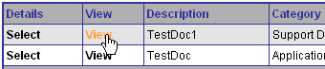

Deleting a Scanned Document

- Click Select for the document that you wish to delete. The entire row will be highlighted, indicating it is selected.

- Click Delete at the top of the page.

EESIS - Additional Information

The following three sections - Immunizations Page, Medical Page and File Page - provide instructions for adding additional information regarding the child and family. Immunizations are required; the others are optional but may be helpful in managing the caseload. The list below provides an overview of the type of information that goes into these pages.

- Immunizations Page – This page is used to track immunizations required for the child. NOTE: This information is used to generate annual state reports.
- Medical Page – You can enter notes regarding checkups the child has had, as well as history data of TB tests and chest x-rays.
- File Page – Allows tracking of most required forms and provides alerts when forms are due.

The Immunizations Page

- Click the Immunizations link on the navigation bar.
- Select the child from the Select Child dropdown.

Notice that the dates in the Date Due column automatically appear for when the child needs each immunization, according to the child’s date of birth.
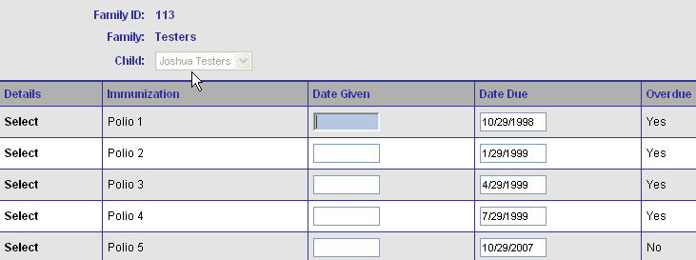

- Click Edit at the top of the page.
- When the screen refreshes, enter the appropriate data into the text fields. You can use the Tab key to go to the next field.

Shortcut: Sort columns by moving your cursor to the column headers. The header will turn white, which indicates you can sort by Immunization name, Date Given, Date Due or Overdue.

Notice that when you go into the Edit mode, a text box will appear at the top for you to enter the reason you are editing the record as shown below:

Enter the reason you are making any changes, for example “entered date for Polio 5 immunization.”

You can also click the double arrows and a window will appear with pre-set reasons to select from as shown below:
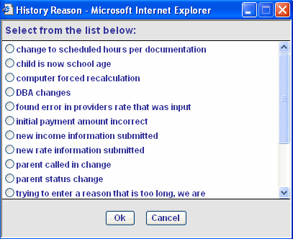

- Click OK when finished.
- Click Save at the top of the page.

If you need to edit the child’s immunizations, click Edit at the top of the page and make the necessary changes.

Immunization Reports

There are two annual reports for the California Department of Public Health that are generated for the entire center using the data in EESIS. These reports are found in EESIS at REPORTS > GOVERNMENT REPORTS (last 2 reports on the list).

- CDPH 8018, Annual Immunization Report on Children Enrolled in Child Care Centers. Provides summary data on all children including the number requiring follow-up.
- CDPH 8342, Vaccine Dose Summary. Lists each child and all immunizations received.
Both reports are generated as of the day they are run. There is no way to indicate a specific “as of” date.

The Medical Page

- Click the Medical link on the navigation bar.

- Select the child from the Select Child dropdown.

- Click Edit at the top of the page. Note that exemptions from immunizations must be entered on this page in order for them to reflect on the CDPH 8018 and CDPH 8342.

- When the screen refreshes, enter the appropriate data into the text fields. You can use the Tab key to go to the next field.
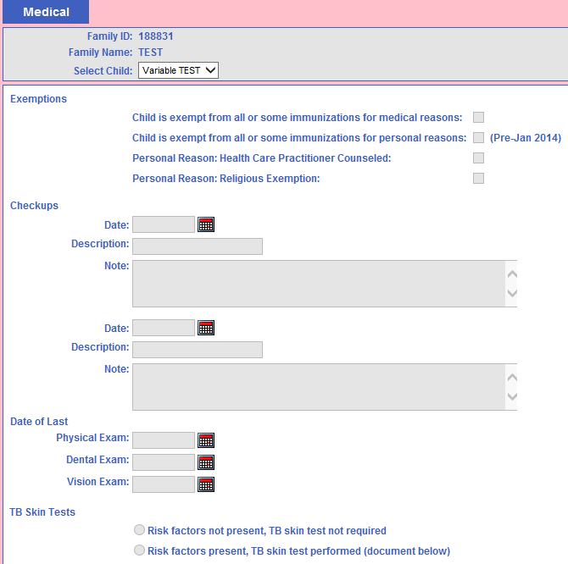

- Enter a change reason at the top of the page.

- Click Save when finished.

If you need to edit the child’s medical information, click Edit at the top of the page and make the necessary changes.

NOTE: The parent must provide a record of current immunizations for the child. Prior to, or within 30 calendar days following enrollment, a written report of the child’s physical exam, prepared by a licensed physician, must be provided. The preferred form is the Department of Social Services form LIC 701, “Physician’s Report”. TB tests are not required for children entering preschool programs unless certain risk factors are present. The LIC 701 has a checkbox at the bottom that indicates whether there is a need for TB screening. Any physician’s report provided by the parent must be less than one year old.

The File Page

The File page allows you to enter, track and update documentation required for the family case file. For example, if you still need the parent’s employment verification, you will enter this in the File page as an outstanding document with the appropriate status: Pending, Required, Not Required, or Received.

- Click the File link on the navigation bar.

- Select the appropriate box. By selecting Required, an alert will be generate prior to the Due Date.

- The File page will appear with the list of documents to choose from. Most mandatory documents are listed but there is also a line for “Other”.

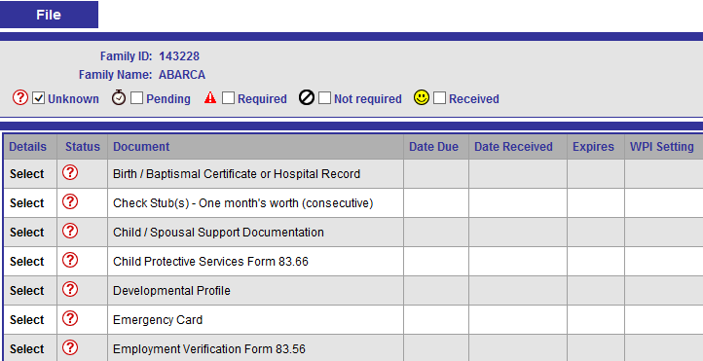

Shortcut: By highlighting the column header with your cursor, you can click to sort the column.

- Scroll down using the scroll bar on the right until you see the desired document, such as Employment Verification.

- Click in the Select column in the Employment Verification row.

This will highlight the row in blue and you can now go to edit mode.

- Click Edit at the top of the page.

- Select the file status from the File Status dropdown. After you select the file status (for example, Required) the Due Date field will appear.
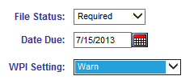

- Enter the appropriate date in the Due Date field.

In the WPI Setting dropdown, WPI stands for Warn, Prevent, Ignore. This setting will allow you to set the warning message that a document with “Required” status is outstanding. This warning will appear when working in the Schedule page according to the following:

- Warn (the message will appear and allow you to continue)
- Prevent (the message will appear and you will not be able to continue)
- Ignore (the message will not appear)

- Set the appropriate WPI setting in the WPI dropdown.

- Click Save when finished.

- Check the Required box and click Refresh at the top. The outstanding documentation you just entered will now appear on the list of required documents.

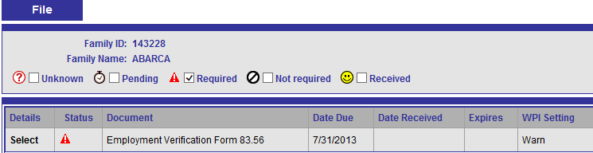

When you receive the outstanding documentation:

- Select the document from the list.

- Click Edit at the top of the page.

- In the File Status dropdown, select Received.

- The Expiration Date field will appear. This is used to set the expiration date (if needed) for a document with “Received” status. An alert will be generated (in the Alerts page) X number days (set up by your administrator) before the expiration date.

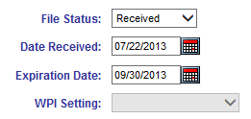

- Click Save at the top of the page.

EESIS - Quick Reference Guide

ENROLLMENT:

- Search for the family. Did you find them? If no, go to #2. If yes, go to #8.
- New Family – Add the family information.
- Parent – Add information for the first parent and designate responsibility as primary parent. If there is another parent, create another new parent page, enter the information for the second parent as designate responsibility as secondary.
- Needs - Add new need for the primary parent. If there is a secondary parent, select that parent from the dropdown and enter a new need for that person.
- Income – Add new income for the primary parent. If there is a secondary parent, select that parent from the dropdown and enter a new income for that person.
- Child – Add information for the first child in the family. Create new Child pages for each child in the family. (Family eligibility is based on family size and income.)
- Schedule – Select the center, program, class room. Parent Fee Rate type will be populated based upon the program selected. Enter the Schedule Start Date and Schedule End Date. See Chapter 16.6 for Varying Schedule information. Show the From and To times each day the child will be attending.
- Existing Family – If the family is found in EESIS they may be terminated or active at another site.
  - If terminated, reactivate the family on the Family page, update information on Parent, Income and Child pages. Create a new schedule.
  - If active at another site, create a new schedule for the child. Do not change schedules of any other children and do not change recertification date.
- Print the 9600 (application) and have the parent sign.
- Print the NOA and have the parent initial.

ONGOING ACTIVITIES IN EESIS:

DAILY

Attendance
- Go to the Attendance page, select Center, Program(s) and Classroom(s).
- Select the week.
- Click the View Attendance button at the top.
- Click on the day/date to highlight the column for that day.
- Click OK to confirm hours.
- Enter absence reasons from the dropdown as appropriate.
- Click to save.

WEEKLY
Print Sign-In Sheets
- Go to Reports > Administrative Reports > Sign-In Sheet
- Choose the parameters that apply (each classroom separately or all at the same time)
- Click to print

Print other reports
As needed, print the Health Inspection Roster, Class Roster, Child Roster by going to Reports > Administrative Reports.

MONTHLY

Generate invoices and distribute to fee-paying families. Go to Invoice > Print Queue, select school and enter dates for the upcoming month.
Collect fees. This should primarily be during the first week of the month but may be done more frequently. Enter each fee in the family Account page in EESIS and provide the parent with a receipt.

Deposit fees. This should primarily be during the first week of the month but may be done more frequently as needed. Fees must be deposited at the bank within the month received.

ANNUALLY

Annual Immunization Report (usually requested in October)
Go to Reports > Government Reports > CDPH 8018. The data is then submitted online based on instructions from District Nursing Services. To see specific children who need follow up, print the CDPH 8342.

Tax Letter (in January)
Go to Reports > Invoice > Tax Letter.
This will print tax letters for all fee-paying parents that can be used when filing for a deduction on income tax.

NEED HELP? Email: eesis@lausd.net

INCOME RANKING TABLE
Child Care and Development Income Rankings – Effective July 1, 2011 until rescinded
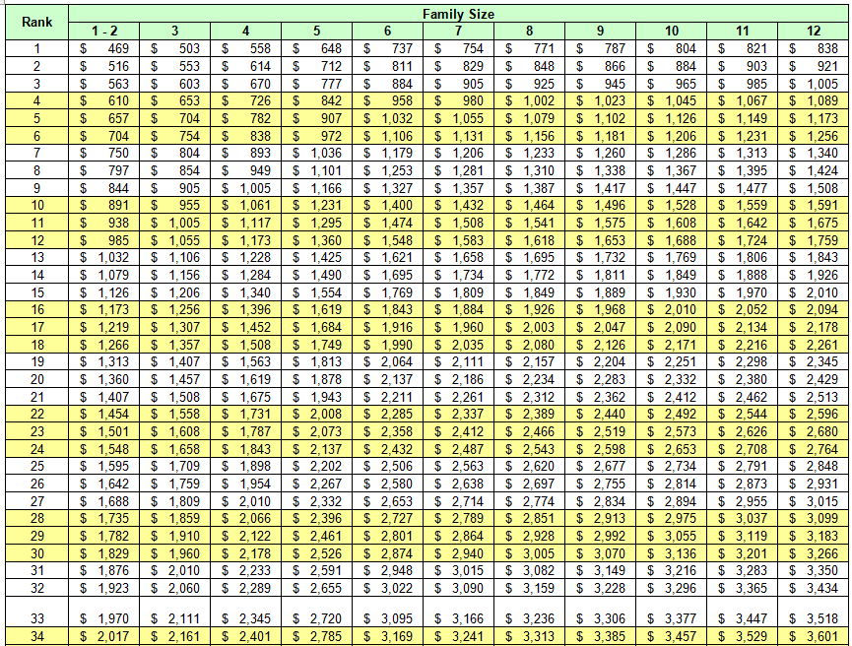

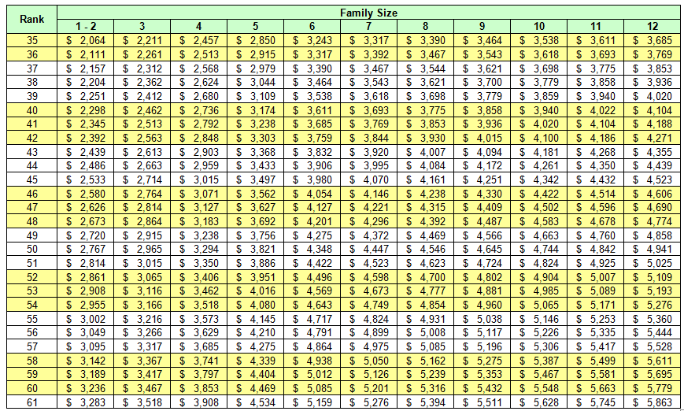
Note: The monthly income in each box represents the upper limit for each rank, adjusted for family size.California Department of Education, July 2011

FAMILY FEE SCHEDULE (Monthly fees implemented in EESIS May 1, 2015)
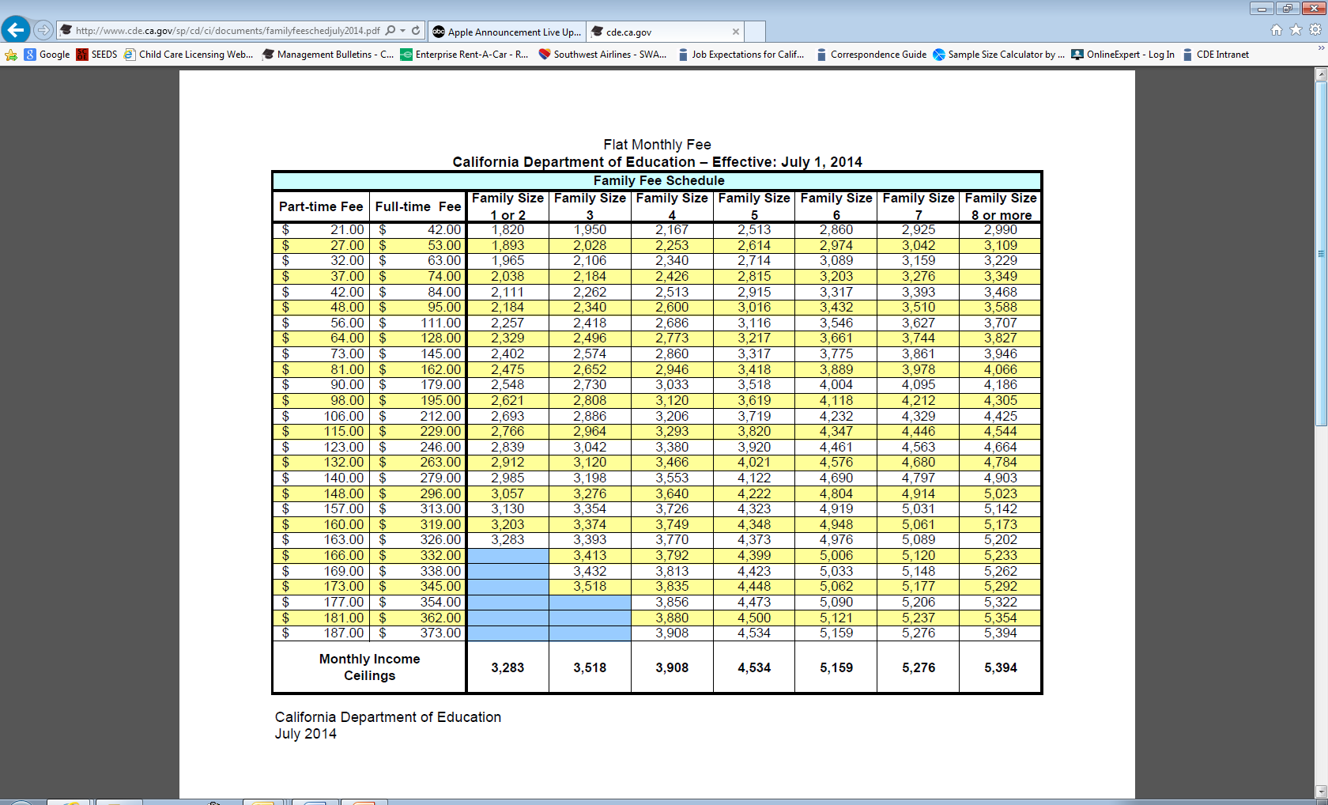

FORMS

TYPE | FORM | DATE
Enrollment  New | Eligibility / Waiting List for LAUSD Early Childhood Education Services | Rev. 5/30/13
Enrollment  New | Parent Enrollment Packet Checklist | 5/2013
Enrollment  New | Home Language Survey 83.76 | Rev. 1/07
Enrollment  New | Student Emergency Information Form | 3/2010
Enrollment  New | Physician’s Report – Child Care Centers (Child’s Pre-Admission Health Evaluation)Department of Social Services Form LIC 701 | 8/08
Enrollment  New | Personal Beliefs Exemption to Required Immunizations, CDPH 8262 | 10/13
Eligibility | CD9600 (Confidential Application for Child Development Services and Certification of Eligibility | Rev. 5/12  (Print from EESIS, Summary page)
Eligibility | CD9600A (Child Care Data Collection Privacy Notice and Consent Form) | Rev. 1/04  (Print from EESIS, Summary page, 9600, check Print Consent)
Eligibility | NOA CA 7617 (Notice of Action) | Rev. 8/11  (Print from EESIS, Summary page)
Eligibility | Notice of Recertification, Form 84.65 | Rev. 7/13
Eligibility | Self-Declaration of Single Parent Status
Eligibility | Self-Declaration of Absent Parent
Eligibility | Homeless Declaration Form
Eligibility | Seeking Permanent Housing Policy, AP300 | 7/15/08
Need | Child Protective Services Form 83.66 | Rev. 7/07
Need / Income | Verification of Employment (Form 83.56) | Rev. 10/2013
Need / Income | Self-Certification of Income Form | Rev. 3/2013,  Spanish Rev. 5/2013
Need | Seeking Employment Agreement 83.14  (BUL-4363.0) | Rev. 3/2013,  Spanish Rev. 5/2013
Need | Seeking Employment Calendar | Revised annually
Need | Training Verification, Form EESD-9605 | Rev. 01/2015
Need | Progress Report, Form 99.1 | Rev. 03/2013
Need | Travel and Study Time Table
Need | Statement of Incapacity, Form CD-9606 | June 2008
Attendance | Agreement for Temporary Service in EECs, Form 83.69, rev. 06/09 | 06/08
Attendance | Interruption of Service 84.24 /Limited Term Services Leave Form | 06/08
Attendance | Attendance Codes Sheet (barcodes) | Print from EESIS Admin Reports
Fees | Verification of Other Care Provider form 84.26 | Rev. 1/07
Miscellaneous | Organization of Family Files | Rev. 02/06/14
Miscellaneous | Request for EESIS User ID Authorization | Rev. 12/2013
Miscellaneous | Claim for Overpayment | 1/8/12
Miscellaneous | Authorized Representative for Local Appeal Hearing | Undated. No specific form required.

Additional reports and forms in EESIS

